A MULTI-TARGET INVESTIGATION INTO THE THERAPEUTIC MECHANISMS OF ACTION OF LUTEOLIN IN COLORECTAL CANCER

BY
OMIRIN, EMMANUEL SUNDAY
MATRIC. NO.: PBM/P/24/25/0028
B. Sc. (Akungba-Akoko)

A DISSERTATION SUBMITTED IN THE
DEPARTMENT OF BIOCHEMISTRY
FACULTY OF BASIC MEDICAL SCIENCES
TO THE SCHOOL OF POSTGRADUATE STUDIES

IN PARTIAL FULFILMENT OF THE REQUIREMENTS FOR THE AWARD OF MASTER OF SCIENCE (M. Sc.) DEGREE IN BIOCHEMISTRY OF
OLABISI ONABANJO UNIVERSITY
AGO-IWOYE, NIGERIA
JULY, 2026

ABSTRACT
Colorectal cancer (CRC) is still one of the major causes of mortality, particularly in nations with low-to-middle income, due late diagnosis and limited access to therapeutics that are effective, affordable and less toxic. Multi-target anticancer potential of luteolin has been reported, yet its mechanisms in CRC are not well understood because most of the studies rely on one-target or one-pathway analysis. Consequently, this study used a multipronged approach including network pharmacology (NP), molecular docking, and In vivo experimentation to investigate the therapeutic potential of luteolin against CRC. Targets of luteolin and CRC were retrieved from online databases with intention to identify shared interactome. Hub genes were identified from protein-protein interaction network using STRING and cytoscape. Stability of luteolin and its targets were validated by docking and subsequent 100ns simulation. In vivo efficacy was verified in an azoxymethane (AOM)-induced Drosophila model of CRC. NP identified 379 shared targets existed between luteolin and CRC, including hub genes like AKT1, mTOR, TP53 and BCL2. Following enrichment analysis, the main targets are those in PI3K/Akt, Wnt and MAPK signaling pathways. Molecular docking predicted high binding energies - caspase-3 (-9.761 kcal/mol), AKT1 (-8.613 kcal/mol) and mTOR (-7.92 kcal/mol). Complexes were predicted to be favourable using MMGBSA, the major complex being predicted for AKT1 (-54.22 kcal/mol). MD simulations (100ns) demonstrated high structural integrity as the mean RMSD of the caspase-3 complex with luteolin was 1.8 Å and the variation of residues was small. In vivo data revealed luteolin significantly reduced tumour burden in all the groups supplemented with the diet compared to the AOM-only groups, achieving an exceptional result. End-point PCR analysis verified the predicted mechanism, as luteolin significantly (p < 0.05) down regulated oncogenic markers including mTOR, AKT1, c-MYC, and the anti-apoptotic BCL2. Luteolin up regulated critical pro-apoptotic and regulatory genes, specifically TP53, CDKN1A (dap), CASP3 (drice), and CASP9 (dronc). Luteolin disrupts CRC hallmarks by simultaneously inhibiting survival signaling and triggering apoptosis through a stable, multi-target interactome. These data scientifically position luteolin as a potent, multi-target chemopreventive agent which should be further investigated in a more physiologically relevant mammalian model of CRC.
Word Count: 347 words
Key Words: Colorectal carcinogenesis, Luteolin, Network pharmacology, PI3K/Akt pathway, Drosophila.

CERTIFICATION
I certify that this study is original and was carried out by EMMANUEL SUNDAY OMIRIN (Matric. No. PBM/P/24/25/0028) under my supervision and has been approved having met the requirements for the award of Master of Science (M. Sc.) Degree in Biochemistry from the Department of Biochemistry, Faculty of Basic Medical Sciences, Olabisi Onabanjo University, Ago-Iwoye under my supervision.

…………………………………………… …...……………………………
Dr. Muinat Moronke ADEYANJU Date
B. Sc., M. Sc., Ph. D. (Ogun)
(SUPERVISOR)

DEDICATION
This work is dedicated to the Almighty God, the source of life and wisdom, without whose guidance and blessings this research would not have been possible.

ACKNOWLEDGEMENTS
I give all glory to God almighty, the One through whom this project became possible. Many thanks to my supervisor, Dr. M. M. Adeyanju - she not only supervised my dissertation, she doubles as my mummy. Mummy, it is one of my best blessings meeting you. You and your kids will surely find help everywhere.
I am deeply grateful to all my lecturers within the department of Biochemistry - Dr. E. N. Ezima (my powerful HOD), Dr. B. O. Adegbesan (the Graduate Coordinator herself), Dr. B. S. Fagbohunka, Dr. K. T. Odufuwa, Dr. A. Akinpelu, Dr. E. Adesanya, and finally Dr. A. S. Faponle, who took the role of my personal “japa” advisor. To all of you, I say a big thanks.
I especially owe a lot to the Eureka Research Laboratory, Anatomy Department, Babcock University, under the leadership of Dr. Afees John Olanrewaju. Dr. Olanrewaju, you are appreciated now and forever. I thank you very much for all the kinds of help rendered, may God reward your children copiously. I am also grateful to Miss T. O. Afolabi (our Lab Coordinator) for her effort before, during, and after my research. I want to thanks my “niggas” in the Lab - E. A. Olugbogi, P. A. Aribisala, and O. E. Soremekun. I am also grateful to Dr. L. O. Arietarhire and Dr. J. I. Enya (both of Eureka Lab). Thank you for all you are doing. I will forever appreciate my moment with you.
Special appreciation goes to my parents (Mr. J. A. and Mrs C. M. Omirin) for their support - financial, spiritual, and all other forms.
To everyone who contributed to the success of this work, friends, mates, colleagues, and the ones I cannot mention because of space provided here, I am very grateful.
LIST OF TABLES
Tables Pages
Table 3.1: Table showing list of primers used for the study 34
Table 4.1: Summary of molecular docking and MMGBSA score 43
Appendix Table A1: Composition of Corn Meal Medium Used for Drosophila Culture 71

LIST OF FIGURES
Figures Pages
Figure 2.1: GLOBOCAN data on CRC incidence and mortality 10
Figure 2.2: Pathways driving the development of CRC 13
Figure 2.3: Molecular mechanisms of AOM-induced carcinogenesis 16
Figure 2.4: Structure of Luteolin 21
Figure 3.1: Illustration of the methodological approach in current study 28
Figure 4.1: Venn illustration of overlap between luteolin and CRC-associated
target genes 37
Figure 4.2: KEGG pathway map illustrating luteolin-associated targets involved
in CRC 38
Figure 4.3: PPI network of overlapping luteolin-colorectal cancer–associated
hub genes 39
Figure 4.4: Protein interaction network of overlapping genes in CRC 40
Figure 4.5: Gene ontology enrichment analysis of overlapping luteolin–CRC 41
Figure 4.6: Pathway enrichment analysis of overlapping luteolin–CRC targets 42
Figure 4.7: RMSD profiles of the Caspase–luteolin complex during MD simulation 44
Figure 4.8: RMSD profiles of the AKT–luteolin complex during molecular MD
simulation 45
Figure 4.9: RMSD profiles of the mTOR–luteolin complex during MD simulation 46
Figure 4.10: RMSF profile of Caspase-3 Cα atoms obtained from MD simulation 47
Figure 4.11: RMSF Plot 3O96 Cα atoms obtained from molecular dynamics simulation 48
Figure 4.12: RMSF Plot 4JSV Cα atoms obtained from molecular dynamics simulation 49
Figure 4.13: Protein-ligand contact histogram 2J30 (Caspase 3) 50
Figure 4.14: Protein-ligand contact histogram 3O96 (AKT1) 51
Figure 4.15: Protein-ligand contact histogram 4JSV (mTOR) 52
Figure 4.16: mRNA expression of TP53 55
Figure 4.17: mRNA expression of Caspase 3 56
Figure 4.18: mRNA expression of Caspase 9 57
Figure 4.19: mRNA expression of c-MYC 58
Figure 4.20: mRNA expression of mTOR 59
Figure 4.21: mRNA expression of CDKN1A 60
Figure 4.22: mRNA expression of BCL 2 61
Figure 4.23: mRNA expression of AKT1 62

List of Abbreviations
CRC: Colorectal cancer
LMICs: Low- and middle-income countries
ABC: ATP-Binding Cassette
STAT3: Signal transducer and activator of transcription
GLOBOCAN: Global cancer observatory
CIN: Chromosomal instability
MSI: Microsatellite instability
CIMP: CpG island methylator phenotype
APC: Adenomatous polyposis coli
EMT: Epithelial-mesenchymal transition
AOM: Azoxymethane
MAM: Methylazoxymethanol

TABLE OF CONTENTS
Contents Pages
Title Page i
Abstract ii
Certification iv
Dedication v
Acknowledgement vi
List of Tables vii
List of Figures viii
List of Abbreviation x
Table of Contents xi
CHAPTER ONE 1
1.0 INTRODUCTION 1
1.1 Background to the Study 1
1.2 Statement of the Problem 4
1.3 Justification of the Study 5
1.4 Research Questions 6
1.5 Research Aim 6
1.6 Research Objectives 6
CHAPTER TWO 8
CHAPTER TWO 8
2.0 LITERATURE REVIEW 8
2.1 Overview 8
2.2 Global Epidemiology and Burden of CRC 8
2.3 Pathophysiology and Molecular Mechanisms of CRC 11
2.3.1 Mechanism of Azoxymethane-Induced CRC 14
2.4 Conventional Therapeutic Approaches and Limitations 15
2.4.1 Phytochemicals in Cancer Therapy 17
2.4.2 Luteolin: Structure and Pharmacological Properties 18
2.5 Network Pharmacology in Drug Discovery 19
2.5.1 Drosophila melanogaster as a Model for Cancer Research 22
2.5.2 Advantages of Drosophila Models 23
2.6 Integration of Network Pharmacology and Drosophila Models 23
CHAPTER THREE 26
3.0 MATERIALS AND METHODS 26
3.1 Materials 26
3.2 Methods 26
3.2.1 Luteolin Retrieval and Target Prediction 26
3.2.2 Identification of Colorectal Cancer–Related Targets 27
3.3 Protein–Protein Interaction (PPI) Network and Hub Gene Analysis 27
3.4 Functional Enrichment and Pathway Analysis 29
3.5 Network Construction and Visualization 29
3.6 Molecular Docking and Dynamics Simulation 30
3.7 Software and Statistical Analysis 31
3.8 In vivo Study Design 31
3.9 Study Location 31
3.10 Drosophila Stock and Culture 31
3.11 Corn Meal Preparation 32
3.12 Sacrifice and Total PolyA RNA Isolation 32
3.13 cDNA Synthesis 32
3.14 PCR Amplification and Agarose Gel Electrophoresis 33
3.15 Gel Cleaning and Number Generation 33
CHAPTER FOUR 35
4.0 RESULTS AND DISCUSSION 35
4.1 Network pharmacology, molecular docking, and molecular dynamic simulation 35
4.2 mRNA expression and qPCR quantification 53
4.3 Discussion 63
CHAPTER FIVE 68
5.0 SUMMARY, CONCLUSION, AND RECOMMENDATION 68
5.1 Summary 68
5.2 Conclusion 69
5.3 Recommendations 70
REFERENCES 72

CHAPTER ONE

1.0 INTRODUCTION

1.1 Background to the Study
Colorectal cancer (CRC) is still of the most redoubtable world health challenges in the 21st century, its major characteristics is uncontrolled proliferation of epithelial cells that line either the colon or rectum, it often progress from benign adenomas to malignant carcinomas through a series of genetic and epigenetic alterations (Adebayo et al., 2023). Being the number three most common malignancy in the world, it accounts for about 10% of all cancer diagnoses and also about 9.4% of all cancer-related mortality – it has an estimated 1.93 million new incidence and 916,000 mortality cases reported in the year 2020 alone (Sukrueangkul et al., 2024). Its burden is not evenly distributed – high-income countries are showing reducing or declining incidence as a result of effective screening interventions, while low-and middle-income nations (LMICs) still experience rapid surge which is adduced to westernized diets, sedentary lifestyles, and ageing populations (Adebayo et al., 2023; Sukrueangkul et al., 2024).
Despite progress in screening, chemotherapy, surgery, and targeted treatments, the treatment of CRC still faces redoubtable limitations that long-term remission and patient quality of life (QoL) (Adebayo et al., 2023). 5-fluorouracil, oxaliplatin, and irinotecan, the common chemotherapeutic agents, are still plagued by acquired drug resistance, occurring in the majority of patients due to genetic mutations and efflux pumps like ATP-Binding Cassette (ABC) transporters (Alatise et al., 2025). Toxicity profiles are equally of concern, with neurotoxicity, gastrointestinal distress, and cardiotoxicity affecting a great deal of patients, leading to dose reductions or discontinuation (Azwar et al., 2025). Single-target therapies, such as EGFR inhibitors (cetuximab) or VEGF blockers (bevacizumab), are limited by tumour heterogeneity and pathway redundancy, resulting in low response rates and inevitable relapse (Bakillah et al., 2025).
Off-target effects of chemotherapeutics further worsen morbidity, particularly secondary malignancy and immune suppression (Moen et al., 2024). Other challenges include high rate of recurrence, lateness of diagnosis in resource-limited nations, variability in genetics across population, and unaffordable cost of precision medicine, restricting access in resource-limited settings like Nigeria (Moen et al., 2024; Alatise et al., 2025). These factors collectively contribute to stagnant improvements in survival, necessitating safer, multi-target therapeutic options that address the multifaceted nature of CRC pathogenesis.
Compounds from natural products have emerged as promising alternatives, with luteolin attracting attention for its reported pleiotropic anticancer potentials. Luteolin is a member of flavone family, a sub-class of flavonoids having pale yellow crystalline appearance. It is the active component of the yellow die from Reseda luteola. The compound is mainly found in the leaves of plants, and has also been detected in the rinds of fruits, in bark tissues, clover flowers, and ragweed pollen (Wang et al., 2025). It was isolated from Salvia tomentosa, a member of the Lamiaceae family, which is aromatic, and it can also be found in peppermint and thyme. Other foods that contain flavonoids: celery, broccoli, artichoke, green pepper, parsley, dandelion, perilla, chamomile tea, carrot, olive oil, rosemary, navel orange, oregano (Fusi et al., 2020).
Luteolin halts proliferation of cancerous cells, causes apoptosis, and restrain metastasis via a lot of pathways - including PI3K/Akt, MAPK, and NF-κB (Almatroodi et al., 2024). Many studies have documented its efficacy against numerous malignancies - it represses growth of tumor in breast cancer by reducing the expression of HER2 and inducing G2/M arrest (Lee et al., 2012); in lung cancer, it sensitizes cells to cisplatin via ROS-mediated apoptosis (Pratheeshkumar et al., 2014); prostate cancer models demonstrate inhibition of androgen receptor signaling and migration (Ganai et al., 2021); colon cancer exhibits reduced invasion via Wnt/β-catenin suppression (Rauf et al., 2024); liver cancer is targeted through STAT3 inhibition (Liu et al., 2010); pancreatic cancer shows enhanced gemcitabine sensitivity (Panebianco et al., 2021); gastric cancer involves p53 upregulation (Busuttil et al., 2014); and leukaemia responds to Bcl-2 downregulation (Tuli et al., 2022). The above listed examples show luteolin has broad spectrum of activity – yet a lot of these focus on tradition one-target or one-pathway approach, leaving behind the holistic and multiple target interactions that occurs in complex disease as in the case of CRC.
This limitation underlines the need for a robust and comprehensive research that unravels the full therapeutic potential of luteolin against CRC. NP – a modern scientific approach that integrates bioinformatics, omics data, and molecular docking, offers a reputable framework which helps to predict drug-target interactions, map signaling networks, and identifying synergistic pathways (Tuli et al., 2022). By constructing compound-target-disease networks, it will reveal how luteolin modulates multiple hubs in CRC pathogenesis, such as apoptosis, angiogenesis, and cell cycle regulation. In vivo validation using Drosophila melanogaster (Drosophila) - genetically tractable, cost-effective, and ethically favourable - further bridges computational predictions to biological outcomes. Drosophila shares above 75% of human disease genes, enabling rapid screening of hub genes like p53 or mTOR orthologues in CRC-like phenotypes (Sang et al., 2024).
This study therefore employs NP to investigate luteolin's multi-target mechanisms against CRC, followed by In vivo validation on hub genes using the Drosophila model. By addressing the gaps in single-target research, the study aims to establish luteolin as a safe, multi-pathway therapeutic candidate, potentially reducing reliance on toxic chemotherapies and improving outcomes in high-burden regions like Nigeria.

1.2 Statement of the Problem
CRC is a growing public health problem, and its increasing incidence and mortality is a major concern in LMICs (Singh et al., 2024). However, current therapeutic options face limitations - these treatments have serious side effects that negatively impact patient QoL, especially vulnerable populations (Adebayo et al., 2023). Furthermore, their high prices mean that they are inaccessible in LMICs (Alatise et al., 2025), where healthcare infrastructure is often weak. However, in a significant fraction of patients, resistance to targeted therapies is mediated by genetic changes in pathways which further decreases the effectiveness of these drugs, and there are few treatment options for advanced CRC with a poor prognosis (Moen et al., 2024).
Phytochemicals have the potential to be used as anti-CRC agents, because they are widely available and relatively inexpensive; however, their use is hindered by a lack of understanding of the molecular mechanisms involved. Pre-clinical studies suggest that luteolin, a naturally occurring flavonoid, possesses anti-inflammatory, antioxidant, and tumor growth inhibitory properties, indicating its potential benefits (Imran et al., 2019; Ganai et al., 2021; Almatroodi et al., 2024). But the exact molecular targets and pathways that luteolin influences in CRC are not well characterized, hindering its progress to clinical use. In contrast, traditional drug discovery strategies are typically targeted towards single molecular targets and are not well suited to the multi-target actions of phytochemicals such as luteolin.
Mammalian models are useful for detailed information, but are costly, have long experiments duration and are genetically complex to be useful for large-scale and rapid testing. The genetic conservation with human species, negligible redundancy and high-throughput in Drosophila have not been fully exploited for CRC research, which can help to connect In silico predictions with clinical studies (Yang et al., 2024). This study aimed to overcome these limitations by using NP to build the molecular network of luteolin in CRC and by measuring its therapeutic effects in Drosophila.

1.3 Justification of the Study
There is a global surge in the incidence of CRC which requires immediate efforts to develop therapies that are readily available and less toxic, particularly in LMICs where healthcare inequities increase mortality rates (Adebayo et al., 2023). Current CRC treatments such as chemotherapy and targeted therapies can have significant side effects, financial costs and genetic mutations causing resistance, making them unavailable to many patients and not accessible in LMICs (Almatroodi et al., 2024). Phytochemicals such as luteolin, a flavonoid with demonstrated anticancer, anti-inflammatory and antioxidant activity, provide an attractive alternative, as they are relatively inexpensive, and have multiple targets. Although luteolin has demonstrated anti-carcinogenic properties in preclinical research, its precise molecular mechanisms in CRC pathways remain largely unclear, hindering its clinical development. The molecular interactions of luteolin with CRC pathways are not well understood and require further investigation to support its clinical advancement (Almatroodi et al., 2024).
The traditional single-target drug discovery strategy is not suitable for finding all the effects of luteolin, so the network pharmacology is used to map the interactome of luteolin. Furthermore, there are no affordable and high throughput In vivo models available, which limits preclinical validation. Drosophila is an often overlooked but ideal platform for CRC drug testing due to its high percentage of human disease gene orthologs, little genetic redundancy, and low cost, rapid screening (Yang et al., 2024). The selection of the focus of this study is justified by the integration of network pharmacology and Drosophila models to gain insight into luteolin's anti-CRC potential, which is supported by preclinical evidence that will aid the development of luteolin as an accessible therapy for global CRC management.
1.4 Research Questions
The following questions will guide this research work:
- What important targets and pathways are modulated by luteolin in CRC progression as predicted by analysis?
- How efficacious is luteolin in repressing the progression of colorectal tumorigenesis and modulating important pathways in Drosopjila model of CRC.
- Can the integration of network pharmacology and Drosophila melanogaster models provide a reliable framework for elucidating the multi-target anticancer mechanisms of phytochemicals like luteolin for affordable CRC therapy development?

1.5 Aim of the Study
This study seeks to investigate the molecular mechanisms by which luteolin exerts its anti-colorectal cancer effects using an integrated network pharmacology approach and Drosophila melanogaster models of colorectal cancer, while validating its predicted interactions with selected druggable targets through molecular docking simulations.

1.6 Objectives of the Study
The main objectives of this study are to:
- identify and characterize the molecular targets and signaling pathways that mediate luteolin's anti-CRC activity.
- determine the In vivo activity of luteolin against CRC in Drosophila by measuring its ability to prevent tumour growth, survival and expression of relevant molecular markers.
- design an integrative approach (network pharmacology and Drosophila models of CRC) to examine the multi-target anticancer activity of luteolin.
- perform binding of luteolin to druggable targets in luteolin-CRC network pathway using molecular docking.

CHAPTER TWO

2.0 LITERATURE REVIEW

2.1 Overview
Colorectal cancer (CRC) is a significant worldwide health issue driven by genetic, epigenetic and environmental factors. Although significant advances have been made in screening and treatment, CRC incidence and mortality are still on the increase, particularly in LMICs where healthcare access is low. Advanced stages may not be treated with conventional therapies like surgery, chemotherapy, or radiotherapy because they are toxic, resistant, and expensive (Adebayo et al., 2023; Alatise et al., 2025). There have been increasing interests in natural compounds and the phytochemicals are being investigated as safer alternative with multiple targets. Luteolin has demonstrated significant anticancer activity among these, characterized by its properties in inhibiting tumor growth, inducing apoptosis and decreasing inflammation and oxidative stress (Almatroodi et al., 2024). Its exact molecular mechanisms are not known, though. In this chapter, the CRC biology, current therapies and therapeutic potential of luteolin are reviewed, and the use of network pharmacology and Drosophila as novel tools to understand the anti-CRC effects of luteolin are discussed.

2.2 Global Epidemiology and Burden of CRC
The Global Cancer Observatory (GLOBOCAN) estimates that there were an estimated 19.3 million new cancer cases and 10 million cancer deaths in the world in 2020. CRC accounted for around 1.93 million (10%) of new cases and 0.94 million (9.4%) deaths (Figure 2.1), making a significant contribution to the global cancer burden (Morgan et al., 2023; Sukrueangkul et al., 2024). CRC incidence and mortality vary significantly between countries and regions, and are strongly associated with socioeconomic status (Arnold et al., 2017). However, both incidence and mortality are higher in wealthier regions globally, and lower in lower income regions (Morgan et al, 2023). CRC is more common in countries with higher income, but there is a rise in prevalence in both men and women in developing countries. The highest incidence of cases (45.94%) and fatalities (49.37%) were reported in upper-middle-income countries, while high-income countries reported 42.43% of cases and 36.40% of fatalities, which could be due to improved access to effective treatment and healthcare infrastructure (Ji et al., 2024).
CRC is the second most common cancer in men, and the sixth most common cancer in women, in 186 and 6 countries respectively worldwide in 2020 (Hossain et al., 2022). In contrast, CRC was the most diagnosed cancer among men in just 10 countries, and among women in no country in 2018 (Bray et al., 2018). About 5% of countries had CRC as the top cancer in men, rising to 10%, and 3.24% of the countries had CRC as top cancer in women. CRC is more prevalent in males than females and has been observed more than four times as often in high income countries as in low income countries. Also, mortalities are roughly 2.5 times more in rich countries than in poor countries (Bray et al., 2018; Hossain et al., 2022).
The age-standardized incidence rate of CRC was 19.8 persons per 100,000 population for both sexes combined in 2020, similar to the incidence rates in 2018, which were 23.4 and 16.2 per 100,000 population for men and women, respectively. The corresponding age-standardized mortality rate was 9.1 per 100,000, comprising 11.0 per 100,000 in men and 7.2 per 100,000 in women (Alatise et al., 2025).
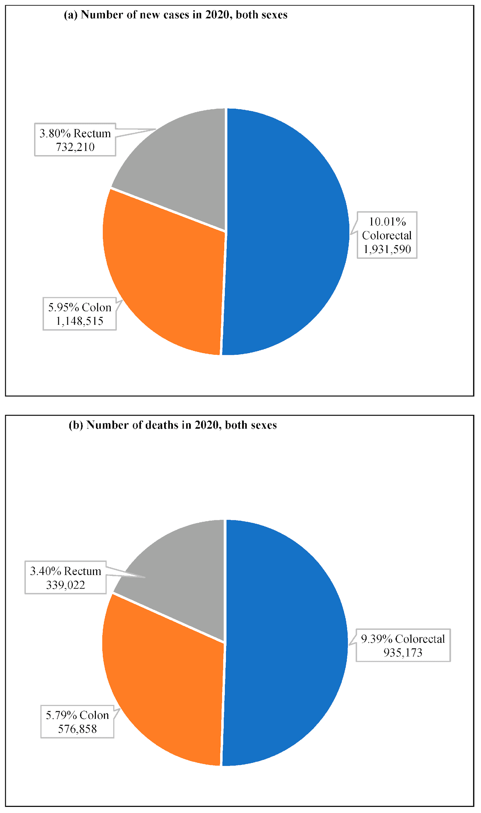
Figure 2.1: Global cancer observatory (GLOBOCAN) data on the incidence and mortality of colorectal cancer (Morgan et al., 2023)

2.3 Pathophysiology and Molecular Mechanisms of CRC
The development of CRC is a complex process that progresses through a series of genetic and epigenetic alterations in the cells of the colon's mucosal lining, leading to the transformation of healthy colon into a tumor with cells that are capable of invading adjacent tissues and organs (Zoratto et al., 2014). This evolution involves sequential stages from aberrant crypt foci (ACF) to adenomas and ultimately invasive carcinomas, driven by diverse mutations and environmental influences (Testa et al., 2018). Recent literature emphasizes the heterogeneity of CRC, with molecular subtypes influencing pathogenesis, prognosis, and therapeutic responses. Several molecular pathways are involved in the pathogenesis of CRC, with chromosomal instability (CIN), microsatellite instability (MSI), and CpG island methylator phenotype (CIMP) being the most relevant, which promote colorectal tumorigenesis in different ways but share some common mechanisms (Yang et al., 2024).
The adenoma–carcinoma sequence is well established as the most important pathway of CRC pathogenesis and is responsible for almost 85% of sporadic CRC via the chromosomal instability (CIN) pathway. This usually starts with mutation of the adenomatous polyposis coli (APC) gene, which is a critical regulator of Wnt/β-catenin signaling. Disruption of APC causes the accumulation and nuclear localization of β-catenin, which turns on the genes required for proliferation, such as MYC or CCND1 (cyclin D1), which facilitate the development of adenomas and the progression of tumors. This fosters hyperproliferation and formation of early adenomas (Wang et al., 2024). Progression to intermediate adenomas involves activating KRAS mutations, amplifying MAPK/ERK signaling to enhance cell survival and proliferation (Singh et al., 2024). Late-stage adenomas acquire mothers against decapentaplegic homolog 4 (SMAD4) or deleted in colorectal cancer (DCC) deletions on chromosome 18q, disrupting TGF-β signaling and promoting invasiveness. Carcinoma transition is marked by mutations in TP53, impairing the repair DNA and apoptosis, enabling unchecked growth and genomic instability (Wang et al., 2024; Bocchi et al., 2025). Metastasis, often to the liver or lungs, involves epithelial-mesenchymal transition (EMT) via pathways like PI3K/AKT/mTOR, upregulated by PTEN loss or PIK3CA mutations (Roshan et al., 2019).
Alternative pathways include the MSI-high (MSI-H) subtype, prevalent in right-sided tumors and linked to Lynch syndrome (hereditary nonpolyposis CRC) or sporadic hypermethylation of mismatch repair (MMR) genes like MLH1 (Battaglin et al., 2018). MSI-H tumors exhibit high mutation burdens, neoantigen loads, and immune infiltration, which correlate with better prognosis but also with resistance to 5-FU chemotherapy (Wang et al., 2025). The CIMP pathway, overlapping with MSI-H, involves hypermethylation of promoter regions, silencing tumor suppressors like CDKN2A (p16) (Chang et al., 2020). Beyond genetic alterations, inflammation plays a pivotal role, as seen in inflammatory bowel disease (IBD)-associated CRC, where chronic cytokine release (e.g., TNF-α, IL-6) activates NF-κB and STAT3 pathways, promoting survival and angiogenesis (Yang et al., 2024). The gut microbiome contributes via dysbiosis, with Fusobacterium nucleatum enhancing Wnt signaling and immune evasion (Roshan et al., 2019). Angiogenesis, mediated by VEGF and HIF-1α under hypoxic conditions, supports tumor vascularization, while metabolic reprogramming (Warburg effect) via PI3K/AKT sustains rapid proliferation (Yang et al., 2024).
To illustrate these mechanisms, Figure 2.2 depicts key molecular pathways in CRC development, encompassing the adenoma-carcinoma sequence and associated genetic alterations. These insights underscore CRC's molecular complexity, informing targeted therapies like EGFR inhibitors for left-sided CRC or immune checkpoint blockers for MSI-H tumors (Yang et al., 2024). However, challenges persist in translating these mechanisms to personalized medicine, particularly in addressing resistance and metastasis. Future research leveraging natural products and AI may further elucidate these pathways for improved interventions.
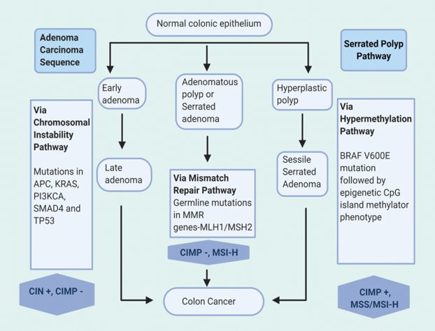
Figure 2.2: Diagrammatic representation showing the key molecular pathways involved in the development of colorectal cancer from normal colonic epithelium to colon cancer (Kasi et al., 2020).

2.3.1 Mechanism of Azoxymethane-Induced CRC
Azoxymethane (AOM) is a powerful chemical form of carcinogen commonly used to model CRC models. It is preferred because closely resembling the molecular and histopathological characteristics of sporadic CRC, it is a useful tool to study the process of carcinogenesis and to test chemopreventive agents (Waly et al., 2014). Carcinogenic process induced by AOM is a sequence of biochemical and molecular events such as metabolic activation, DNA alkylation, oxidative stress, inflammation and activation of oncogenic signaling pathways (Chen and Huang, 2009).
After administration, AOM is activated to the active carcinogenic metabolite, methylazoxymethanol (MAM), principally in the liver, by enzymes of the cytochrome P450 family, specifically CYP2E1 (Dalrymple, 2014) (Fig. 2.3). This metabolite is subsequently carried via the blood to the colon and rectum and it possesses genotoxic properties on the epithelial cells (Waly et al., 2014; Dalrymple, 2014). In the colonic tissue MAM is converted into methyl diazonium ions that can alkylate DNA bases, specifically O6 position of guanine, generating O6-methylguanine adducts (Nyskohus et al., 2013). During DNA replication, these adducts can incorrectly pair with thymine, generating mutations that frequently affect key cancer-associated genes, including KRAS, CTNNB1 (β-catenin), and TP53, thereby promoting malignant transformation and tumour progression. (Chen and Huang, 2009; Nyskohus et al., 2013).
AOM exposure also triggers genotoxic stress which results in excessive production of ROS and nitrosative stress, which causes lipid peroxidation, mitochondrial dysfunction and chronic inflammation in colonic tissues (Waly et al., 2014). This inflammatory environment facilitates other genetic changes and is a conducive environment for tumor initiation and progression (Nyskohus et al., 2013; Waly et al., 2014). Several oncogenic signaling pathways are triggered by the DNA damage and inflammation resulting from AOM. They are Wnt/β-catenin pathway which control uncontrolled proliferation and maintain the cancer stem cell properties (Kohno et al., 2025); the MAPK/ERK pathway that fosters mitogenic signaling (Aravindaram and Yang, 2010); the NF-κB pathway that maintains inflammation and thereby dampens apoptosis (Huang et al., 2022); and the generation of ROS (Huang et al., 2026). These signaling pathways are co-activated, ultimately causing unchecked cell growth, suppression of cell death, and increased angiogenesis, which promote tumor growth.

2.4 Conventional Therapeutic Approaches and Limitations
The standard treatment for CRC is a multitargeted approach using surgery, chemotherapy, targeted therapy and immunotherapy, depending on the stage and molecular characteristics of the disease. Surgical resection continues to play a crucial role in CRC treatment and is the main curative option, with 5-year survival rates > 90%, especially for localized disease (stages I and II) (Aigner et al., 2025) In stage III and metastatic CRC, treatment with adjuvant chemotherapy, mainly fluoropyrimidine-based such as 5-fluorouracil (5-FU) or capecitabine and oxaliplatin (FOLFOX), has been shown to prolong survival, but they are associated with adverse effects such as myelosuppression and neuropathy (Taieb and Gallois, 2020). Specific molecular subtypes can be targeted, such as with anti-EGFR (cetuximab) and anti-VEGF (bevacizumab) monoclonal antibodies; however, there are issues with resistance and cost of these treatments, and they can cost more than other therapies. $100,000 per course (Hecht et al., 2009). Immunotherapies like PD-1 inhibitors have been found to be effective in microsatellite instability-high (MSI-H) CRC, but not in microsatellite stable (MSS) tumors (Kasi et al., 2020). When applied sparingly (in rectal cancer), radiotherapy is a long-term risk of bowel dysfunction (Vendrely et al., 2022). These modalities, despite providing better outcomes, are limited by toxicity, resistance, lack of availability in LMICs and inadequate results in high burden disease, calling for new therapeutic approaches.

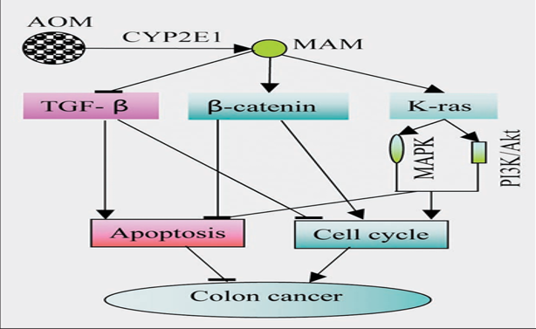
Figure 2.3: Summary of the mechanisms by which AOM induce CRC (Chen and Huang, 2009).

2.4.1 Phytochemicals in Cancer Therapy

Colorectal cancer (CRC) is a growing global disease and the currently available therapeutic options are not effective enough to curb the burden of the disease. Plant-derived phytochemicals are one of the more promising candidates as a group of naturally occurring molecules that are bioactive and have inhibitory effects on various cancer-promoting processes. These compounds have been demonstrated to cause interference in cellular proliferation, metastatic progression and resistance to programmed cell death, and are generally less toxic and less costly to produce than many synthetic drugs (Ganai et al., 2021; Almatroodi et al., 2024). Further, epidemiological investigations have indicated that the consumption of diets high in phytochemical-rich foods is associated with reduced risk of CRC, suggesting that diets containing these phytochemicals may be potential cancer prevention diets (Adebayo et al., 2023; Almatroodi et al., 2024).

The anticancer properties of phytochemicals occur through a wide range of biological activities such as inducing apoptosis, inhibiting angiogenic signaling pathways, dampening chronic inflammation and reducing oxidative stress by neutralizing reactive oxygen species (ROS). They work on several targets at once, unlike therapies that target one molecular target, and because of this, are less likely to fail due to mutations that contribute to resistance, like those in KRAS or BRAF, in CRC (Ganai et al., 2021). The high abundance of these compounds in edible plants makes them good candidates for use in prevention or treatment, especially in low and middle income countries where access to costly cancer treatment is limited. The ability of phytochemicals to target multiple hallmarks of cancer has been shown in numerous experimental studies and early-stage clinical trials, suggesting that their effect on CRC may be more comprehensive and a more holistic approach to its management (Imran et al., 2019; Almatroodi et al., 2024).

The flavonoids luteolin and quercetin are two of the most widely studied phytochemicals, both with strong anticancer properties. Luteolin has been shown to induce apoptosis in CRC cells from 10–50 μM by upregulating the pro-apoptotic mediators BAX and caspase-3, while down-regulating Bcl-2, an anti-apoptotic protein. The molecular effects are reflected in significant inhibition of tumour growth in xenograft models (Singh Tuli et al., 2022). Quercetin has also exhibited strong activity against CRC, as it has been shown to inhibit the Wnt/β-catenin signaling cascade, which is involved in the majority of colorectal tumours, and led to a significant reduction in CRC tumours in experimental animal studies (Duan et al., 2025). Moreover, phenolic acids such as caffeic acid and ferulic acid play a role in chemoprevention by exerting antioxidant properties that prevent accumulation of mutations and genomic damage in colorectal epithelial cells caused by ROS (Fakhri et al., 2025). Caffeic acid phenethyl ester (CAPE), a derivative of caffeic acid, inhibits PI3K/AKT signaling and inhibits HCT-116 cells proliferation at 20 μM (Kapare et al., 2022). Additionally, CAPE has been shown to increase the sensitivity of 5-fluorouracil (5-FU), and thus the therapeutic efficacy, in preclinical models of CRC (Chuu et al., 2012; Kapare et al., 2022; Fakhri et al., 2025).

2.4.2 Luteolin: Structure and Pharmacological Properties
Structurally, luteolin possesses the characteristic C6–C3–C6 flavonoid framework built around a 2-phenyl-1-benzopyran-4-one nucleus. Its molecular architecture is distinguished by hydroxyl substituents located at the 3′, 4′, 5, and 7 positions, together with a C2=C3 unsaturation within the heterocyclic C-ring. This configuration, depicted in Fig. 2.4 enhances its electron-donating capacity, contributing to its antioxidant activity and ability to chelate metal ions. The catechol moiety (3',4'-dihydroxy) in the B-ring is critical for ROS scavenging and enzyme inhibition, while the planar structure facilitates interactions with cellular targets like kinases and transcription factors.
Luteolin possesses potent antioxidant and anti-inflammatory effects with significant implications for the pathogenesis of colorectal cancer (CRC). The hydroxyl groups are capable of effectively scavenging reactive oxygen species (ROS) which can lead to oxidative DNA damage, which is known to play a significant role in about 10-15% of sporadic cases of CRC (Adebayo et al., 2023). HCT-116 cells treated with 20 μM luteolin markedly reduce ROS production within the cells, preventing lipid peroxidation and mutagenesis (Kapare et al., 2022). In addition to redox modulation, luteolin has strong anti-inflammatory properties, and it inhibits the NF-κB and STAT3 signaling pathways, resulting in significant decreases for pro-inflammatory cytokines like IL-6, TNF-α and IL-1β (Fakhri et al., 2025). In models of CRC associated with chronic inflammation, like inflammatory bowel disease, this is especially important, as chronic inflammation accounts for approximately 15–20% of CRC cases (Adebayo et al., 2023).
Luteolin possesses significant anticancer, anti-angiogenic, anti-metastatic, antioxidant and anti-inflammatory properties. It promotes apoptosis of CRC cell lines, such as HT-29 and SW480, in a concentration-dependent manner at 10–60 μM by increasing pro-apoptotic markers (Bax, caspase-3 and caspase-9) and decreasing the anti-apoptotic protein Bcl-2, causing marked growth inhibition (Singh Tuli et al., 2023; Zhu et al., 2024). Luteolin inhibits key oncogenic pathways that are involved in almost 80% of all CRCs such as Wnt/β-catenin (with decreased c-Myc expression), PI3K/AKT, and MAPK/ERK signaling (Aigner et al., 2025). Luteolin has been shown to decrease tumor volume by 40–60%, and formation of aberrant crypt foci (ACF) by about 50% in AOM/DSS-induced mouse models at a dosage of 20–50 mg/kg (Ashokkumar and Sudhandiran, 2011). Moreover, luteolin exerts anti-angiogenic and anti-metastatic effects through the repression of the expression of VEGFA and MMP-2/9, the suppression of invasion capacity in xenograft models, and the downregulation of markers for epithelial–mesenchymal transition (vimentin and N-cadherin) involved in the metastatic potential of advanced CRC (Rocchetti et al., 2023).

2.5 Network Pharmacology in Drug Discovery
Network pharmacology is a revolution in drug discovery, which combines systems biology, bioinformatics, and multi-omics, to chart complex drug-target-disease interactions. It is different from traditional single-target methods as it builds dynamic interactomes of drugs, targets, and pathways with disease, and is based on databases, allowing the prediction of therapeutic mechanisms and synergies (Li and Kar, 2025). The method is well adapted to the study of multi-target drugs such as phytochemicals in complex diseases such as CRC.
Network pharmacology is a method used to analyze biological systems as networks, in order to discover key nodes (genes, proteins) and pathways which are altered by drugs (Olanrewaju et al., 2024). It uses computational tools to put together genomic, proteomic and metabolic data, predicting the efficacy and side effects of drugs. Drug repurposing, polypharmacology and personalized medicine applications (Li and Kar, 2025). In cancer, it correlates oncogenic pathways (e.g. Wnt/β-catenin, PI3K/AKT) and prioritizes lead compounds, thereby minimizing preclinical failures. In CRC, for example, novel targets of 5-FU have been identified by network analyses, which improves the efficacy of combination therapies (Liao et al., 2022; Huang et al., 2022).
Phytochemicals with their multi-target activity are well suited for network pharmacology and to elucidate how they interact with cancer pathways. It integrates databases such as TCMSP and DisGeNET, which predict the interactions between phytochemicals and their targets, and shows 20-30 targets per compound in CRC, including EGFR, MAPK and NF-κB (Olanrewaju et al., 2024). In silico and In vivo, recent studies have demonstrated that quercetin and curcumin induce modulation of Wnt and PI3K/AKT which in turn inhibit tumor growth (Reyes-Farias and Carrasco-Pozo, 2019; Shahbaz et al., 2023). This will shorten lead optimization time and enable identification of synergistic combinations.
The various targets of luteolin in CRC, such as inducing apoptosis and inhibiting Wnt/β-catenin, are in line with network pharmacology. This maps the interactions of luteolin with hub genes and predicts the effect of luteolin on these targets in CRC. In this study, the CRC interactome of luteolin is first mapped using network pharmacology and then validated in In vivo Drosophila system, which will help develop luteolin as a low-cost and low-toxicity therapeutic agent for CRC.

2.5.1 Drosophila melanogaster as a Model for Cancer Research
The current drawbacks in CRC treatment, including toxicity, cost, and drug resistance, make it essential to have an efficient preclinical model to assess new drugs, including luteolin. The model system Drosophila is an excellent In vivo system for cancer research, because of its genetic conservation, physiological relevance, and economy of use. Drosophila offers a powerful system to study CRC pathogenesis and test phytochemicals, such as luteolin, as more than 75% of human disease related genes have orthologs in Drosophila. The advantage of having a short life cycle and high-throughput also fits this study, which integrates network pharmacology with in vivo validation to explore luteolin's anti-CRC activity and its effect on physiological changes in the case of wild-type flies (WT).
The midgut is very similar to the human colon, in which the intestinal stem cells (ISCs) give rise to the epithelial renewal of the colon, as seen in the fly (Sadaqat et al., 2021; Silcock, 2024; Park et al., 2025). Human CRC's adenoma-carcinoma sequence is recapitulated in chemically induced CRC models as conserved signaling pathways such as Wnt (Wingless), EGFR/RAS/MAPK and Notch regulate ISC proliferation and differentiation (Silcock, 2024). Familiarize flies with AOM or other cancer-provoking chemicals can cause tumor-like overgrowths that can reflect early stages of CRC in flies. Similar to human CRC, inflammation and microbiota dysbiosis are also triggers for the fly gut.

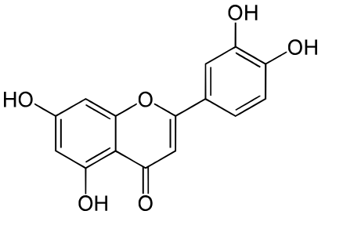
Figure 2.4: Structure of Luteolin (wikipedia)

In such models, aberrant crypt-like structures are formed in the intestines of WT flies within 7-14 days which allows for a fast evaluation of therapeutic compounds. Tumour-like growth is suppressed by 40% with luteolin at 50-100 μM in the diets of the wild-type flies (Yang et al., 2024). The model is also validated by the ability of known CRC drugs, such as aspirin (1 mM) and metformin (5 mM), to also inhibit ISC proliferation. phenotypic assays, such as survival, gut morphology (via microscopy) and gene expression (qPCR for Wingless and Ras) offer quantifiable readouts as part of a high throughput screen of phytochemicals combined with network pharmacology predictions.

2.5.2 Advantages of Drosophila Models of CRC
Drosophila offers distinct advantages over mammalian models for CRC research. Its streamlined genome minimizes genetic redundancy, providing clearer phenotypic responses to carcinogens or drugs compared to mice, where compensatory pathways obscure effects. The short lifecycle (10-14 days) and high fecundity (thousands of progeny) enable rapid experiments, unlike rodents requiring 6-12 months. Cost is a major benefit, with WT fly experiments costing <$0.01 per fly versus $100-$500 per rodent. Ethically, Drosophila bypasses vertebrate regulations (for example, EU Directive 2010/63), aligning with 3Rs principles (replacement, reduction, refinement). WT flies allow straightforward chemical induction of CRC-like phenotypes, simplifying setup compared to genetically engineered rodents, while maintaining relevance for screening luteolin’s effects.

2.6 Integration of Network Pharmacology and Drosophila Models
The complexity of CRC necessitates innovative approaches to identify and validate novel therapeutics. Integrating network pharmacology with Drosophila models offers a powerful strategy to bridge In silico predictions with In vivo validation, leveraging the strengths of systems-level analysis and a cost-effective, genetically relevant model. Network pharmacology maps luteolin’s multi-target interactions within CRC pathways, while WT Drosophila provides a rapid, high-throughput platform to test its efficacy, aligning with this dissertation’s aim to elucidate luteolin’s anti-CRC potential. This approach addresses the limitations of conventional drug discovery, enhancing mechanistic understanding and therapeutic translation for resource-constrained settings.
Network pharmacology, rooted in systems biology, constructs dynamic interactomes of drug-target-pathway-disease networks using bioinformatics tools and databases (Olanrewaju et al., 2024). It predicts how compounds like luteolin modulate multiple CRC pathways by identifying hub genes and protein-protein interactions (PPIs). This holistic approach captures the polypharmacological effects of phytochemicals, contrasting with single-target methods that miss synergistic actions. Drosophila complements this by providing a living system to validate predictions, using WT flies exposed to carcinogens (AOM) to model CRC-like phenotypes. The fly’s conserved pathways and quantifiable readouts enable functional testing of network-derived targets, integrating In silico and In vivo insights for robust drug discovery.
Recent studies demonstrate the efficacy of combining network pharmacology with Drosophila models (Yamamura et al., 2021; Munnik et al., 2022). For instance, a 2026 study mapped curcumin’s CRC targets using network analysis, then validated its suppression of Ras-driven midgut tumors, reducing proliferation significantly (Yuan et al., 2026). Another study used network pharmacology to predict quercetin’s inhibition of NF-κB, confirming reduction in inflammation-driven gut lesions (Bai et al., 2025). These studies highlight the synergy of In silico target identification and Drosophila’s rapid screening, achieving 2-3-fold faster validation than mammalian models.
Despite these advances, knowledge gaps persist in applying integrated approaches to luteolin in CRC. Network pharmacology studies predict luteolin’s modulation of CRC targets (e.g., APC, KRAS, VEGF), but In vivo validation, particularly in WT Drosophila, is limited. Existing Drosophila studies focus on genetically modified flies, overlooking WT models’ simplicity for chemical induction and screening. This study addresses these gaps by using network pharmacology to map luteolin’s CRC interactome and WT Drosophila to validate its efficacy against AOM-induced tumors, aiming to provide preclinical evidence for luteolin as a safe, affordable CRC therapy, particularly for low-resource settings.

CHAPTER THREE

3.0 MATERIALS AND METHODS

To gain insight into the effect of luteolin on the prevention of colorectal cancer (CRC), target prediction and pathway enrichment were conducted. Further, molecular docking and molecular dynamics simulations were used to confirm the suggested mechanisms of action. The whole flow of this study is shown in Figure 3.1.

3.1 Materials

Spectrophotometer (Jenway 6100), electric weighing balance (TORBAL AGZN120), centrifuge (Jenway 3117), polymerase chain reaction (PCR) machine (MERRAD PTC-15), electrophoretic machine (MERRAD PRC-24), photophoretic machine (Fotodyne 1-1430). Azoxymethane, luteolin, and nipagin were all supplied by Meck Pharmaceuticals and Chemicals. Corn-meal, ethanol, formamide, RNase-free water, tris-boric acid EDTA (TBE) buffer, primers, glycerol, isoamyl alcohol, TRIzol, chloroform, reverse transcriptase mix, PCR master mix, sucrose and all other reagents used for this research work were of top and analytical grade.

3.2 Methods

3.2.1 Luteolin Retrieval and Target Prediction
Luteolin structure was retrieved from the PubChem database as its SMILES structure in accordance with the procedure outlined by Olanrewaju et al. (2024). The SwissTargetPrediction and BindingDB were used to search for potential molecular targets. For SwissTargetPrediction, Drosophila melanogaster was chosen as the target species and only genes with prediction probabilities ≥ 0.70 were kept. Likewise, BindingDB was searched for the 2D SDF structure of luteolin and the targets with similarity score ≥ 0.70 were selected. The UniProtKB database was then used to map to official gene and protein information using corresponding UniProt identifiers. All recovered targets were picked, combined and sorted to eliminate duplicates. The non-redundant set of targets was used in the following analysis.

3.2.2 Identification of Colorectal Cancer–Related Targets

The gene targets involved in CRC were identified from OMIM, GeneCards and DisGeNET databases with the search term of “colorectal cancer” (Piñero et al., 2016; Jain et al., 2024). The gene lists were merged and duplicated genes were eliminated, resulting in a unique list of targets associated with CRC. Later, potentially shared targets between luteolin and CRC were identified by the Venny 2.1.0 platform (Olanrewaju et al., 2023; Jain et al., 2024). The intersection genes were then chosen for the construction of the network and molecular docking validation.

3.3 Protein–Protein Interaction (PPI) Network and Hub Gene Analysis
The targets that overlap for CRC and luteolin were subjected to computational query on STRING version 11.5 online database at (https://string db.org/) to capture intersection that exist between the targets (Szklarczyk et al., 2019). Multiple proteins section in STRING was used to search for the official gene symbols for common targets with organism name set as D. melanogaster. 0.70 was set as the minimum confidence score – this was done to increase the reliability of the interactions (Szklarczyk et al., 2019; Olanrewaju et al., 2024).

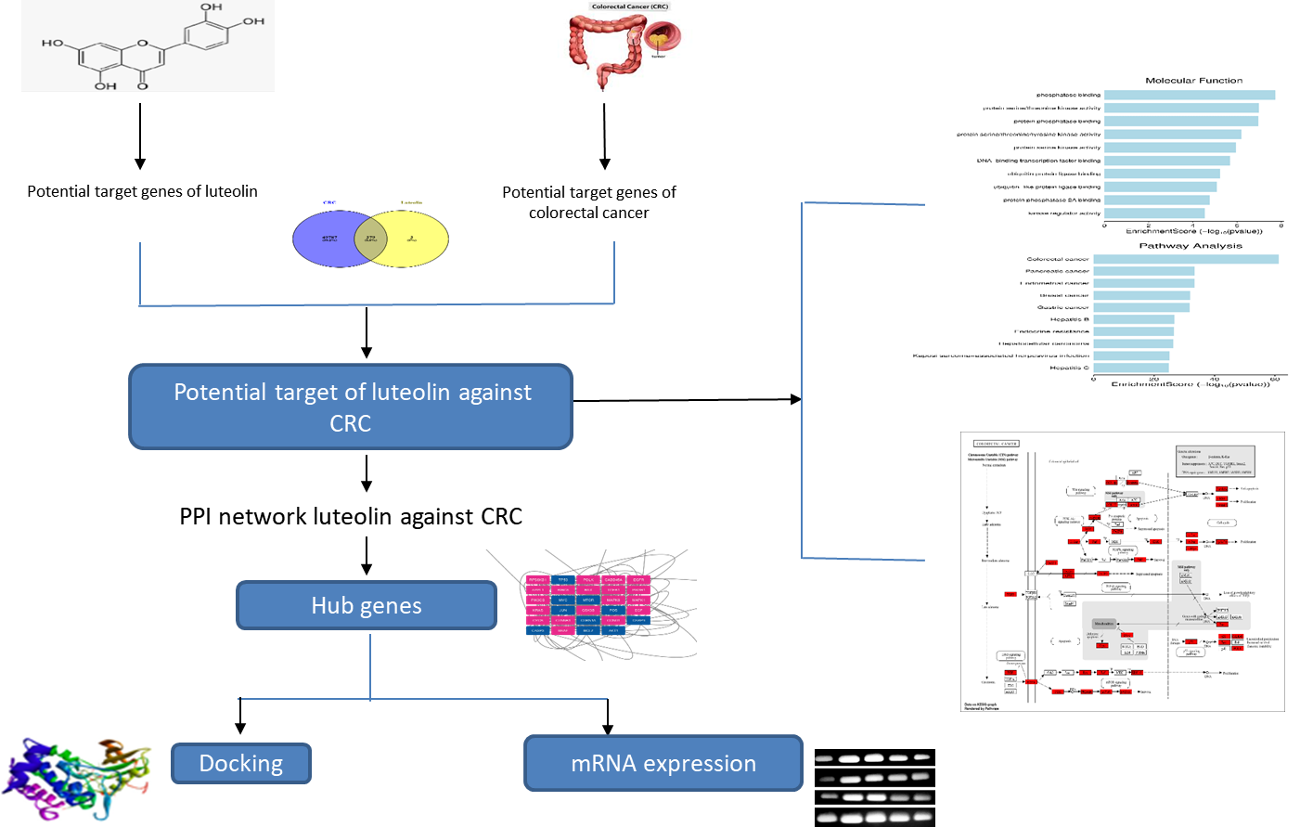
Figure 3.1: Illustration of the methodological approach in current study.

A protein–protein interaction network was generated and saved as TSV file which was then imported into Cytoscape for the purpose of visualizing the network and conducting topological evaluation (Olanrewaju et al., 2024). The Network Analyzer plugin was used to calculate the properties of the network such as node and edge parameters. These key targets were then identified using the CytoNCA plugin, which uses degree, betweenness and closeness centrality metrics (Li et al., 2021). The ten most influential hub genes were first identified using the CytoHubba plugin (Jain et al., 2024) and nodes with degree values equal to or higher than the median were then retained for subnetwork construction.

3.4 Functional Enrichment and Pathway Analysis

To elucidate the therapeutic mechanisms of luteolin against CRC, the identified core targets were subjected to Gene Ontology (GO) and KEGG pathway enrichment analyses using the DAVID 2021 functional annotation platform. Official gene symbols were uploaded with D. melanogaster specified as the reference organism. The analyses generated the top 10 molecular function terms and pathway categories, alongside the top 20 enriched KEGG pathways. Significant terms were selected based on gene count, p < 0.01, and FDR < 0.01 (Dorant et al., 2024). GO and KEGG enrichment results, including bubble plots, were subsequently visualized using SRPlot

3.5 Network Construction and Visualization

To investigate the relationship between luteolin and the predicted overlapping targets (Olanrewaju et al., 2024), a bioactive target network was created in Cytoscape v3.9.1. The compound and shared gene targets were added to the software and the network topology was evaluated with the cytoNCA plugin according to the degree values. The PPI enrichment and KEGG enrichment results were integrated to create a luteolin–target–pathway network that includes the top 20 paths taken from the KEGG pathways and the hub genes. Each node in this network reflects a compound, target, or pathway; each edge reflects an interaction between the nodes.

3.6 Molecular Docking and Dynamics Simulation
The protein–protein interaction network and the bioactive compound–target–pathway network were employed to identify core protein targets to which luteolin was docked to determine its possible anticancer effects by binding to these protein targets. The 3D coordinates of the hub proteins were taken from the RCSB Protein Data Bank while the 2D structure of luteolin was downloaded from PubChem and optimized with the LigPrep module in Maestro Schrödinger v12.8 (Omirin et al., 2024). The grid centre coordinates for the receptor grids are given in Table 4.1, which were created in the Glide Grid module.
The Glide module was then used to perform molecular docking in extra precision (XP) mode. The stability of the obtained complexes was also evaluated by Prime MMGBSA module calculation of the binding free energies. Favourable binding affinities were screened and complexes with these affinities were subjected to molecular dynamics simulation with the Desmond package of Maestro (Olanrewaju et al., 2023). Simulations were performed for 100 ns at NPT conditions, 300 K and 1.01325 bar. The preparation of the system was performed with the System Builder tool, water water model, an orthorhombic simulation box of 10 × 10 × 10 Å, and the OPLS3e force field (Omirin et al., 2024). Na⁺ and Cl⁻ ions were added to the systems to neutralize their charge and to minimize their energy.
To investigate the dynamic behaviour and stability of protein–ligand complexes, the root mean square deviation (RMSD) and root mean square fluctuation (RMSF) analyses were performed. RMSD was used to measure the deviation in the structure from the initial structure, while RMSF was used to measure the flexibility of the residues over the course of the simulation.

3.7 Software and Statistical Analysis
BIOVIA Discovery Studio Visualizer, Cytoscape v3.9.1, Maestro Schrodinger v12.8, and GraphPad Prism V9.

3.8 In vivo Study Design
This aspect of the study was designed to delineate the molecular mechanism by which luteolin modulates the expression of key hub genes in AOM-induced colorectal cancinogenesis in Drosophila model.

3.9 Study Location
The Eureka Research Laboratory at the Anatomy Department, Babcock University, Ilishan-Remo, Ogun State, was used for the In vivo aspect of this study.

3.10 Drosophila Stock and Culture
The Eureka Research Laboratory, Department of Anatomy, Babcock University, Ogun State, Nigeria, supplied and housed the wild-type (Oregon) Drosophila. They were cultured `as earlier described by Omoboyowa et al. (2025). The models were transferred to enclosed jar containing corn meal and they were made to feed ad libitum. After successfully culturing and acclimatizing the models on the prepared corn meal diet, they were randomly assigned into the following groups (n = 40): Baseline control (Basal CtrL), 0.5M AOM, AOM + 150mg/kg luteolin, AOM + 300mg/kg luteolin, and 300mg/kg luteolin. Colorectal carcinogenesis was modelled by addition of 0.5M AOM to the prepared diet of the models for the first six days. After induction, the meals were changed and luteolin was added in the right groups as mentioned. The flies were monitored daily for survival, feeding activity, and general health status. At the end of the treatment period, flies were harvested and processed for subsequent molecular assessments. All experimental procedures were conducted at room temperature.

3.11 Corn Meal Preparation
Corn meal medium was prepared by boiling distilled water and incorporating yeast, agar-agar, corn meal, sugar, and nipagin under continuous stirring to obtain a homogeneous mixture. After preparation, the medium was allowed to cool before use. The detailed composition and proportions of the corn meal medium are presented in Appendix Table A1.

3.12 Sacrifice and Total PolyA RNA Isolation from Drosophila
After the fourteenth day of culture, the drosophila were ethically sacrificed via carbon (iv) oxide asphyxiation, and were completely homogenized in RNA SNAPTM Kit following manufacturer’s protocol (Omoboyowa et al., 2025). After homogenization in Eppendorf tubes, homogenates were centrifuged for 30 minutes at 14500 rpm. After carefully aspirating the RNA phase into fresh tubes, RNA was precipitated by the addition isopropanol (1:1). Following an hour of incubation at 4 degree celsius and additional centrifugation, the pelleted RNA was recovered using 70 % ethanol. The RNA isolated was resuspended in molecular water (RNase-free water). The amount and purity of the isolated RNA was determined by A260/A280 ratio.

3.13 cDNA Synthesis
The ration of the absorbance at 260/280 was read spectrophotometrically in order to determine the total RNA and purity level prior to cDNA conversion. Following DNase I (NEB; Cat: M0253S) treatment, all contaminants were eliminated following manufacturer’s procedure. The reverse transcriptase (RT) enzyme kit (NEB; Cat: M0303S) was used to convert suitable concentration of DNA-free RNA in right volume to cDNA for downstream experiment. Overnight, the cDNA synthesis continued at room temperature. RT enzyme was inactivated for 20 minutes at sixty degree celsius following the method of Omotuyi et al. (2018).

3.14 PCR Amplification and Agarose Gel Electrophoresis
Primers (Table 3.2) were designed using Primer3 software prior to PCR amplification for mRNA expression, and BLAST in the NCBI database was used for primer verification. Inqaba Biotec, West Africa, supplied all the designed primers. The reaction mechanism was tuned before amplification. Multigen Optimax PCR machine was used to perform the PCR reaction, which involved template cDNA, RNase-free water, forward and reverse primers, and a mix of Taq Polymerase for a full enzymatic reaction. Five minutes of pre-denaturation at 94⁰C, thirty-five cycles of 94⁰C for 30 seconds, annealing at 56⁰C for 45 seconds, extension at 72⁰C for 90 seconds, and a final extension at 72 degree for 10 minutes comprise the amplification cycle. After that, the generated amplicons were assayed in 1 % agarose gel electrophoresis following the method earlier described by Omotuyi et al. (2018).

3.15 Gel Cleaning and Number Generation
The Keynote software of the Mac OS was used to clean every dark region around the gel image generated from the electrophoresis experiment, and subsequently, the ImageJ software was also used to do cell counting which eventually generated the figures analyzed for the mRNA quantification.
Table 3.1: Table showing list of primers used for the study.
Primer | Forward (5’- 3’) | Reverse (5’- 3’)
TP53 | ATGAGCGCAAACAATCCGTG | CTCGGAAATTCCCTTGCCCT
c-MYC | AATCCGTGATGAGCGCAAAC | CTTGCTTGTGGCGCATGTTGT
mTOR | GAGAGACAAGAGTACCGCCG | AGTACGTTGTGCTGGCTCG
CDKN1A (dap) | GTGCGCTCATAGCCGAAAAG | CGCCAAAGCGAACTGTCAAA
CASP9 (dronc) | ACGACGACAACAACAAAGCG | TACGACGAGGAGGTCACCAT
CASP3 (drice) | TCGCAGTGCTTGTGACTCAT | GTTCTTGTGGCGCATGTTGT
BCL2 (buffy) | ATACTGGGCTCCACCTCCAT | TGGCGTACACAATCAACGGA
AKT1 | TTGTGACTCATATACTGGG | GTTCGTTGTGCTGGCTCG
GAPDH | CATTGATAAGGGCGCCAACG | GCTCCAGTGGAAGCTGGAAT

CHAPTER FOUR

4.0 RESULTS AND DISCUSSION

4.1 Network pharmacology, molecular docking, and molecular dynamic simulation
The results from network pharmacology and molecular docking and molecular dynamic analysis are presented here. The overlap between the targets associated with luteolin and genes related to CRC is illustrated in Figure 4.1, which is a Venn diagram. Thirty-seven common targets were identified, suggesting that the therapeutic activity of luteolin is not likely to occur through a single molecular target. Instead, its activity could be attributed to its ability to modulate various conserved biological targets and pathways involved in CRC pathogenesis.
Figure 4.2 is a KEGG pathway showing that luteolin targets multiple CRC pathways, including Wnt/β-catenin, PI3K/Akt, MAPK, p53, and apoptosis signaling. It modulates key genes (TP53, AKT1, MYC, BCL2, CASP3), suppressing proliferation, enhancing apoptosis, and inhibiting tumor progression.
Figure 4.3 shows a PPI network of luteolin-CRC intersection. The analysis identified TP53, AKT1, MYC, MTOR, BCL2, CASP3, EGFR, KRAS, and CCND1 as highly interconnected hub genes, meaning luteolin’s anti-CRC effects is a coordinated regulation of proliferation, apoptosis, survival, and cell-cycle pathways as also clarified in Figure 4.4. Figure 4.5 shows GO molecular function analysis – showing luteolin targets are mainly involved in kinase activity, phosphatase binding, transcription factor interactions, and ubiquitin-mediated regulation. Also, pathway enrichment analysis (Figure 4.6) identified colorectal cancer as the most significantly enriched pathway, suggesting luteolin modulates shared oncogenic pathways involved in tumor growth, survival, and progression.
Table 4.1 shows the calculated binding energy (kcal/mol) that exist the top ten ranked luteolin targets in CRC. Biological molecules seek to exist at minimum energy possible, so the more negative the binding score, the more thermodynamically favorable the interaction is. Luteolin docked best with caspase 3 and evidenced by a binding energy of -9.761 kcal/mol. AKT1, mTOR also recorded favorable binding energy of -8.613, -7.92 respectively, demonstrating robust interaction between luteolin and the identified targets. Also captured in the table is the complex (luteolin-target) stability of the docked entities. The grid box and its dimension were equally summarized in the table. Overall, the table showed luteolin interacted tightly with the targets and the complexes formed remained thermodynamically favourable throughout the period of docking simulation.
Figure 7 shows the RMSD plot for caspase 3-luteolin complex over a 100ns MD simulation. The convergence of the trajectory profile within 2-3 Å shows that luteolin maintains rigid and sustained interaction with the target. The same pattern was also observed for AKT1-luteolin complex (Figure 8) and mTOR-luteolin complex (Figure 9). The protein RMSF (showing positional or residual fluctuation) for caspase 3, AKT1, and mTOR were also presented in Figures 10, 11, and 12 respectively. The conformational change seen in this plots showed that the residues allowed for optimal binding of the ligand at the binding sites of the assessed targets.
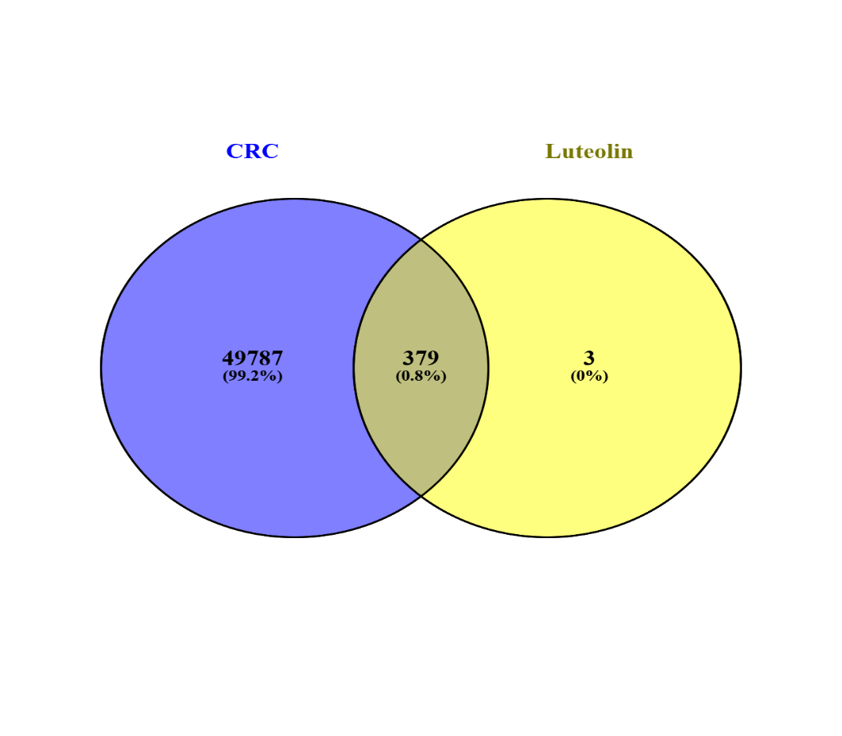
Figure 4.1: Venn diagram illustrating the overlap between luteolin and CRC-associated target genes.
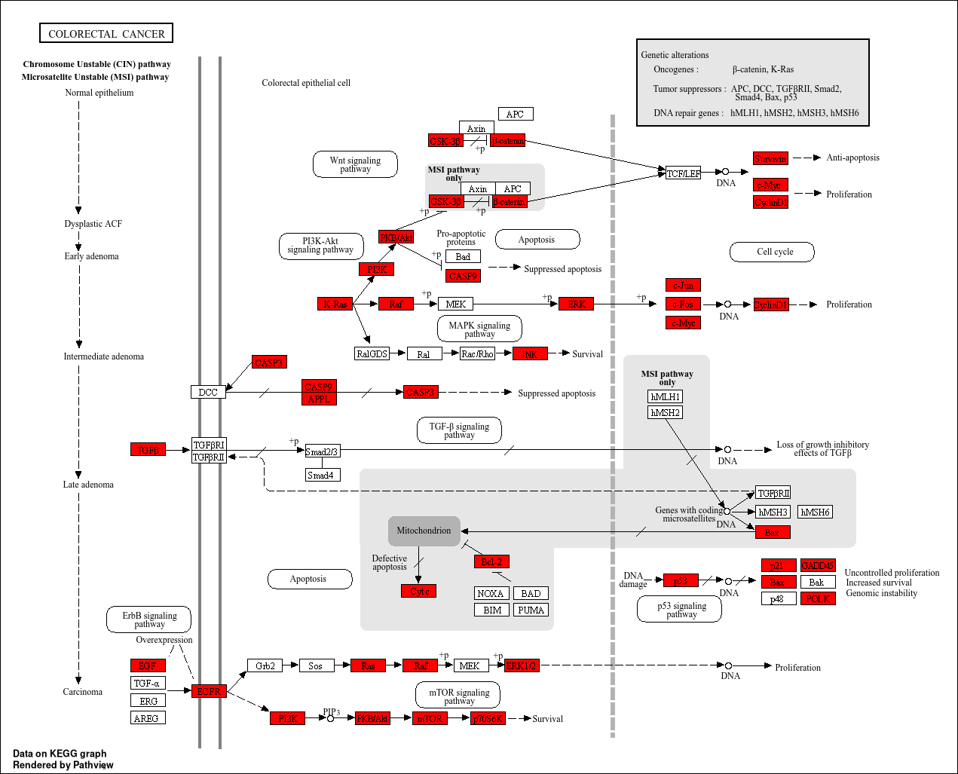
Figure 4.2: KEGG pathway map illustrating luteolin-associated targets involved in CRC signaling.
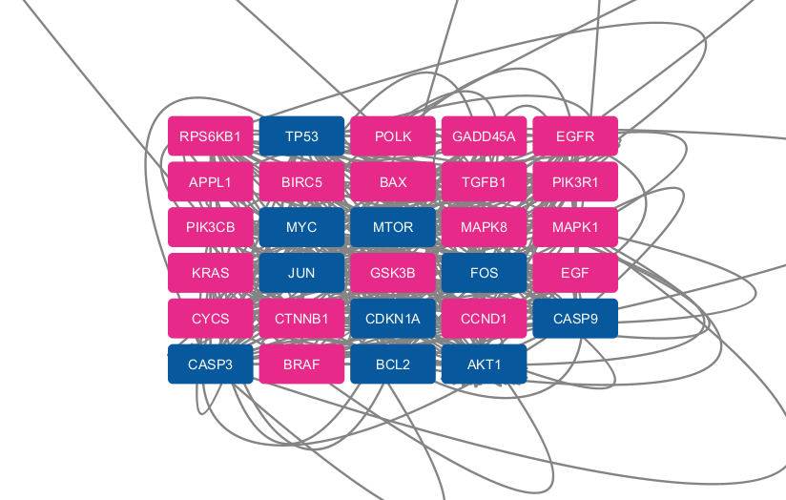
Figure 4.3: Protein–protein interaction (PPI) network of overlapping luteolin targets and colorectal cancer–associated genes.
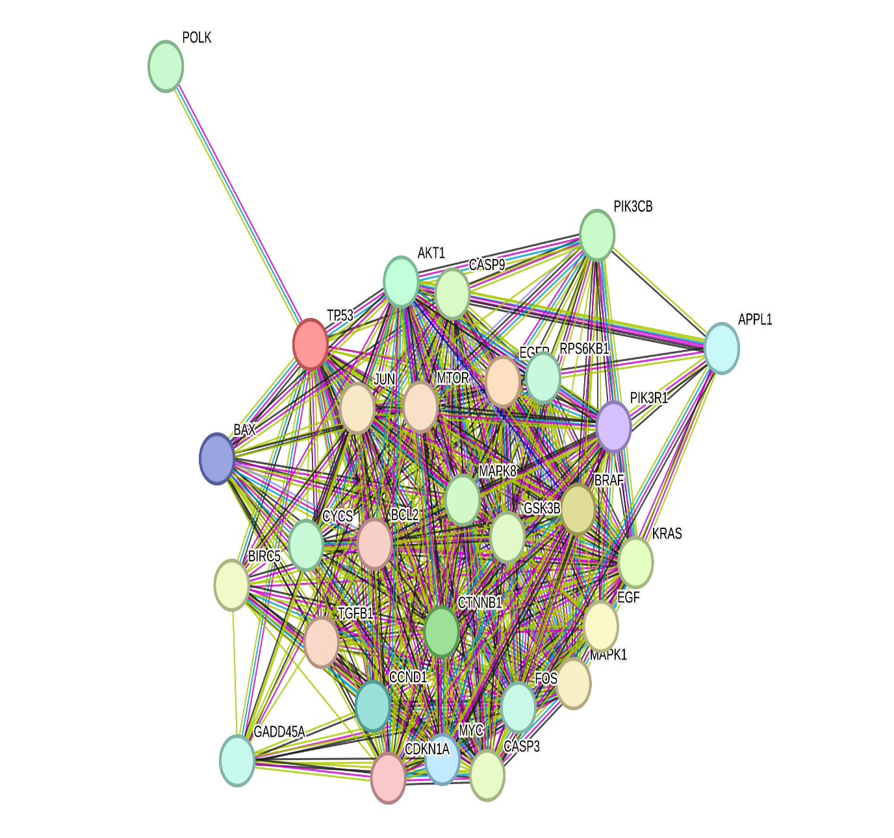Figure 4.4: Protein–protein interaction (PPI) network of overlapping targets between luteolin and colorectal cancer (CRC).
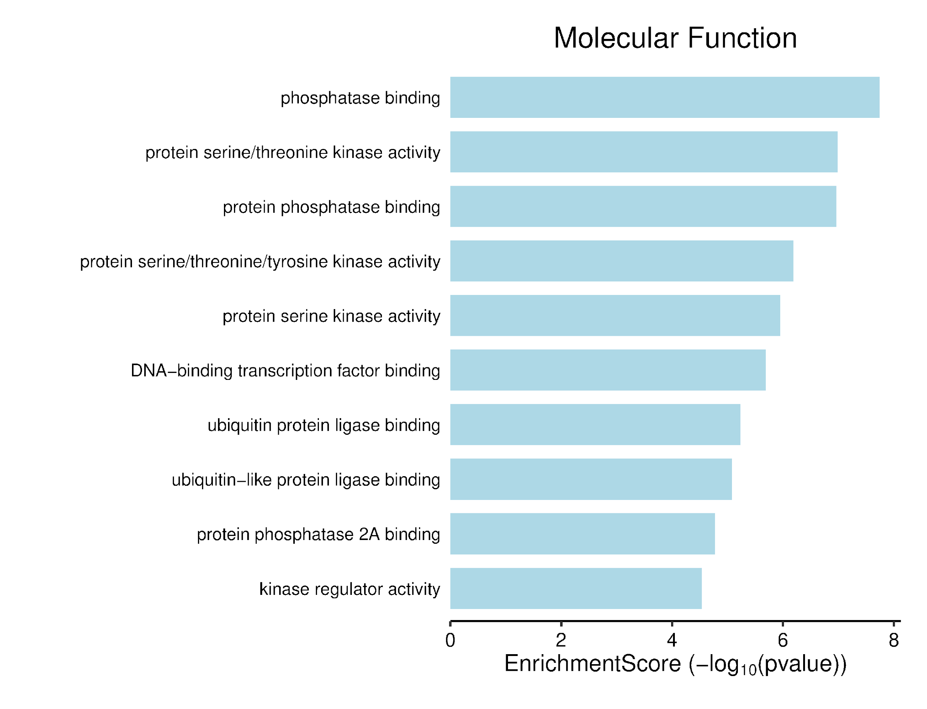Figure 4.5: Gene Ontology (GO) molecular function enrichment analysis of overlapping luteolin–colorectal cancer targets.
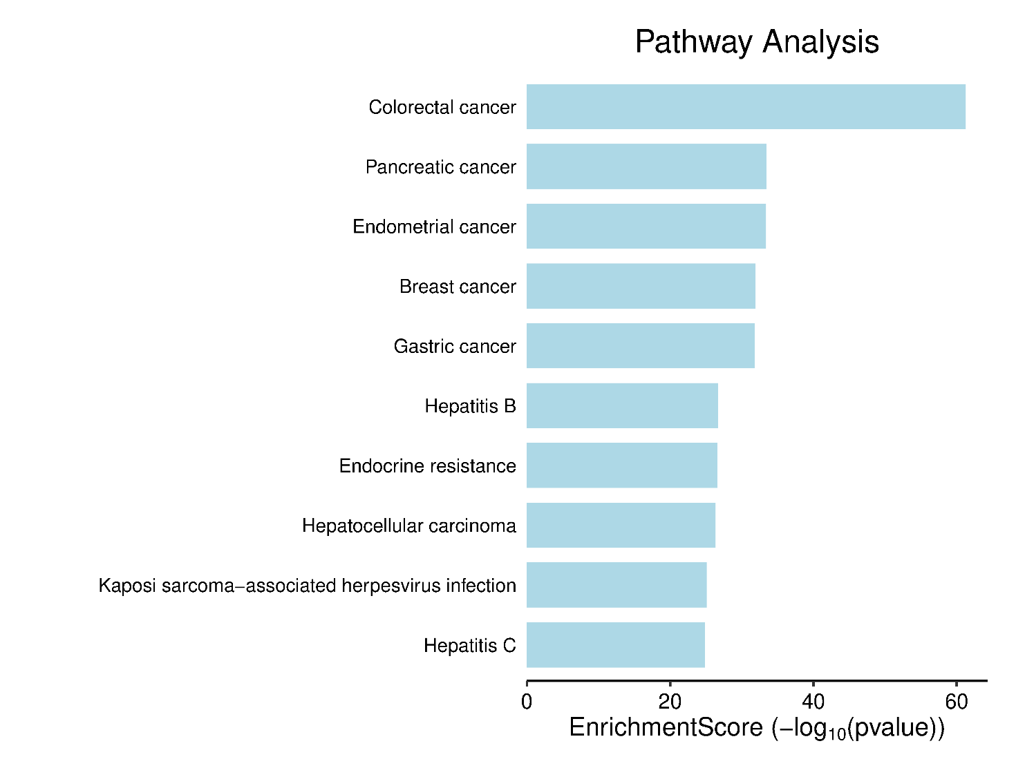Figure 4.6: Pathway enrichment analysis of overlapping luteolin–colorectal cancer targets.

Table 4.1: Summary of molecular docking and MMGBSA score.
Target | Docking score (kcal/mol) | MMGBSA score (kcal/mol) | Grid box (X, Y, Z)
Casp 3 | -9.761 | -34.217 | -16.2, 0.78, -15.35
AKT1 | -8.613 | -54.22 | -12.67, 7.96, -14.68
mTOR | -7.92 | -26.31 | -2.78, -12.73, 2.97
P53 | -7.418 | -16.921 | 12.34, -4.72, 12.26
Bcl2 | -6.711 | -23.181 | -9.37, 14.29, 6.92
Casp 9 | -6.07 | -17.31 | -3.87, 15.28, -7.27
CDKN1A | -4.672 | -12.762 | 21.24, -2.71, 16.09

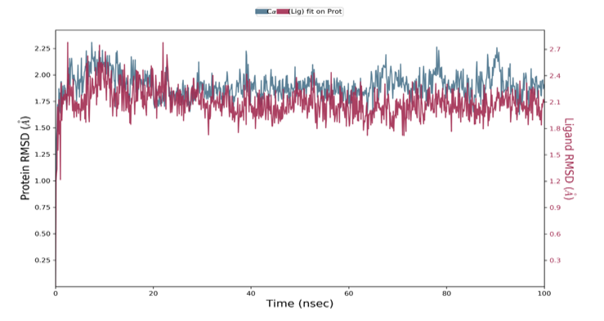Figure 4.7: RMSD plot Caspase-3 (2J30)–luteolin complex over a 100 ns molecular dynamics simulation.

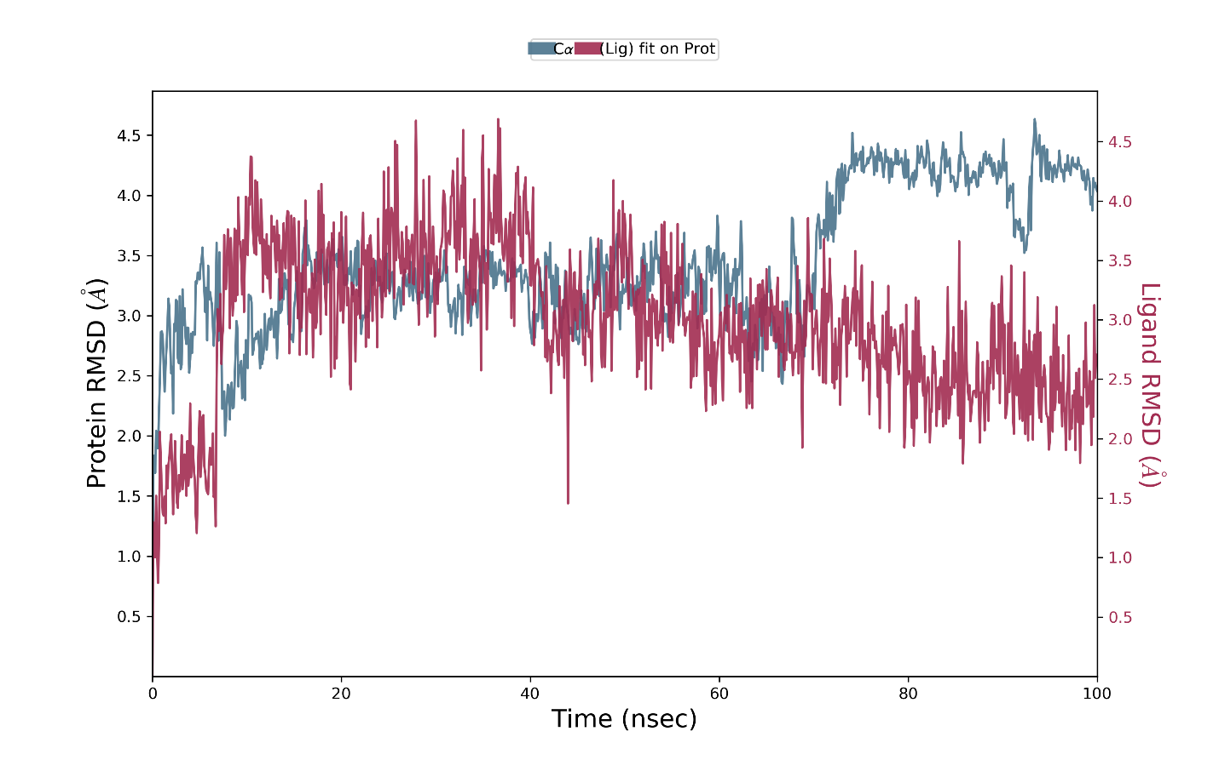Figure 4.8: RMSD plot for AKT1 (3O96)–luteolin complex over a 100 ns molecular dynamics simulation.
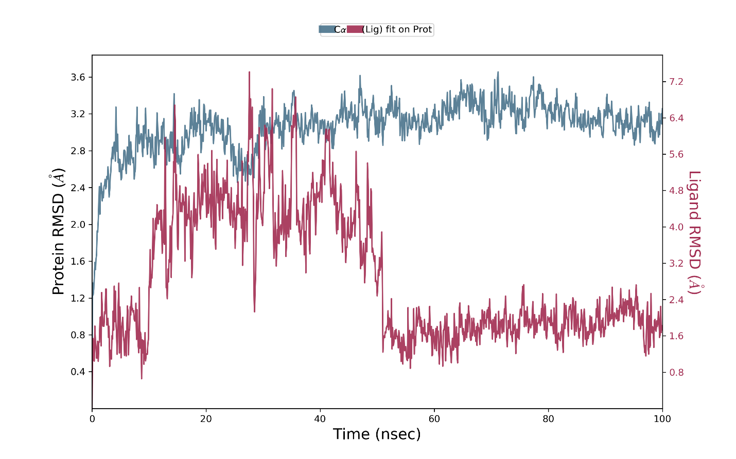Figure 4.9: Root mean square deviation (RMSD) profiles of the mTOR (PDB ID: 4JSV)–luteolin complex over a 100 ns molecular dynamics simulation. The backbone RMSD of mTOR (blue, left y-axis) and the RMSD of luteolin fitted on the protein (red, right y-axis) are shown as a function of simulation time.
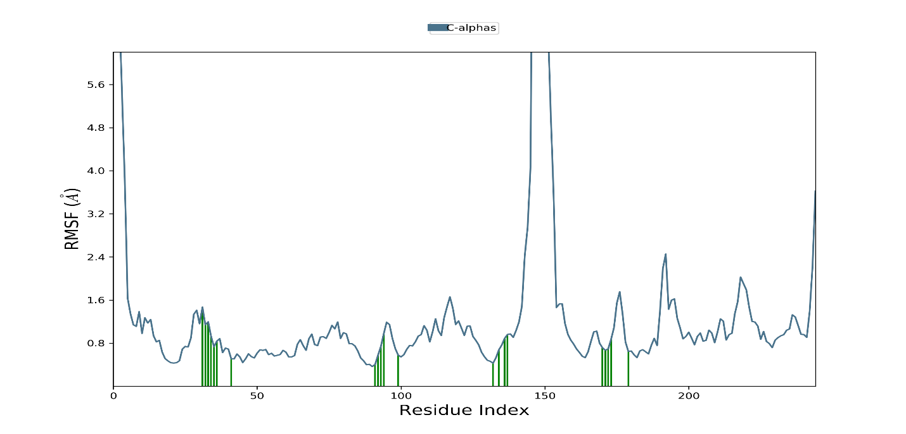Figure 4.10: Root mean square fluctuation (RMSF) profile of Caspase-3 Cα atoms obtained from the 100 ns molecular dynamics simulation of the Caspase-3–luteolin complex.
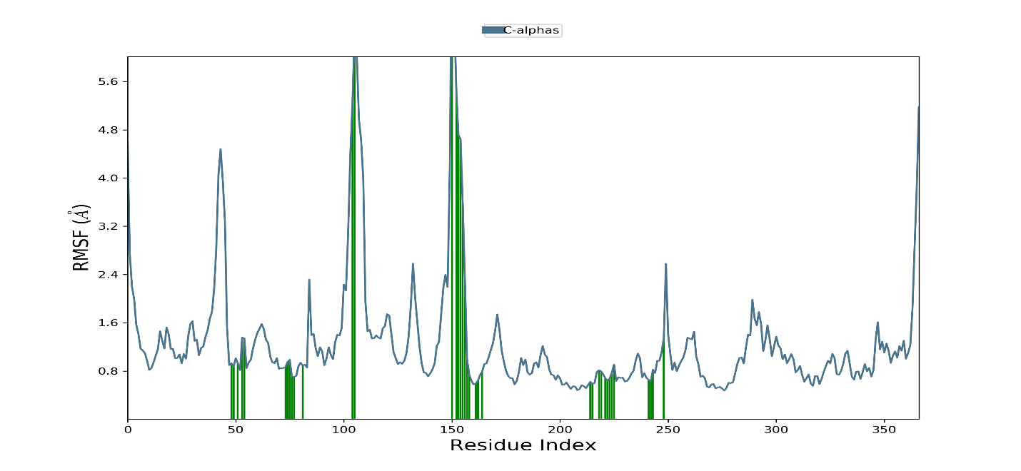Figure 4.11: RMSF Plot 3O96 Cα atoms obtained from the 100 ns molecular dynamics simulation of the 3O96–luteolin complex.
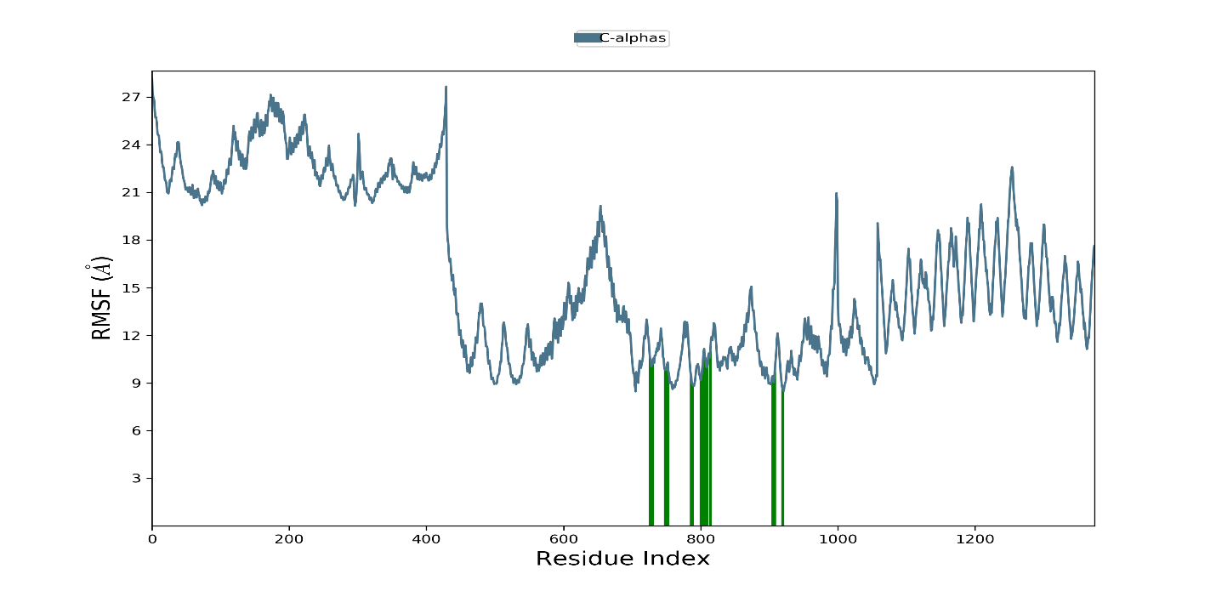Figure 4.12: RMSF Plot 4JSV Cα atoms obtained from the 100 ns molecular dynamics simulation of the 4JSV–luteolin complex.
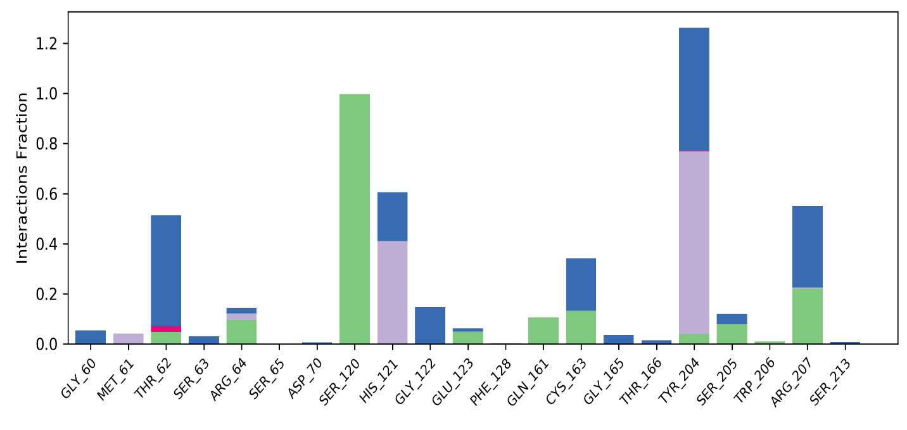Figure 4.13: Protein-ligand contact histogram 2J30 (Caspase 3).
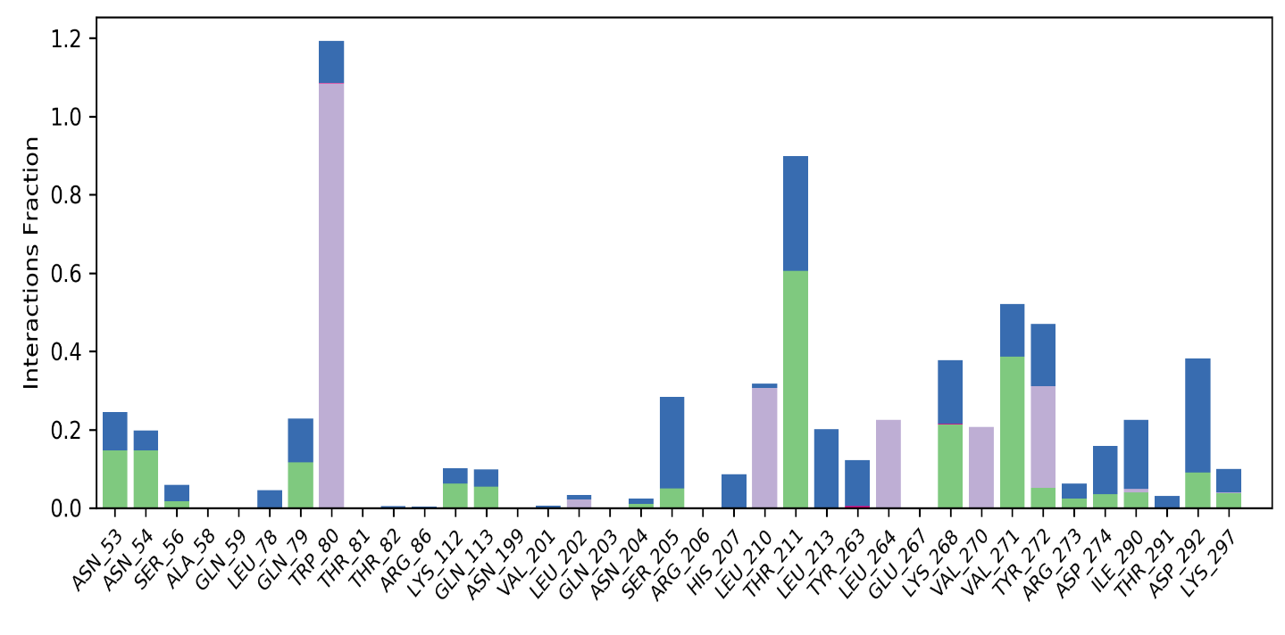Figure 4.14: Protein-ligand contact histogram 3O96 (AKT1).
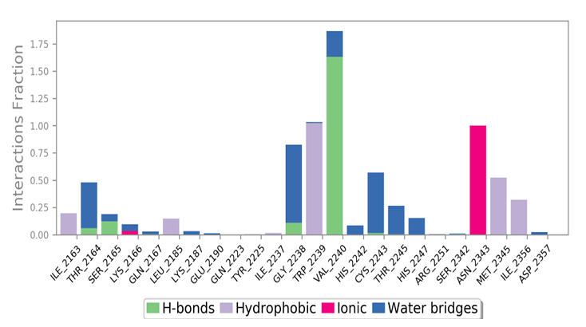Figure 4.15: Protein-ligand contact histogram 4JSV (mTOR).

4.2 mRNA expression and qPCR quantification.
Figure 4.16 show the relative expression of TP53 in the drosophila model of colorectal tumorigenesis. Treatment with AOM alone significantly (p < 0.05) downregulated the expression of the mRNA, signaling the possible loss of the activity of the tumor suppressor protein the modes. Beautifully, luteolin was able to reverse this in the treatment groups. Figure 4.17 and 4.18 shows the relative expression of caspases 3 and 9. The administration of AOM significantly downregulated the mRNA levels of these genes; however, luteolin treatment was able to reverse the reduction in the amount of the reduction caused by the toxicant. Figure 4.19 shows the relative expression of c-MYC in the Drosophila model of colorectal tumorigenesis. Administration of AOM significantly (p < 0.05) upregulated the expression of c-MYC, suggesting enhanced cellular proliferation and tumor progression. Treatment with luteolin significantly reversed this increase, indicating its potential to suppress oncogenic signaling and uncontrolled cell growth.
Figure 4.20 presents the relative expression of mTOR. Exposure to AOM resulted in a significant (p < 0.05) elevation in mTOR mRNA expression, reflecting activation of pathways associated with cell growth, survival, and metabolic regulation. Luteolin treatment markedly reduced mTOR expression toward normal levels, suggesting inhibition of mTOR-mediated tumor-promoting activities. Figure 4.21 shows the relative expression of CDKN1A (p21). AOM administration significantly (p < 0.05) reduced the expression of this cell-cycle regulatory gene, indicating impaired cell-cycle checkpoint control. However, treatment with luteolin significantly restored CDKN1A expression, suggesting the re-establishment of growth arrest mechanisms and protection against uncontrolled proliferation. Figure 4.22 illustrates the relative expression of BCL2. The toxicant significantly (p < 0.05) increased BCL2 expression, reflecting enhanced anti-apoptotic activity and increased survival of transformed cells. Luteolin treatment significantly attenuated this upregulation, demonstrating its ability to promote apoptotic signaling and counteract tumor cell survival.
Figure 4.23 shows the relative expression of AKT1. Ad57 ministration of AOM significantly (p < 0.05) increased AKT1 mRNA expression, indicating activation of the PI3K/AKT signaling pathway, which is commonly associated with cell survival, proliferation, and resistance to apoptosis. Luteolin treatment effectively reversed this increase, suggesting suppression of AKT-mediated oncogenic signaling and a potential role in inhibiting colorectal tumor progression

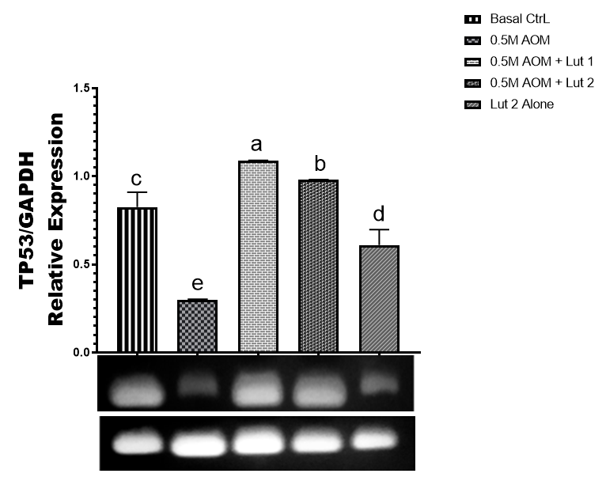
Figure 4.16: mRNA expression of TP53. Graph represents snapshot of RT-PCR-agarose gel electrophoresis data of AOM and Luteolin fed Drosophila model. Band density was made by Image-J and plotted as mean ± SEM.

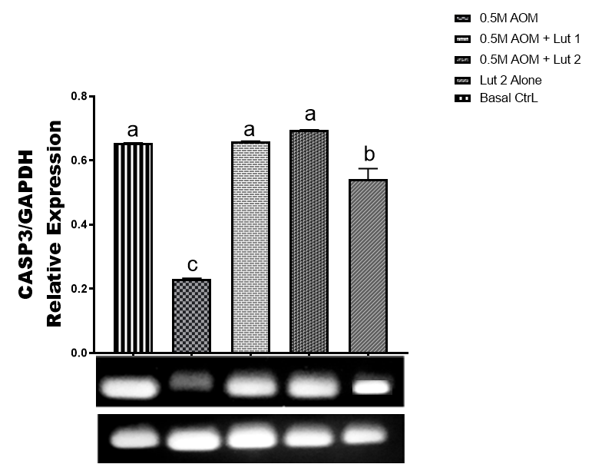
Figure 4.17: mRNA expression of Caspase 3. Graph represents snapshot of RT-PCR-agarose gel electrophoresis data of AOM and Luteolin fed Drosophila model. Band density was made by Image-J and plotted as mean ± SEM
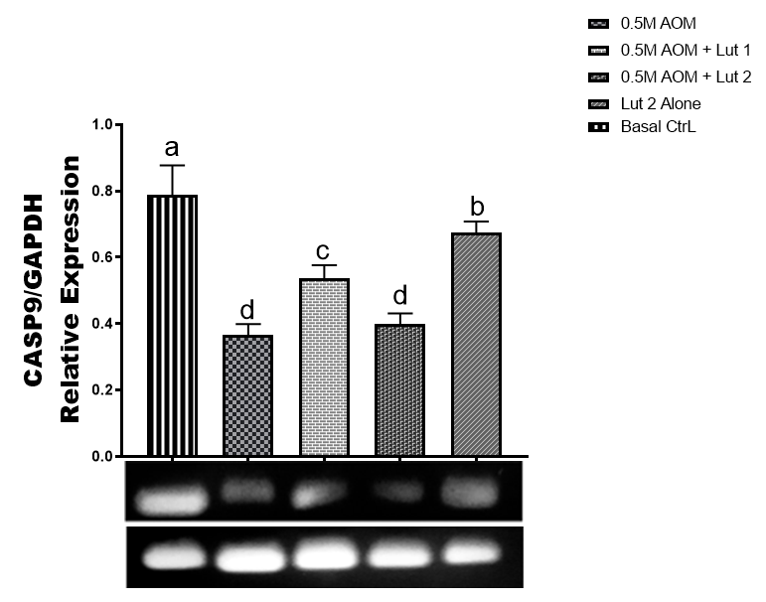
Figure 4.18: mRNA expression of Caspase 9. Graph represents snapshot of RT-PCR-agarose gel electrophoresis data of AOM and Luteolin fed Drosophila model. Band density was made by Image-J and plotted as mean ± SEM
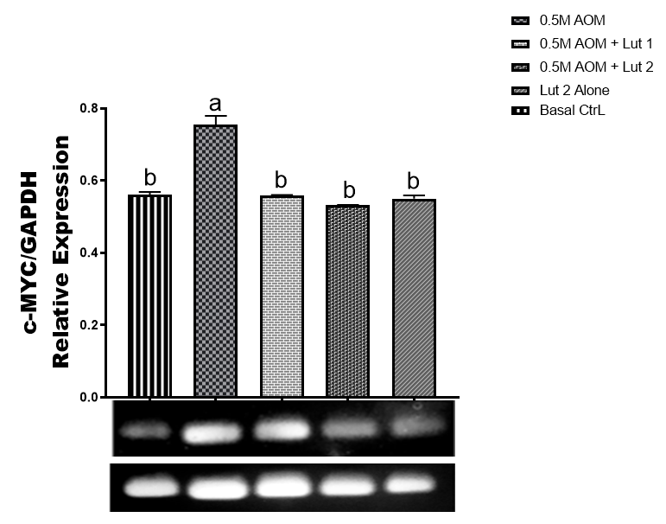Figure 4.19: mRNA expression of c-MYC. Graph represents snapshot of RT-PCR-agarose gel electrophoresis data of AOM and Luteolin fed Drosophila model. Band density was made by Image-J and plotted as mean ± SEM
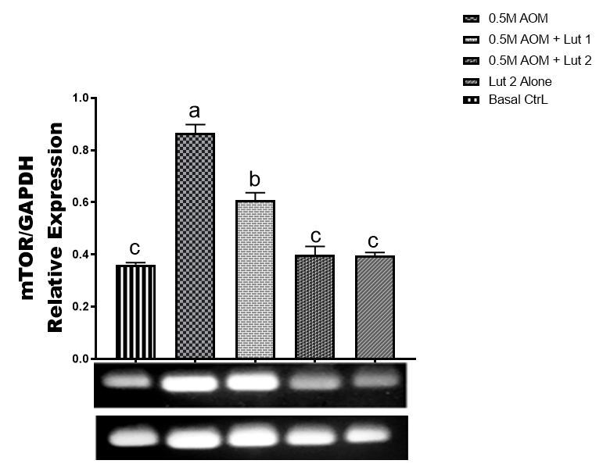Figure 4.20: mRNA expression of mTOR. Graph represents snapshot of RT-PCR-agarose gel electrophoresis data of AOM and Luteolin fed Drosophila model. Band density was made by Image-J and plotted as mean ± SEM
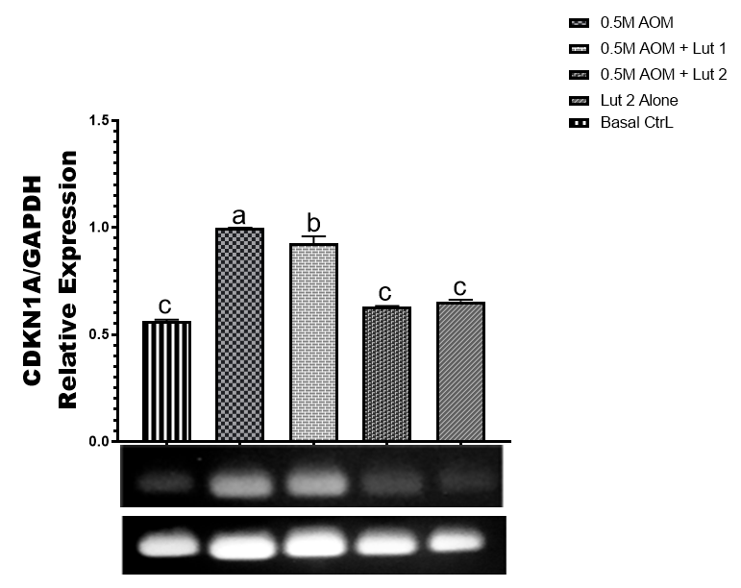Figure 4.21: mRNA expression of CDKN1A. Graph represents snapshot of RT-PCR-agarose gel electrophoresis data of AOM and Luteolin fed Drosophila model. Band density was made by Image-J and plotted as mean ± SEM
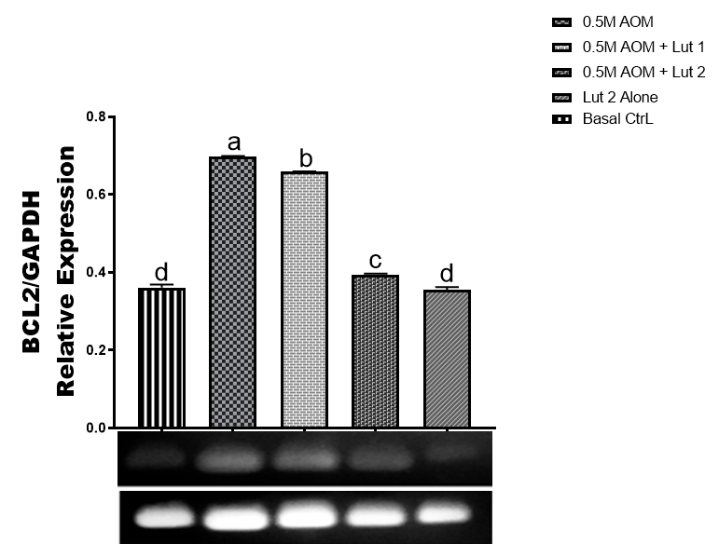Figure 4.22: mRNA expression of BCL 2. Graph represents snapshot of RT-PCR-agarose gel electrophoresis data of AOM and Luteolin fed Drosophila model. Band density was made by Image-J and plotted as mean ± SEM
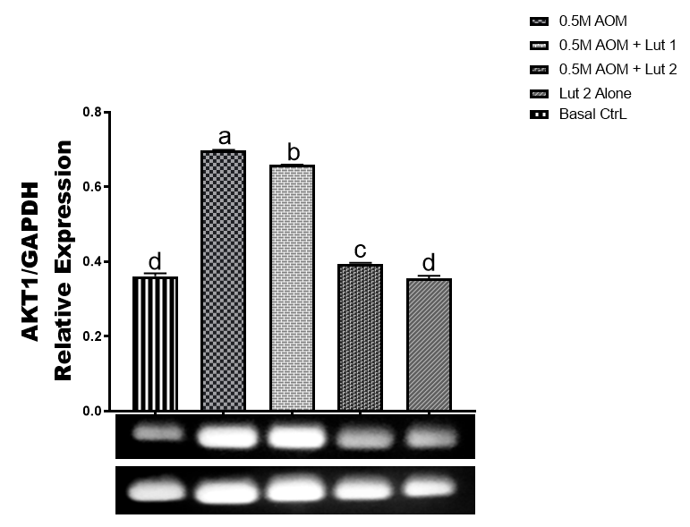
Figure 4.23: mRNA expression of AKT1. Graph represents snapshot of RT-PCR-agarose gel electrophoresis data of AOM and Luteolin fed Drosophila model. Band density was made by Image-J and plotted as mean ± SEM

4.3 Discussion
Globally, CRC is one of the biggest challenges in modern oncology, accounting for some 1.93 million new cases and nearly 916,000 deaths each year (Sukrueangkul et al., 2024). In high-income countries, strong screening programs have helped to level off incidence, but in Sub-Saharan Africa, screening is subject to a concern surge every year, with the growth of urbanization and the introduction of westernized diets (Moen et al., 2024). Nigeria, however, is having a particularly severe crisis with more than 7,000 new cases annually, and an abysmal 5-year survival rate of less than 10%, compared to the global average of 64% (Alatise et al., 2025). This is further complicated by the fact that the existing treatments are often poor, with the use of standard drugs such as 5-fluorouracil (5-FU) becoming ineffective because of the drug resistance associated with ATP-binding cassette transporters and the use of targeted drugs such as cetuximab being ineffective because of the heterogeneity of the tumor and the redundancy of signaling (Azwar et al., 2025; Bakillah et al., 2025). Hence, it is imperative to develop a polypharmacological intervention strategy, instead of the reductive single-target approach, and implement a network-based approach using compounds with pleiotropic activity, such as luteolin, phytochemicals.
The first computational component of this study involved mining of 382 target genes for luteolin and 50,166 genes associated with CRC to identify the Luteolin-CRC interactome. Venn diagrams analysis showed that there are 379 common genes. The high degree of concordance indicates that luteolin's therapeutic effects are not serendipitous, single-target binding, but are attributed to evolutionary conservation of the flavonoid-binding domain in a large number of genes across human diseases as reported earlier by Olanrewaju et al. (2024). To explain the functional implications of this interactome, KEGG pathway enrichment revealed that the co-expressed nodes are distributed strategically across hallmark oncogenic cascades - PI3K/Akt, MAPK, Wnt and p53 pathways (Alatise et al., 2025). It is a multi-pathway regulatory mechanism that offers a substantial basis for control of the inherent heterogeneity of CRC, by simultaneously interfering with multiple stages of tumorigenesis ranging from the initial hyperproliferation to evasion of apoptosis.
The PPI networks were then topologically analyzed to identify central regulatory nodes. Rigorous metrics like degree centrality, betweenness centrality, closeness centrality were applied and master regulator genes like TP53, AKT1, mTOR, and CASP3 were prioritized as critical hub genes. These hubs are the main crosspoints of cellular survival and programmed death processes, having high betweenness and closeness values in the Luteolin-CRC network indicating that they play a crucial role as “gatekeepers” of the signaling flow (Olanrewaju et al., 2024). This systems-level view was further supported by functional enrichment using Gene Ontology (GO) and pathway analysis, which was largely focused on the enriched terms being related to kinase activity and transcription factor binding. Luteolin's broad regulatory profile suggests that it is superior to other phytochemicals such as apigenin or quercetin that have more limited pathway profiles (Neamtu et al., 2022; Ahmadzadeh et al., 2024), and may be better suited to the treatment of CRC sub-groups that are resistant to therapy.
Molecular docking was used to determine the binding ability of luteolin with the hub proteins to confirm the thermodynamics of these interactions (Olanrewaju et al., 2024). The results show high binding efficacy to all major targets such as Casp 3, AKT1, mTOR, P53, Bcl2, Casp 9 and CDKN1A. Remarkably, Casp 3 exhibited the best binding affinity and also good post-docking MMGBSA. This interaction is made possible by luteolin binding with residues that are essential to the stability of the catalytic triad of caspase-3 (Nadendla et al., 2025). Similarly, the critical residues were involved in binding to AKT1 and it was found that it disrupts the ATP pocket (Baby et al., 2023). Luteolin's ability is quite competitive when compared to synthetic benchmarks, such as the MMGBSA score of well-established inhibitors such as idelalisib (Nadendla et al., 2025). Such structural validation shows that luteolin's polypharmacological potential is supported by its high affinity to target precisely those regulators that promote CRC progression.
The stability of these complexes was analyzed in detail by 100 ns molecular dynamics (MD) simulations. The conformational stability was verified by Root Mean Square Deviation (RMSD) profiles. The overlapping of these profiles in a narrow range of 2-3 Å suggests that luteolin has a tight and stable binding in the active sites. Residue flexibility (Root Mean Square Fluctuation; RMSF) was very low for the Cα atoms in the vicinity of the binding pockets. This indicates that luteolin stabilizes these enzymes in a specific conformation, for example by locking them into a proapoptotic conformation of Caspase-3 or inhibiting their oncogenic activity at mTOR and AKT1. Another measure of interaction persistence was obtained by contact histograms that identified the existence of persistent hydrogen bonds and hydrophobic contacts, in particular with Val164 and Tyr272 in the mTOR complex (Kawade et al., 2018). This persistence enables the stability of the interactome of the target luteolin under the conditions of simulated physiology.
To bring these computational and structural insights to the biological realm, a Drosophila model was used, which shares more than 75% of human disease genes and is similar to the human colonic epithelium (Sang et al., 2024). Here, luteolin proved to be highly effective in inhibiting AOM-induced tumorigenesis in this In vivo model, resulting in a remarkable decrease in the number of tumors burden. This performance is comparable to the traditional AOM mouse model, where significant reduction is generally reported, indicating that the Drosophila model might be more sensitive to the targets of luteolin or better reflect the bioavailability of luteolin. This suppression was confirmed by quantitative PCR (qPCR) of the hub genes. The structural stabilization and "locking" of the catalytic triad seen during the course of MD simulations gave the mechanism from which the high upregulation of Casp 3 expression levels was deduced. The up regulation of TP53, Caspase 9 and CDKN1A were also observed as similar pro-apoptotic shifts.
At the same time, the In vivo results demonstrated that the hubs for oncogenic survival were significantly down regulated. This included the suppression of c-MYC, mTOR, BCL 2, and AKT1. The down-regulation of BCL 2 and AKT1 is especially important as a "kill shot" towards CRC cells because these nodes play a key role in resistance to autophagy and protein synthesis, respectively. Luteolin simultaneously downregulates the expression of these survival hubs and upregulates apoptotic markers, thus interfering with the core hallmarks of cancer. This biological verification gives important evidence for the proof of concept that the multi-target interactions simulated In silico can be correlated with tangible anti-tumor effects in vivo, which represents a good structural stability proof at the residue level and is essential for the successful introduction of inhibitors into the clinic.
The multi-target advantage of luteolin over single-node therapies is highlighted by the systems-level synthesis of the above data. Compensatory pathway activation is frequently a problem associated with modern inhibitors, however, because luteolin affects a number of upstream nodes including IGF1R as well as numerous downstream nodes including mTOR and AKT1, it offers a complete blockade on oncogenic signaling. This is a polypharmacological intervention that is crucial in the treatment of CRC subtypes with a mutation in KRAS or PIK3CA, which are currently not targeted by conventional treatment. The hydroxyl pattern around the carbon backbone makes luteolin particularly attractive, as opposed to other phytochemicals such as EGCG or quercetin, which are unable to retain its binding to the PI3K/Akt/mTOR axis. In addition, the use of a wild-type Drosophila model to replicate sporadic CRC is highly translational with the ability to rapidly validate precision nutraceuticals in a high quality and cost-effective method than rodent studies.
Overall, this study provides a comprehensive multi-omics validation of the therapeutic potential of luteolin in CRC. The convergence of all data from the identification of 379 overlapping binding sites to stable binding to the Caspase-3 active site and the significant reduction in the amount of tumor burden In vivo, consistently identify luteolin as a potent, mechanistically validated chemopreventive agent. It is very effective and is a candidate for use in resource-limited countries such as Nigeria, where CRC is a major problem and conventional therapies are scarce. This study offers a paradigm shift in how computational predictions can be linked to structure and stability, and how these can be correlated with biological results to develop inexpensive multi-target drugs to control colorectal cancer at a global level.

CHAPTER FIVE

5.0 SUMMARY, CONCLUSION AND RECOMMENDATIONS

5.1 Summary
The aim of this study was to be carried out under an integrated multi-tiered framework to explain the therapeutic potential of luteolin (a flavonoid) against CRC. The investigation was conducted systematically from the systems level network pharmacology analysis, through to high resolution structural bioinformatics by molecular docking and 100 ns molecular dynamics (MD) simulations, and finally to functional in vivo validation in the Drosophila model.
The first network pharmacology step led to the identification of 379 common targets between luteolin and CRC, which indicates a high degree of molecular intersections. These targets were mapped to key oncogenic pathways by KEGG enrichment, such as the PI3K/Akt, MAPK and Wnt/β-catenin pathways. The results indicate that luteolin's effect is not through any specific single target of action, but through modulation of a complex interactome. The thermodynamic profile of these interactions was subsequently determined and revealed a high binding affinity for Caspase-3 (docking score of -9.761 kcal/mol; MMGBSA free energy of -34.217 kcal/mol) and AKT1 (docking score of -8.613 kcal/mol; MMGBSA free energy of -54.22 kcal/mol). Specific amino acid residues involved in the stabilization of the complexes, such as Arg207, His121, and Ser120 in the binding interface of Caspase-3, and Trp80 and Ala50 in AKT1 were identified.
The 100 ns MD simulations supplied crucial evidence of the conformational stability of the protein-ligand complexes in simulated physiological situations. Casp3-Luteolin complex was specifically the most rigid with the mean RMSD of 1.8 Å. The simulations showed that luteolin promoted binding of the enzyme to a rigid conformation in the substrate binding cleft, thus locking the enzyme into an active conformation that promotes apoptosis. These structural insights were successfully bridged with biological outcomes. The results in vivo indicated that the treatment of luteolin led to a significant decrease in the tumor burden. The expected mechanism of action was validated with significant quantitative downregulation of oncogenic genes such as mTOR, AKT1 and buffy, the BCL2 ortholog; and genes that promote cell death, such as TP53 (ortholog dap), CDKN1A (ortholog dap), Caspase-3 (ortholog drice) and Caspase-9 (ortholog dronc).

5.2 Conclusion
It is concluded that on the basis of computational, structural and biological information, luteolin could be considered a strong multi-target chemopreventive agent that is able to interfere with the basic hallmarks of CRC. In this study, we have used a systems biology approach and found that the therapeutic activity of luteolin is based on its ability to target multiple nodes within redundant signaling pathways, such as the PI3K/Akt/mTOR and mitochondrial apoptosis axis. In contrast to the single-target approach of other agents (e.g. EGFR inhibitors), which are often ineffective because of the diversity of tumor types and the presence of parallel pathways, luteolin's multi-target mechanism results in its effectiveness, especially in the context of KRAS mutations and genetic heterogeneity.
The research has successfully shown that predictions of high-affinity binding to a target protein in the virtual environment directly correlates with dramatic In vivo tumor suppression and modulation of targeted gene expression. This alignment confirms the integrated framework as a trustworthy drug discovery approach. Moreover, the results suggest that luteolin could be a safe and affordable treatment option in place of standard chemotherapies such as 5-fluorouracil and as a complementary therapy. Luteolin is an alternative natural therapy that can be used in resource-limited clinical settings, like those in Sub-Saharan Africa, where the burden of CRC is growing, and the availability of costly targeted therapies is restricted, while maintaining the beneficial effect of improved oncological outcomes without debilitating toxic effects of standard-of-care agents.

5.3 Recommendations
The clinical translation of these findings is recommended to be advanced by starting phase I clinical trials to gain human safety profile and tolerability with luteolin-based interventions in CRC patients. Such activities should be supported by thorough pharmacokinetic and pharmacodynamic (PK/PD) research to establish optimum doses. The main limitation of flavonoids, which is low systemic bioavailability, needs to be addressed by the development of more sophisticated formulation strategies in the future to deliver therapeutically effective concentrations to the target colonic tissues.
The use of luteolin as an adjunct therapy, in addition to standard-of-care agents such as 5-fluorouracil, should also be investigated in clinical trials. These combination treatments can offer synergistic benefits to overcome drug resistance and enable the use of lower doses of the chemotherapies, so as to limit the systemic side effects. Moreover, studies should focus on patient subsets to optimize the use of luteolin in a personalized medicine context, such as MSI-H and/or PIK3CA-mutated patients.
Lastly, more research is needed to study the anti-metastatic property of luteolin to combat the most devastating side of colorectal cancer. The use of advanced orthotopic models is crucial to test the compound's efficacy in inhibiting Epithelial-Mesenchymal Transition (EMT), which is a major step in the transition from localised tumors to invasive disease. These markers of metastasis and advanced models expand the scope of research and the full therapeutic potential of luteolin can be utilized to address the world's problem of colorectal malignancy.

Appendix Table A1: Composition of Corn Meal Medium Used for Drosophila Culture

Component | Quantity | Ratio/Concentration
Distilled Water | 1200 mL | -
Agar-agar | 13 g | 1.08% w/v
Yeast | 26 g | 2.17% w/v
Corn Meal | 90 g | 7.50% w/v
Sugar | 50 g | 4.17% w/v
Nipagin (Methylparaben, 10% solution | 5 g | 0.42% v/v

References
Adebayo, A. S., Agbaje, K., Adesina, S. K. and Olajubutu, O. (2023). Colorectal cancer: disease process, current treatment options, and future perspectives. Pharmaceutics, 15(11), 2620.
Ahmadzadeh, K., Roshdi Dizaji, S., Ramezani, F., Imani, F., Shamseddin, J., Sarveazad, A. and Yousefifard, M. (2024). Potential therapeutic effects of apigenin for colorectal adenocarcinoma: A systematic review and meta-analysis. Cancer Med. 13(17):e70171. doi: 10.1002/cam4.70171.
Aigner, F., Skias, C., Duller, D., Wisiak, S., Strohmeyer, K., Horvath, Z. and Koter, N. (2025). Salvage Surgery After Non-Curative Endoscopic Submucosal Dissection for Early Colorectal Cancer: A Comprehensive Review. Journal of Clinical Medicine, 14(17), 6343.
Alatise, O., Allen, H., Barton-Burke, M., Abiodun, A., Ajayi, A., Ajayi, N., Akande, K., Akitikori, O., Alkali, M., Anyanechi, C., Bello, R., Bojuwoye, M., Chukwurah, S., Egbegbedia, P., Ekwunife, C., Ijoma, N., Madubuike, C., Manko, M., Nnabuchi, C., Obateru, O., Okereke, C., Okonkwo, U., Omaiye, P., Oyeleke, G., Kahn, R., Doyle, A., Samaila, A., Udofia, U., Ugiagbe, R., Yusuf, M., Zawaya, K., Tansley, G., Knapp, G., Kingham, P., and Murthy, S. (2025). Endoscopy capacity in Nigeria: a national needs assessment and recommendations. Surgical Endoscopy, 39: 5698 - 5713. https://doi.org/10.1007/s00464-025-11874-3.
Almatroodi, S., Almatroudi, A., Alharbi, H., Khan, A. and Rahmani, A. (2024). Effects and Mechanisms of Luteolin, a Plant-Based Flavonoid, in the Prevention of Cancers via Modulation of Inflammation and Cell Signaling Molecules. Molecules, 29. https://doi.org/10.3390/molecules29051093.
Anderson, S. E. (2025). Characterization of a Drosophila CRC 3-hit model using genetic approaches. MSc Dissertation, University of Dayton.
Aravindaram, K. and Yang, N. S. (2010). Anti-inflammatory plant natural products for cancer therapy. Planta medica, 76(11), 1103-1117.
Arnold, M., Sierra, M. S., Laversanne, M., Soerjomataram, I., Jemal, A., and Bray, F. (2017). Global patterns and trends in colorectal cancer incidence and mortality. Gut, 66(4): 683-691.
Ashokkumar, P. and Sudhandiran, G. (2011). Luteolin inhibits cell proliferation during Azoxymethane-induced experimental colon carcinogenesis via Wnt/β-catenin pathway. Investigational new drugs, 29(2), 273-284.
Azwar, S., Seow, H., Abdullah, M., Jabar, M. and Mohtarrudin, N. (2021). Recent Updates on Mechanisms of Resistance to 5-Fluorouracil and Reversal Strategies in Colon Cancer Treatment. Biology, 10. https://doi.org/10.3390/biology10090854.
Baby, K., Maity, S., Mehta, C. H., Nayak, U. Y., Shenoy, G. G., Pai, K. S. R., Harikumar, K. B. and Nayak, Y. (2023). Computational drug repurposing of Akt-1 allosteric inhibitors for non-small cell lung cancer. Sci Rep. 16;13 (1):7947. doi: 10.1038/s41598-023-35122-7.
Bai, S., Chen, B., Li, F., Yao, W., Wei, Y., and Hua, Y. (2025). Network-based pharmacological study of the mechanism of Baitouweng decoction in the treatment of ulcerative colitis through the NF-κB pathway. Medicine, 104(42), e44167
Bakillah, E., Rosenthal, J., Syvyk, S., Wirtalla, C., Sharpe, J., Merchant, R., Mehta, S., Guerra, C., and Kelz, R. (2025). The Burden of Colorectal Cancer Treatment on Quality of Life: A Paired Longitudinal Analysis of Medicare Advantage Enrollees. Journal of Surgical Oncology, 132. https://doi.org/10.1002/jso.28161.
Battaglin, F., Naseem, M., Lenz, H. J., and Salem, M. E. (2018). Microsatellite instability in colorectal cancer: overview of its clinical significance and novel perspectives. Clinical advances in hematology and oncology: HandO, 16(11), 735.
Bocchi, M., Fernandes, E. V., Pereira, N. D. S., and Amarante, M. K. (2025). Etiopathogenesis and Treatment of Colorectal Cancer. Immuno, 5(3), 31.
Bray, F., Ferlay, J., Soerjomataram, I., Siegel, R. L., Torre, L. A., and Jemal, A. (2018). Global cancer statistics 2018: GLOBOCAN estimates of incidence and mortality worldwide for 36 cancers in 185 countries. CA: a cancer journal for clinicians, 68(6), 394-424.
Busuttil, R. A., Zapparoli, G. V., Haupt, S., Fennell, C., Wong, S. Q., Pang, J. M. B... and Boussioutas, A. (2014). Role of p53 in the progression of gastric cancer. Oncotarget, 5(23), 12016.
Chang, S. C., Li, A. F. Y., Lin, P. C., Lin, C. C., Lin, H. H., Huang, S. C... and Lan, Y. T. (2020). Clinicopathological and molecular profiles of sporadic microsatellite unstable colorectal cancer with or without the CpG island methylator phenotype (CIMP). Cancers, 12(11), 3487.
Chen, J. and Huang, X. F. (2009). The signal pathways in azoxymethane-induced colon cancer and preventive implications. Cancer biology and therapy, 8(14), 1313-1317.
Chuu, C. P., Lin, H. P., Ciaccio, M. F., Kokontis, J. M., Hause Jr, R. J., Hiipakka, R. A... and Jones, R. B. (2012). Caffeic acid phenethyl ester suppresses the proliferation of human prostate cancer cells through inhibition of p70S6K and Akt signaling networks. Cancer Prevention Research, 5(5), 788-797.
Dalrymple, L. I. (2014). Chemopreventive and Possible Toxicological Effects of Cocoa and Coffee in AOM-Induced Fisher 344 Male Rats (Doctoral dissertation, Alabama Agricultural and Mechanical University). Pp 1-165
Dorant, Y., Quillien, V., Le Luyer, J. and Ky, C. L. (2024). Comparative transcriptomics identifies genes underlying growth performance of the Pacific black-lipped pearl oyster Pinctada margaritifera. BMC genomics, 25(1), 717.
Duan, X., Zhang, L. and Liu, F. (2025). The potential value of quercetin for colorectal cancer: a systematic review and a meta-analysis of preclinical studies. Frontiers in Pharmacology, 16, 1642957.
Fakhri, K. U., Sharma, D., Fatma, H., Yasin, D., Alam, M., Sami, N... and Rizvi, M. A. (2025). The dual role of dietary phytochemicals in oxidative stress: implications for oncogenesis, cancer chemoprevention, and ncRNA regulation. Antioxidants, 14(6), 620.
Fusi, F., Trezza, A., Tramaglino, M., Sgaragli, G., Saponara, S. and Spiga, O. (2020). The beneficial health effects of flavonoids on the cardiovascular system: focus on K(+) channels. Pharmacol. Res. 152, 104625. 10.1016/j.phrs.2019.104625
Ganai, S., Sheikh, F., Baba, Z., Mir, M., Mantoo, M. and Yatoo, M. (2021). Anticancer activity of the plant flavonoid luteolin against preclinical models of various cancers and insights on different signalling mechanisms modulated. Phytotherapy Research, 35, 3509 - 3532. https://doi.org/10.1002/ptr.7044.
Hecht, J. R., Mitchell, E., Chidiac, T., Scroggin, C., Hagenstad, C., Spigel, D... and Amado, R. G. (2009). A randomized phase IIIB trial of chemotherapy, bevacizumab, and panitumumab compared with chemotherapy and bevacizumab alone for metastatic colorectal cancer. Journal of Clinical Oncology, 27(5), 672-680.
Hossain, M. S., Karuniawati, H., Jairoun, A. A., Urbi, Z., Ooi, D. J., John, A... and Hadi, M. A. (2022). Colorectal cancer: a review of carcinogenesis, global epidemiology, current challenges, risk factors, preventive and treatment strategies. Cancers, 14(7), 1732.
Huang, J., Jiang, T., Kang, J., Xu, J., Dengzhang, Y., Zhao, Z... and Lou, Z. (2022). Synergistic effect of Huangqin decoction combined treatment with Radix Actinidiae chinensis on DSS and AOM-induced colorectal cancer. Frontiers in Pharmacology, 13, 933070.
Huang, X., Ke, K., Jin, W., Zhu, Q., Zhu, Q., Mei, R... and Sui, X. (2022). Identification of genes related to 5-fluorouracil based chemotherapy for colorectal cancer. Frontiers in immunology, 13, 887048.
Huang, Z., Hong, H., Yang, H. and He, C. (2026). Ursodeoxycholic Acid Alleviates DSS/AOM-Induced Colorectal Cancer in Mice by Inhibiting PI3K/Akt/mTOR Signaling Pathway. Drug Design, Development and Therapy, (4):1-19.
Imran, M., Rauf, A., Abu-Izneid, T., Nadeem, M., Shariati, M., Khan, I., Imran, A., Orhan, I., Rizwan, M., Atif, M., Gondal, T. and Mubarak, M. (2019). Luteolin, a flavonoid, as an anticancer agent: A review. Biomedicine and pharmacotherapy, 112, 108612. https://doi.org/10.1016/j.biopha.2019.108612.
Ji, J., Phang, H. C., Gu, X., Widodo, R. T., Goh, B. H., Kee, P. E., ... and Liew, K. B. (2024). A Review on Colorectal Cancer and the Role of Traditional Chinese Herbal Medicine as Complementary Therapy. Progress In Microbes and Molecular Biology, 7(1) 1115 - 1123.
Kapare, H., Nagaraj, S., Wakalkar, S. and Rathi, K. (2022). Caffeic acid phenethyl ester: a potential anticancer bioactive constituent of propolis. Current Cancer Therapy Reviews, 18(3), 181-192.
Kasi, A., Handa, S., Bhatti, S., Umar, S., Bansal, A. and Sun, W. (2020). Molecular pathogenesis and classification of colorectal carcinoma. Current colorectal cancer reports, 16(5), 97-106.
Kawade, V. S., Satpute, P. S., Dhulap, S. A. and Gurjar, S. (2018). Therapeutic Potential of PI3K/Akt/mTOR Signalling Pathway: Effective Combination Therapy for Cancer. Indian Journal of Pharmaceutical Sciences, 80(4) 809 - 817.
Kohno, H., Suzuki, R., Sugie, S. and Tanaka, T. (2005). β‐Catenin mutations in a mouse model of inflammation‐related colon carcinogenesis induced by 1, 2‐dimethylhydrazine and dextran sodium sulfate. Cancer science, 96(2), 69-76.
Lee, E. J., Oh, S. Y. and Sung, M. K. (2012). Luteolin exerts anti-tumor activity through the suppression of epidermal growth factor receptor-mediated pathway in MDA-MB-231 ER-negative breast cancer cells. Food and chemical toxicology, 50(11), 4136-4143.
Li, L. and Kar, S. (2025). Leveraging network pharmacology for drug discovery: Integrative approaches and emerging insights. Medicine in Drug Discovery, 100220.
Liao, Y. F., Luo, F. L., Tang, S. S., Huang, J. W., Yang, Y., Wang, S... and Wu, Y. Y. (2022). Network analysis and experimental pharmacology study explore the protective effects of Isoliquiritigenin on 5-fluorouracil-Induced intestinal mucositis. Frontiers in Pharmacology, 13, 1014160.
Liu, Y., Li, P. K., Li, C. and Lin, J. (2010). Inhibition of STAT3 signaling blocks the anti-apoptotic activity of IL-6 in human liver cancer cells. Journal of Biological Chemistry, 285(35), 27429-27439.
Moen, L., Liu, B., Bukirwa, P., Chingonzoh, T., Chokunonga, E., Finesse, A., Korir, A., Lamin, B., Lorenzoni, C., Manraj, S., N’da, G., Odzèbe, A., Ogunbiyi, O., Somdyala, N., Packzowski, M. and Parkin, D. (2024). Trends in the incidence of colorectal cancer in sub‐Saharan Africa: A population‐based registry study. International Journal of Cancer, 155, 675 - 682. https://doi.org/10.1002/ijc.34942.
Morgan, E., Arnold, M., Gini, A., Lorenzoni, V., Cabasag, C. J., Laversanne, M... and Bray, F. (2023). Global burden of colorectal cancer in 2020 and 2040: incidence and mortality estimates from GLOBOCAN. Gut, 72(2), 338-344.
Munnik, C., Xaba, M. P., Malindisa, S. T., Russell, B. L. and Sooklal, S. A. (2022). Drosophila melanogaster: A platform for anticancer drug discovery and personalized therapies. Frontiers in Genetics, 13, 949241.
Nadendla, E. K., Tweedell, R. E., Kasof, G. and Kanneganti, T. D. (2025). Caspases: structural and molecular mechanisms and functions in cell death, innate immunity, and disease. Cell Discov. May 5;11(1):42. doi: 10.1038/s41421-025-00791-3. PMID: 40325022; PMCID: PMC12052993.
Neamtu, A. A., Maghiar, T. A., Alaya, A., Olah, N. K., Turcus, V., Pelea, D., Totolici, B. D., Neamtu, C., Maghiar, A. M. and Mathe, E. (2022). A Comprehensive View on the Quercetin Impact on Colorectal Cancer. Molecules. 14;27(6):1873. doi: 10.3390/molecules27061873.
Nyskohus, L. S., Watson, A. J., Margison, G. P., Le Leu, R. K., Kim, S. W., Lockett, T. J... and Hu, Y. (2013). Repair and removal of azoxymethane-induced O6-methylguanine in rat colon by O6-methylguanine DNA methyltransferase and apoptosis. Mutation Research/Genetic Toxicology and Environmental Mutagenesis, 758(1-2), 80-86.
Olanrewaju, J. A., Arietarhire, L. O., Soremekun, O. E., Olugbogi, E. A., Aribisala, P. O., Alege, P. E... and Sodipo, A. O. (2024). Reporting the anti-neuroinflammatory potential of selected spondias mombin flavonoids through network pharmacology and molecular dynamics simulations. In silico Pharmacology, 12(2), 74.
Omoboyowa, D. A., Ojo, F. E., Samuel, M., Leleji, S., Okeyomi, D. V. and Joshua, P. E. (2025). Curculigo pilosa (Schumach. and Thonn.) Engl Rhizome Protects against Aluminum chloride-induced neurotoxicity in Drosophila melanogaster model. Pharmacological Research-Natural Products, 100382.
Omotuyi, O. I., Nash, O., Inyang, O. K., Ogidigo, J., Enejoh, O., Okpalefe, O. and Hamada, T. (2018). Flavonoid-rich extract of Chromolaena odorata modulates circulating GLP-1 in Wistar rats: computational evaluation of TGR5 involvement. 3 Biotech, 8(2), 124.
Panebianco, C., Trivieri, N., Villani, A., Terracciano, F., Latiano, T. P., Potenza, A.. and Pazienza, V. (2021). Improving gemcitabine sensitivity in pancreatic cancer cells by restoring miRNA-217 levels. Biomolecules, 11(5), 639.
Park, J. S., Sung, M. J. and Na, H. J. (2025). Drosophila model systems reveal intestinal stem cells as key players in aging. Annals of the New York Academy of Sciences, 1547(1), 88-99.
Piñero, J., Bravo, À., Queralt-Rosinach, N., Gutiérrez-Sacristán, A., Deu-Pons, J., Centeno, E... and Furlong, L. I. (2016). DisGeNET: a comprehensive platform integrating information on human disease-associated genes and variants. Nucleic acids research, gkw943.
Pratheeshkumar, P., Son, Y. O., Divya, S. P., Roy, R. V., Hitron, J. A., Wang, L... and Shi, X. (2014). Luteolin inhibits Cr (VI)-induced malignant cell transformation of human lung epithelial cells by targeting ROS mediated multiple cell signaling pathways. Toxicology and applied pharmacology, 281(2), 230-241.
Rauf, A., Wilairatana, P., Joshi, P., Ahmad, Z., Olatunde, A., Hafeez, N., Hemeg, H. and Mubarak, M. (2024). Revisiting luteolin: An updated review on its anticancer potential. Heliyon, 10. https://doi.org/10.1016/j.heliyon.2024.e26701.
Reyes-Farias, M. and Carrasco-Pozo, C. (2019). The anti-cancer effect of quercetin: molecular implications in cancer metabolism. International journal of molecular sciences, 20(13), 3177.
Rocchetti, M. T., Bellanti, F., Zadorozhna, M., Fiocco, D. and Mangieri, D. (2023). Multi-faceted role of luteolin in cancer metastasis: EMT, angiogenesis, ECM degradation and apoptosis. International Journal of Molecular Sciences, 24(10), 8824.
Roshan, M. K., Soltani, A., Soleimani, A., Kahkhaie, K. R., Afshari, A. R., and Soukhtanloo, M. (2019). Role of AKT and mTOR signaling pathways in the induction of epithelial-mesenchymal transition (EMT) process. Biochimie, 165, 229-234.
Sadaqat, Z., Kaushik, S. and Kain, P. (2021). Gut feeding the brain: drosophila gut an animal model for medicine to understand mechanisms mediating food preferences. In Preclinical Animal Modeling in Medicine. IntechOpen. https://doi.org/10.5772/intechopen.96503
Sang, T., Liang, A., Zhou, H., Qiu, W., Shi, L. and Zhou, H. (2024). Integrating UPLC‐MS/MS Bioinformatics and In vivo Experiments Validation to Elucidate the Mechanism of Wenzi Jiedu Decoction in Suppressing Colorectal Cancer. Phytochemical Analysis, 36. https://doi.org/10.1002/pca.3495.
Shahbaz, M., Naeem, H., Momal, U., Imran, M., Alsagaby, S. A., Al Abdulmonem, W... and Al Jbawi, E. (2023). Anticancer and apoptosis inducing potential of quercetin against a wide range of human malignancies. International Journal of Food Properties, 26(1), 2590-2626.
Silcock, L. (2024). A novel genetic system to study tumour heterogeneity and clonal dynamics in gastrointestinal tract cancers (Doctoral dissertation, Queen Mary, University of London). Pp 1-281
Singh Tuli, H., Rath, P., Chauhan, A., Sak, K., Aggarwal, D., Choudhary, R... and Haque, S. (2022). Luteolin, a potent anticancer compound: from chemistry to cellular interactions and synergetic perspectives. Cancers, 14(21), 5373.
Singh, D. and Shukla, G. (2024). The multifaceted anticancer potential of luteolin: involvement of NF-κB, AMPK/mTOR, PI3K/Akt, MAPK, and Wnt/β-catenin pathways. Inflammopharmacology, 33, 505 - 525. https://doi.org/10.1007/s10787-024-01596-8.
Sukrueangkul, A., Sirisuwan, P., Anonjarn, K., Poungsamai, P., Hudrudchai, S., Thongkamwong, N... and Suangpho, P. (2024). Health Literacy and Demand for Medical Cannabis use among Colorectal Cancer Patients in Northern Thailand: A Cross-Sectional Study. Asian Pacific Journal of Cancer Prevention: APJCP, 25(3), 999.
Szklarczyk, D., Gable, A. L., Lyon, D., Junge, A., Wyder, S., Huerta-Cepas, J.... and Mering, C. V. (2019). STRING v11: protein–protein association networks with increased coverage, supporting functional discovery in genome-wide experimental datasets. Nucleic acids research, 47(D1), D607-D613. Szklarczyk, D., Gable, A. L., Lyon, D., Junge, A., Wyder, S., Huerta-Cepas, J.,... and Mering, C. V. (2019). STRING v11: protein–protein association networks with increased coverage, supporting functional discovery in genome-wide experimental datasets. Nucleic acids research, 47(D1), D607-D613.
Taieb, J. and Gallois, C. (2020). Adjuvant chemotherapy for stage III colon cancer. Cancers, 12(9), 2679.
Testa, U., Pelosi, E. and Castelli, G. (2018). Colorectal cancer: genetic abnormalities, tumor progression, tumor heterogeneity, clonal evolution and tumor-initiating cells. Medical Sciences, 6(2), 31.
Tuli, H., Rath, P., Chauhan, A., Sak, K., Aggarwal, D., Choudhary, R., Sharma, U., Vashishth, K., Sharma, S., Kumar, M., Yadav, V., Singh, T., Yerer, M. and Haque, S. (2022). Luteolin, a Potent Anticancer Compound: From Chemistry to Cellular Interactions and Synergetic Perspectives. Cancers, 14. https://doi.org/10.3390/cancers14215373.
Vendrely, V., Del Campo, E. R., Modesto, A., Jolnerowski, M., Meillan, N., Chiavassa, S.. and Peiffert, D. (2022). Rectal cancer radiotherapy. Cancer/Radiothérapie, 26(1-2), 272-278.
Waly, M. I., Al-Rawahi, A. S., Al Riyami, M., Al-Kindi, M. A., Al-Issaei, H. K., Farooq, S. A... and Rahman, M. S. (2014). Amelioration of azoxymethane induced-carcinogenesis by reducing oxidative stress in rat colon by natural extracts. BMC complementary and alternative medicine, 14(1), 60.
Wan, C., Liang, Q., Ma, Y., Wang, Y., Sun, L., Lai, J., Wu, J. and Chen, Z. (2025). Luteolin: a natural product with multiple mechanisms for atherosclerosis. Frontiers in pharmacology, 16, 1503832. https://doi.org/10.3389/fphar.2025.1503832
Wang, Q., Yu, M. and Zhang, S. (2025). The characteristics of the tumor immune microenvironment in colorectal cancer with different MSI status and current therapeutic strategies. Frontiers in Immunology, 15, 1440830.
Wang, T., Fu, J., Huang, Y. and Fu, C. (2024). Mechanism of APC truncation involved in colorectal cancer tumorigenesis. Oncology Letters, 29(1), 2.
Wikipedia: https://en.wikipedia.org/wiki/Luteolin
Yamamura, R., Ooshio, T. and Sonoshita, M. (2021). Tiny Drosophila makes giant strides in cancer research. Cancer Science, 112(2), 505-514.
Yang, H., Zhao, Y., Song, W. and Fan, G. (2024). The inhibition of β-catenin activity by luteolin isolated from paulownia flowers leads to growth arrest and apoptosis in cholangiocarcinoma. International Journal of Biological Macromolecules, 254, 127627.
Yang, Z., Liu, H., Song, Y., Gao, N., Gao, P., Hui, Y., Li, Y. and Fan, T. (2024). Luteolin enhances drug chemosensitivity by downregulating the FAK/PI3K/AKT pathway in paclitaxel-resistant esophageal squamous cell carcinoma. International Journal of Molecular Medicine, 54. https://doi.org/10.3892/ijmm.2024.5401.
Yang, Z., Wang, X., Zhou, H., Jiang, M., Wang, J. and Sui, B. (2024). Molecular complexity of colorectal cancer: pathways, biomarkers, and therapeutic strategies. Cancer Management and Research, 1389-1403.
Yang, Z., Zhang, X., Bai, X., Xi, X., Liu, W. and Zhong, W. (2024). Anti‐angiogenesis in colorectal cancer therapy. Cancer Science, 115(3), 734-751.
Yuan, Z., Hu, J., Cai, C., Liu, F., Chen, H. and Zeng, B. (2026). Integrated network pharmacology and experimental verification to reveal the mechanisms of curcumin in the treatment of colorectal cancer. Frontiers in Pharmacology, 16, 1703562.
Zhu, M., Sun, Y., Su, Y., Guan, W., Wang, Y., Han, J... and Kuang, H. (2024). Luteolin: a promising multifunctional natural flavonoid for human diseases. Phytotherapy Research, 38(7), 3417-3443.
Zoratto, F., Rossi, L., Verrico, M., Papa, A., Basso, E., Zullo, A... and Tomao, S. (2014). Focus on genetic and epigenetic events of colorectal cancer pathogenesis: implications for molecular diagnosis. Tumor Biology, 35(7), 6195-6206.

