EFFECTS OF DIETARY SUPPLEMENTATION WITH SESAMUM INDICUM L. SEED ON PLASMA LIPID PROFILE AND OXIDATIVE STRESS BIOMARKERS IN HYPERLIPIDEMIC RATS

BY
AJIBODE, BAMIDELE AINA
MATRIC. NO: PBM/P/23/24/0026
B. Sc. (Ogun)
BEING A DISSERTATION SUBMITTED TO THE
DEPARTMENT OF BIOCHEMISTRY
FACULTY OF BASIC MEDICAL SCIENCES
OLABISI ONABANJO UNIVERSITY
AGO-IWOYE, OGUN STATE, NIGERIA

IN PARTIAL FULFILMENT OF THE REQUIREMENTS FOR THE AWARD OF MASTER OF SCIENCE (M.Sc.) DEGREE IN BIOCHEMISTRY

JULY, 2026

ABSTRACT
Hyperlipidemia is a major metabolic disorder associated with cardiovascular diseases (CVDs), atherosclerosis, and oxidative stress. Due to the cost and hepatotoxic risks associated with statins, safer natural alternatives are increasingly needed. This study evaluated the modulatory potential of a Sesamum indicum (sesame)-supplemented diet on lipid profile and oxidative stress biomarkers in hyperlipidemic male rats. Forty rats (95.37 ± 9.79) were randomized into four groups (n = 10): Basal Control, HFD Untreated, HFD + Sesame (50% fortification), and HFD + Atorvastatin (0.02 mg/kg/day Per os). Following an 8-week protocol (4-week induction and 4-week treatment), plasma lipid profile and oxidative stress biomarkers (SOD, CAT, GPx, GST, GSH, and MDA) were assessed after ethical sacrifice of animals. HFD feeding significantly (p < 0.05) increased body weight compared to the basal control, whereas both atorvastatin administration and sesame diet reversed the obesogenic effect. HFD increased total cholesterol (TC) in untreated rats to 29.17 ± 1.39 mg/dL compared to 16.96 ± 1.26 mg/dL observed in the basal control group, while atorvastatin and sesame significantly reduced circulating TC to 22.18 ± 2.01 mg/dL and 21.62 ± 1.56 mg/dL respectively. Similarly, HFD increased triglycerides (TRIG) in untreated rats to 196.26 ± 12.12 mg/dL compared to a value of 75.18 ± 9.81 mg/dL observed in the basal control; however, sesame reduced TRIG 124.38 ± 10.07 mg/dL which is comparable to 126.18 ± 8.93 mg/dL observed in rats administered atorvastatin. HFD also increased LDL-C in untreated rats to 59.03 ± 7.21 mg/dL which is comparable to 23.17 ± 2.58 mg/dL observed in the basal control whereas sesame and atorvastatin significantly lowered LDL-C to 26.18 ± 2.16 mg/dL and 28.09 ± 3.08 mg/dL respectively. Both interventions similarly reversed HFD-induced reductions in HDL-C. Hyperlipidemia disrupted antioxidant defenses, reducing SOD (16.26 ± 2.01 U/L), CAT (19.8 ± 2.73 U/L), GST (56.15 ± 5.16 U/L), GPx (31.24 ± 2.61 U/L), and GSH (0.51 ± 0.01 μM) relative to baseline values of 40.36 ± 4.81 U/L, 56.27 ± 2.92 U/L, 72.31 ± 6.03 U/L, 56.86 ± 3.51 U/L, and 1.47 ± 0.03 μM, respectively. Sesame diet restored antioxidant enzyme activities and GSH level to near-normal levels which is comparable to the values observed in rats administered atorvastatin, while it significantly reduced MDA concentrations. In conclusion, this study indicates that dietary sesame supplementation improved lipid metabolism and reduced oxidative stress in hyperlipidemic rats, underscoring its potential as a low-cost functional food for promoting metabolic health and managing hyperlipidemia.
Key words: Hyperlipidemia, oxidative stress, antioxidant enzymes, lipid profile, sesame.

CERTIFICATION
This is to certify that this research work is carried out by AJIBODE BAMIDELE AINA with the Matric number PBM/P/23/24/0026 in the department of Biochemistry, Faculty of Basic Medical Sciences, Olabisi Onabanjo University, Ogun State under my supervision.

_______________________________ ____________________
DR.M.M.ADEYANJU (Ph.D). DATE
B.Sc., M.Sc., Ph. D.(Ogun)
SUPERVISOR

DEDICATION
I dedicate this project to my Lord and Saviour, Jesus Christ, my ultimate source of wisdom, strength, and inspiration. May His name be forever praised. I also extend my heartfelt dedication to my beloved parents, Mr. S. M. Ajibode and Mrs. C. A. Ajibode, whose love and legacy continue to inspire me. And to all who contributed to this journey, I offer my sincerest gratitude.

ACKNOWLEDGEMENTS
I would love to express my heartfelt gratitude to the Almighty God for his limitless blessing, wisdom, strength, and guidance throughout this journey.
I extend my sincere appreciation to my supervisor Dr. Muinat M. Adeyanju whose expertise, guidance, and mentorship have been invaluable. Your patience, motherly love, and unwavering support have been instrumental in my growth. I am using this medium to say a very big thank you for being so intentional about my fellow colleagues and me. My appreciation also goes to my wonderful lecturers in the Department of Biochemistry, Olabisi Onabanjo University and the laboratory staff who contributed to the success of my program.
To my Parents, Mr. S. M. Ajibode and Mrs. C. A. Ajibode, whose love, sacrifices, legacy, encouragement, and unwavering support have shaped me into the person I am today, I pray that the Lord will reward your labour of love over me and my siblings. To my brother and sister in the person of Ajibode Ilesanmi and Ajibode Odunyemi, thank you so much, and I love you immensely.
To my wonderful daughter, Bashorun Oluwafeyisayo, I am indeed grateful for your understanding. Thank you for your love and support throughout this journey, I am blessed to have you by my side. Thank you so much.
Finally, I thank my friends and Colleagues for their love, support, and encouragement throughout this journey. I love you all, and yes we did it!!!

TABLE OF CONTENTS
Contents Pages
Title page i
Abstract ii
Certification iv
Dedication v
Acknowledgements vi
Table of Contents vii
List of Figures xi
List of Tables xii
List of Abbreviations xiii
CHAPTER ONE: INTRODUCTION 1
1.1 Background to the Study 1
1.2 Statement of the Problem 3
1.3 Justification of the Study 4
1.4 Aim of the Study 5
1.5 Research Questions 5
1.6 Objectives of the Study 5
CHAPTER TWO: LITERATURE REVIEW 6
2.1 Hyperlipidemia 6
2.1.1 Pathophysiology of Hyperlipidemia 6
2.1.2 Risk Factors for Hyperlipidemia 10
2.1.3 Clinical Implications of Hyperlipidemia 13
2.1.4 Management of Hyperlipidemia 14
2.2 Association between Lipid Profile and Hyperlipidemia 17
2.3 Nutritional Modulators of Lipid Profile 19
2.4 Oxidative Stress in Hyperlipidemia 21
2.5 Role of Antioxidant Enzymes 22
2.6 Botanical Description and Taxonomy of Sesamum indicum 24
2.7 Morphological Characteristics 25
2.8 Global Distribution and Production 27
2.9 Economic Importance 27
2.10 International Trade 28
2.11 Socioeconomic Importance 29
2.12 Challenges in Sesame Production 29
2.13 Environmental Factors 30
2.14 Strategies for Improvement 31
2.15 Sesame Seeds (Nutritional Composition 31
2.16 Relevance in Hyperlipidemia Studies 34
2.17 Pharmacological Properties 34
2.18 Industrial Applications 35
CHAPTER THREE: MATERIALS AND METHODS 38
3.1 Materials and Methods 38
3.2 Chemicals and Reagents 38
3.3 Animal Management 38
3.4 Lipid Extraction 43
3.5 Lipid Profile Determination 43
3.6 Antioxidant Enzyme Assays 43
3.6.1 Superoxide Dismutase 43
3.6.2 Catalase 44
3.6.3 Glutathione Peroxidase 45
3.6.4 Glutathione S-transferase 45
3.7 Determination of GSH and MDA 45
3.8 Statistical Analysis 46
CHAPTER FOUR: RESULTS AND DISCUSSION 47
4.1 Body weight 47
4.2 Lipid profile 49
4.3 Antioxidant enzymes 55
4.4 Oxidative stress markers 61
4.5 Discussion 64
CHAPTER FIVE: SUMMARY, CONCLUSION AND RECOMMENDATIONS 70
5.1 Summary 70
5.2 Conclusion 70
5.3 Recommendations 71
References 72

LIST OF FIGURES
Figures Pages
Figure 2.1: Pathophysiology of hyperlipidemia 7
Figure 2.2: Oxidative stress, lipid oxidation and peroxidation in hyperlipidemic state 9
Figure 2.3: Risk factors of hyperlipidemia 11
Figure 3.1: Components of the HFD and commercial rat chow 40
Figure 3.2: Photograph of pelletized high fat diet 43
Figure 4.1: Body weight change data over eight weeks in HFD-fed rats 48
Figure 4.2: Total cholesterol concentration (TC) in HFD-fed rats 51
Figure 4.3: Total Triglyceride (TRIG) concentration in HFD-fed rats 52
Figure 4.4: High density lipoprotein cholesterol concentration in HFD-fed rats 53
Figure 4.5: Low density lipoprotein cholesterol concentration in HFD-fed rats 54
Figure 4.6: Catalase activity in 57
Figure 4.7: Superoxide dismutase activity 58
Figure 4.8: Glutathione S - transferase activity 59
Figure 4.9: Glutathione peroxidase activity in HFD-induced hyperlipidemic Wistar rats 60
Figure 4.10: Malondialdehyde concentration in HFD-induced hyperlipidemic Wistar rats 61
Figure 4.11: Effect of treatments on reduced glutathione (GSH) levels. 62

LIST OF TABLES
Tables Pages
Table 3.1: Animal Grouping, Feeding and Treatment 41

List of Abbreviations
CAT: Catalase
GPx: Glutathione peroxidase
GSH: Reduced glutathione
GST: Glutathione - S - transferase
HDL-C: High Density Lipoprotein
HFD: High fat diet
LDL-C: Low Density Lipoprotein
MDA: Malondialdehyde
ROS: Reactive oxygen species
SOD: Superoxide dismutase
TC: Total Cholesterol
TCA: Trichloroacetic acid
TG: Triglyceride
VLDL: Very low density lipoprotein

CHAPTER ONE

INTRODUCTION

1.1 Background to the Study
Elevated plasma levels of low-density lipoprotein cholesterol (LDL-C), total cholesterol (TC), and triglycerides (TG), sometimes accompanied by decreased high-density lipoprotein cholesterol (HDL-C), are the hallmarks of hyperlipidemia, a multifactorial metabolic illness (Stewart et al., 2020). This dyslipidemic state significantly contributes to the onset of cardiovascular diseases, thereby representing a major global health challenge (Yao et al., 2020; Alloubani, et al., 2021). This disorder results from the interactions of genetic predisposition, diet, lack of exercise, and insulin resistance and obesity (Karr, 2017; Yanai et al., 2023).
Hyperlipidaemia is caused by dyslipidaemia, which is characterised by increased production of non-functional LDL, very-low-density lipoproteins (VLDL) and decreased clearance of lipids, cause the accumulation of atherogenic lipids in the blood (Karr, 2017; Stewart et al., 2020). This accumulation leads to lipid deposition in the walls of the vessels and is a first step to the development and progression of atherosclerosis (Kelle et al., 2024). Further, postprandial lipemia worsens lipid imbalance because it raises the levels of triglyceride-rich lipoproteins in the blood, leading to endothelial dysfunction (Yanai et al., 2023).
One of the key characteristics of hyperlipidaemia is its tight link with oxidative stress. Raised lipid levels promote the production of ROS (reactive oxygen species), which promotes the peroxidation of lipids and the generation of oxidized LDL (ox-LDL), a very atherogenic molecule (Nouh et al., 2019; Roy et al., 2023). Ox-LDL leads to inflammation, endothelial injury and foam cell formation, which speeds up the cardiovascular consequences (Yao et al., 2020). At the same time, hyperlipidaemia is linked to the deficiency in antioxidant defence mechanism such as catalase (CAT), superoxide dismutase (SOD) and glutathione peroxidase (GPx) which aggravates oxidative damage (Hussain et al., 2023; Jomova et al., 2024).
An increasing emphasis has been directed to dietary and functional food interventions as alternative approaches in hyperlipidaemic management under these challenges. Sesamum indicum (Sesame) is a widely cultivated oilseed which contains bioactive compounds such as lignans (Sesamin, Sesamol, Sesamolin), Phytosterols, Dietary fiber and polyphenols (Sharma et al.,2020; Wei et al., 2022). These components have hypolipidemic activities due to their LDL-C and TG reduction, HDL-C enhancement, cholesterol absorption inhibition, and hepatic lipid metabolism improvement effects (Santos et al., 2018).
Sesame has also strong antioxidant capacity, mediated by the phenolic compounds and lignans, which have the potential to scavenge free radicals, and enhance antioxidant enzyme activity ( Wu et al., 2019; Mili et al., 2021). Experimental studies conducted in male Wistar rats have shown that the supplementation of sesame decreases the lipid peroxidation markers and also enhances antioxidant status with a normalization of plasma lipid profiles (Myint et al., 2020; Hussain et al., 2023).
Hence, the current study aimed to explore the modulatory effect of S. indicum diet on plasma lipid levels and antioxidant enzymes in hyperlipidemic male rats for further understanding the dietary modulation of lipid disorders and the antioxidant enzymes related effects.
The scientific, clinical/medical and public health implications of this study are very important. The scientific contribution will be in the field of the effect of functional foods, in particular, Sesamum indicum, on the modulation of lipid metabolism and oxidative stress. The study will give a comprehensive picture of the relationship between mechanisms of oxidative stress and hyperlipidaemia by looking at plasma lipid parameters and antioxidant enzyme activities.
The results of this ongoing examination could help in the development of more natural, and safer, additional treatment options for hyperlipidaemia. Due to the negative side effects of the conventional drugs, it is crucial to find alternative sources to medication such as sesame so that patient compliance could be enhanced while the reliance on drugs can be reduced (Sharma et al., 2020; Andargie et al., 2021). This study can also be applied in resource poor environment where access to the conventional lipid lowering drug is limited because sesame is locally available, affordable and culturally accepted and therefore is a suitable choice for widespread dietary intervention program on cardiovascular risk reduction.
Moreover, this study will confirm the validity of rat models of hyperlipidemia for metabolic disorders and nutraceutical interventions studies, and will promote translational research. Finally, the findings can be used to develop further clinical research and nutritional guidelines to prevent and control hyperlipidaemia and its effects.
1.2 Statement of the Problem
Hyperlipidemia remains a health challenge in the world and it stands as a potential precedence to cardiovascular diseases, despite advances in pharmacological management (Stewart et al., 2020; Alloubani et al., 2021). Conventional agents for reducing lipid levels “niacin, statins, and fibrates” have proven efficacy; however, their long-term prescription is notably connected with health-limiting effects comprising myopathy, gastrointestinal disturbances, and hepatotoxicity, which may limit patient adherence (Last et al., 2017; Rauf et al., 2022). In addition, limited access to medications in low- and middle-income settings, further exacerbates the challenge of untreated dyslipidemia.
Oxidative stress also partakes in the progression and consequences of hyperlipidemia. Elevated reactive oxygen species (ROS) generation results into formation of oxidized LDL, lipid peroxidation, and subsequent endothelial dysfunction, thereby accelerating atherosclerosis (Yao et al., 2020; Roy et al., 2023). Importantly, under hyperlipidemic conditions, antioxidant defense mechanisms are often impaired, along with the activity of SOD, CAT, and GPx, leading to increased oxidative damage (Hussain et al., 2023).
Unfortunately, there is not sufficient experimental data supporting the potential of many natural agents to modulate both lipid profile and antioxidant systems. Sesamum indicum has exhibited good lipid-lowering and antioxidant activity due to the presence of lignans, phytosterols, and unsaturated fatty acids (Mili et al., 2021; Wei et al., 2022). But further controlled experimental studies with well-established animal models like male rats are warranted to make its mechanisms of action and therapeutic potential more clear.
1.3 Justification of the Study
The high prevalence of hyperlipidaemia and the “aftermath” of its complications highlight the need for an urgent and important plan for complementary/alternative and adequate therapeutic means that are effective, safe and easily accessible. Pharmacological treatments are currently the primary management strategy, but there are several drawbacks to these therapies, such as adverse effects, financial costs, and dependence on pharmaceuticals for the long term, which makes it important to investigate other natural dietary strategies (Last et al., 2017; Rauf et al., 2022).
In this regard, Sesamum indicum is a potential candidate due to its bifunctional lipid regulation-antioxidant enhancing action. Sesamol, sesamin, phytosterols, and sesamolin are bioactive components of sesame that have been reported to modulate lipid metabolism by reducing triglycerides and LDL-C level and elevating HDL-C levels (Dibaba, 2019; Sharma et al., 2020). Moreover, these compounds have also demonstrated good antioxidant property in terms of free radical scavenging and induction of antioxidant enzymes (Wu et al., 2019).
The aim of this study is therefore to offer empirical evidence of the effect of diets based on sesame on oxidative stress and lipid profile markers. Hyperlipidemic male rats provide a consistent and reproducible model to investigate these effects allowing better understanding of physiological mechanisms involved. The results will fill in gaps in knowledge and help validate the use of sesame as a nutraceutical intervention.
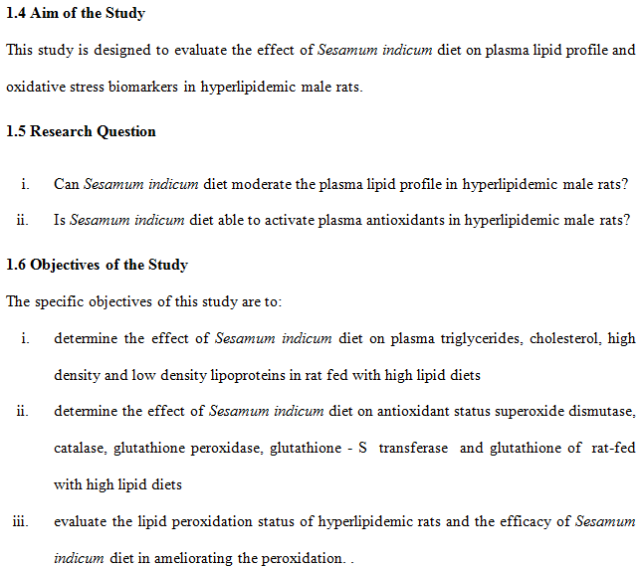
CHAPTER TWO
LITERATURE REVIEW

2.1 Hyperlipidemia
Hyperlipidemia is a challenge of diet metabolism, which is lined with increasing TC, LDL-C, and TG levels with a concomitant reduction in HDL-C level (Stewart et al., 2020;). This imbalance in plasma lipids contribute significantly to cardiovascular diseases, atherosclerosis, and stroke (Yao et al., 2020; Alloubani et al., 2021).

2.1.1 Pathophysiology of Hyperlipidemia
Hyperlipidemia disrupts the normal metabolism of lipids, leading to elevated plasma lipids and associated oxidative stress. The pathophysiology of hyperlipidemia (Fig. 2.1) can be broken down into several interrelated mechanisms, including dysregulation in lipoprotein metabolism, oxidative stress, lipid peroxidation, postprandial lipemia, inflammatory pathways, uncontrolled diet, disadvantageous lifestyle, genetic alteration and enzymatic deficiencies or over secretion.

2.1.1.1 Role of Lipoprotein metabolism dysregulation in hyperlipidemia
Hyperlipidemia arises from altered lipoprotein synthesis, transport, and clearance. Elevated LDL-C and TG result from hepatic overproduction of very low-density lipoproteins (VLDL), impaired LDL receptor activity, or decreased catabolism of lipoproteins (Karr, 2017; Stewart et al., 2020). Dysregulation of lipoprotein metabolism increases the circulating pool of atherogenic lipids, which promotes vascular deposition and plaque formation (Kelle et al., 2024)
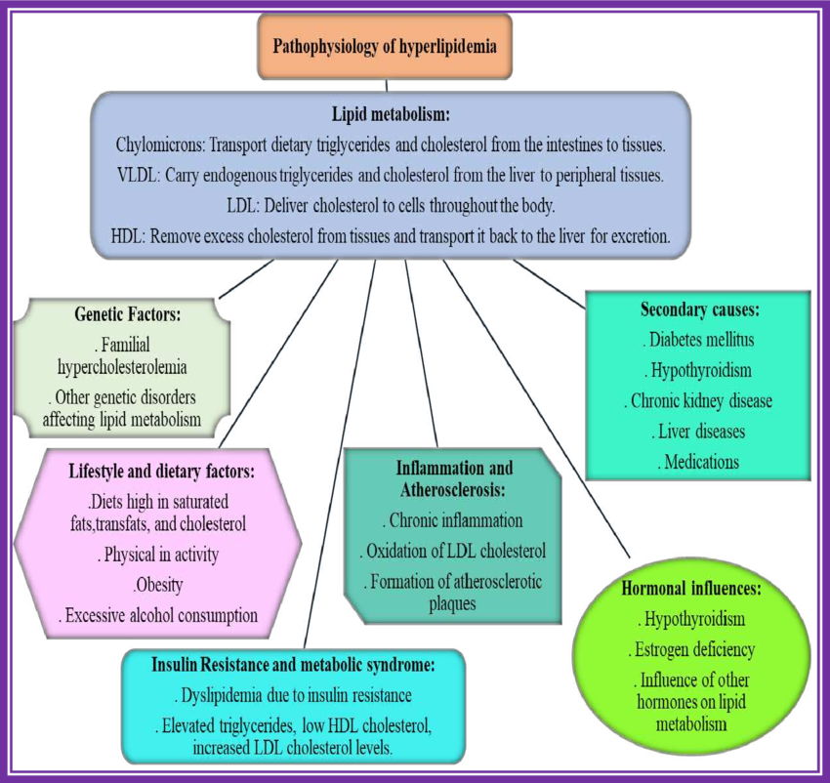
Figure 2.1: Pathophysiology of hyperlipidemia
Source: Rani et al., (2024)

2.1.1.2 Association between Oxidative stress and lipid peroxidation
Excess circulating lipids undergo oxidation, forming oxidized LDL (ox-LDL) (Figure 2.2). Ox-LDL induces endothelial dysfunction, activates macrophages, and triggers foam cell formation (Nouh et al., 2019; Yao et al., 2020). This process is closely linked with ROS accumulation that further exacerbates lipid peroxidation by depleting the endogenous antioxidants (Poornima et al., 2022).

2.1.1.3 Inflammatory pathways aid hyperlipidemia
Hyperlipidemia is connected to chronic inflammation because elevated TG and LDL-C stimulate the production of pro-inflammatory cytokines “c-reactive proteins (CRP), tumor necrosis factor- α (TNF-α), interneuin-6 (IL-6). This inflammatory milieu accelerates endothelial injury, proliferation in smooth muscle, and progression of atherosclerotic-based lesions (Alloubani et al., 2021; Yanai et al., 2023).

2.1.1.4 Genetic and enzymatic activities influence hyperlipidemia
Genetic mutations in enzymes that participate in metabolism of lipid, such as hepatic lipase, lipoprotein lipase, and apolipoproteins, can predispose individuals to hyperlipidemia (Nagarthn et al., 2020; Durrington et al., 2026). These enzymatic disruptions affect cholesterol synthesis, transport, and clearance, resulting in persistent dyslipidemia.

2.1.1.5 Diet and lifestyle contribute to hyperlipidemia
Consumption of trans fats, foods rich in cholesterol, and saturated fats directly influences plasma lipid levels. Sedentary lifestyle and obesity reduce HDL-C and impair lipoprotein metabolism (He and Ye, 2020; Giles, 2024). Conversely, diets rich in bioactive compounds, such as those present in Sesamum indicum, can modulate lipid metabolism by reducing cholesterol absorption and enhancing LDL clearance (El-Tantawy and Temraz, 2019; Rauf et al., 2022).

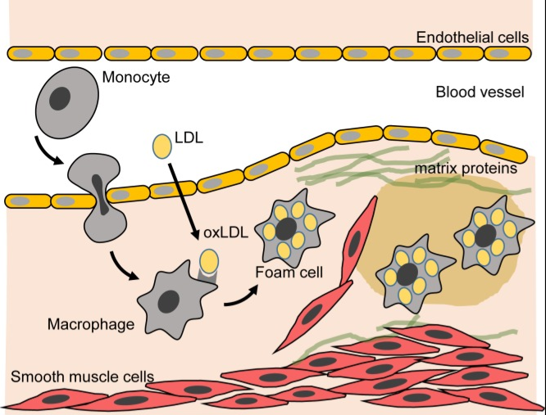
Figure 2.2: Oxidative stress, lipid oxidation and peroxidation in hyperlipidemic state.
Source: Barr, 2018

2.1.1.6 Postprandial Lipemia
Postprandial hyperlipidemia, characterized by transient elevation of plasma TG and remnant lipoproteins after meals, contributes to endothelial stress and atherogenesis (Yanai et al., 2023). Experimental models in Wistar rats show that diets supplemented with bioactive-rich foods, including sesame, can attenuate postprandial lipid spikes and improve overall lipid homeostasis.

2.1.2 Risk Factors for Hyperlipidemia
Hyperlipidemia, a multifactorial health challenge is impacted by genetic, dietary, lifestyle, and environmental conditions. When these risk factors (Figure 2.3) are checked properly, essential interventions will be designed to modulate any alteration in lipid profiles and antioxidant enzyme activity in hyperlipidemic models.

2.1.2.1 Genetic Predisposition
Mutations in genes encoding apolipoproteins (ApoB, ApoE), LDL receptors, and enzymes like lipoprotein lipase can lead to primary hyperlipidemia (Karr, 2017; Aguilar-Salinas et al., 2022). Individuals or animal models with these genetic predispositions often exhibit elevated LDL-C and TG, making them more susceptible to cardiovascular consequences.

2.1.2.2 Dietary Influences
It is reported that increasing consumption of trans fats, dietary cholesterol, and saturated fats is strongly associated with elevated plasma lipids (Nouh et al., 2019; Stewart et al., 2020). Conversely, ingestion of diets rich in unsaturated fatty acids, phytosterols, lignans, and polyphenols, such as those present in Sesamum indicum, can stimulate HDL-C levels but lower LDL-C, TG levels (El-Tantawy and Temraz, 2019; Rauf et al., 2022).
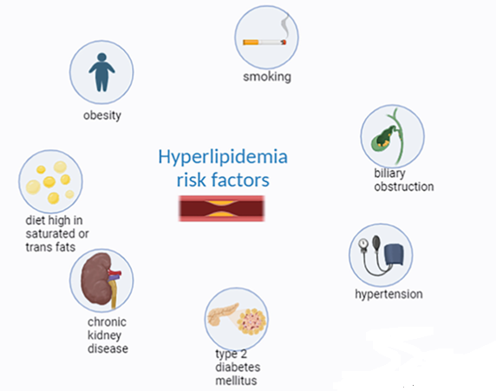

Figure 2.3: Risk factors of hyperlipidemia
Source: Abo-Elenien et al. (2024)

Figure 2.3: Risk factors of hyperlipidemia
Source: Abo-Elenien et al. (2024)
2.1.2.3 Obesity and Metabolic Syndrome
Dyslipidemia is primarily caused by excess adiposity and insulin resistance (Adeyanju et al., 2022; Yanai et al., 2023). In animal studies, dietary interventions using sesame have been shown to reduce these effects through lipid metabolism and antioxidant mechanisms, which lead to a decrease in plasma TG and LDL-C levels and an increase in HDL-C levels (Myint et al., 2020; Hussain et al., 2023).
2.1.2.4 Physical Inactivity
Lifestyle, such as sedentary lifestyle, plays a significant role in lipid homeostasis. Lack of physical activity results in a decrease in lipoprotein lipase activity, which impairs the clearance of TGs and causes a decrease in HDL-C levels (He and Ye, 2020; Giles, 2024). Functional diets containing sesame bioactives have been found to enhance the lipid profile and this can be further enhanced with exercise interventions (Gordon et al., 2016; Doewes et al., 2023).
2.1.2.5 Age and Gender
Plasma lipid levels are different at different stages of life and between sexes. Increases in lipid levels are observed from midlife onwards in women, particularly postmenopausal, compared to males, who have increased LDL-C and TG levels until midlife only (Ambikairajah et al., 2019; Poornima et al., 2022). Such differences emphasize the importance of differential treatment (dietary modulation, etc.) for young and old, male and female.
2.1.2.6 Comorbid Conditions
Hyperlipidemia frequently coexists with type 2 diabetes, hypertension, chronic kidney disease (CKD), exacerbating cardiovascular risk (CVD) (Wang and Bao, 2019; Alloubani et al., 2021). Dysregulation of glucose and insulin metabolism can lead to higher production of VLDL and decrease HDL-C, which may be partially prevented by antioxidant- and lipid-modulating diets like sesame supplementation.
2.1.2.7 Environmental and Lifestyle Factors
Environmental exposures such as air pollution, consumption of alcohol, and smoking, can influence lipid metabolism by causing inflammation-medicated oxidative stress (Han et al., 2016; Gaio et al., 2019). However, lifestyle modification, together with the functional food, Sesamum indicum, has been shown to reverse the disturbances in lipid profiles and thus to activate the enzymatic activity in animal models.
2.1.3 Clinical Implications of Hyperlipidemia
Increased concentration of lipids is a pre-requisite to metabolic disorders, atherosclerosis, cardiovascular diseases (CVDs). A successful hyperlipidaemic treatment, however, would require combination of pharmacological treatment, lifestyle change and new functional food interventions like Sesamum indicum supplementation.
2.1.3.1 Cardiovascular Implications
High levels of plasma lipids – especially LDL-C and triglycerides – increase the likelihood of endothelial dysfunction, oxidative stress, and plaque formation, which raises the risk of stroke, peripheral vascular disease, and myocardial infarction (Stewart et al., 2020; Alloubani et al., 2021). Hyperlipidaemia also promotes the instability of atherosclerotic plaques by lipid peroxidation and inflammatory cascades (Yao et al., 2020). Some other critical mediators of the mechanism associated with CVDs have been modulated by dietary bioactives such as unsaturated fatty acids and lignans present in sesame (Wu et al., 2019; Hussain et al., 2023).
2.1.3.2 Metabolic and Endocrine Implications
Hyperlipidaemia is also associated with other metabolic problems such as obesity, type 2 diabetes, and insulin resistance, which form a dyslipidemic cycle and metabolic derangements (Stewart et al., 2020; Poornima et al., 2022). Disordered lipid metabolism increases oxidative stress which leads to beta-cell dysfunction and a disruption in glucose homeostasis. The effects of sesame supplementation have been tested in preclinical settings involving Wistar rats that showed positive outcomes in terms of improvement of lipid metabolism, reduction of triglycerides, and an increase in the activity of antioxidant enzymes, thus decreasing the metabolic consequences (Miraj and Kiani, 2016; Myint et al., 2020).
2.1.4 Management of Hyperlipidemia
Treatment of hyperlipidaemia is complex, and includes dietary supplementation, lifestyle changes and drugs. In addition to lowering cardiovascular risk, effective management of plasma lipids improves antioxidant defence mechanisms, (Stewart et al., 2020).
2.1.4.1 Pharmacological Management of Hyperlipidemia
When lifestyle measures alone are not enough to reach target levels of lipids, or in people with high risk, pharmacological treatment is often used. It is said that statins” (inhibitors of hydroxyl-methyl glutaryl CoA reductase) reduce hepatic cholesterol synthesis and are effective in reducing TC and LDL-C synthesis (Last et al., 2017; Aguilar-Salinas et al., 2022). Fibrates lower plasma TG content, while also raising HDL-C content (Kris-Etherton et al., 2023), and cholesterol absorption inhibitors decrease the absorption of cholesterol in the intestine, which further lowers the plasma LDL-C content (Last et al., 2017). Resistant cases are treated with inhibitors of cholesterol absorption (ezetimibe) and LDL receptor (PCSK9 inhibitors) (Aguilar-Salinas et al., 2022). The combination of these drugs with functional dietary interventions may exhibit additive or synergistic effects on lipid modulation and antioxidants enzyme activity, which is beneficial for the protection of tissues against hyperlipidaemic induced oxidative damage, as indicated by the preclinical studies (Poornima et al., 2022; Rauf et al., 2022). The use of dietary complementary interventions is essential, as pharmacological agents can cause adverse effects such as hepatotoxicity, myopathy, or gastrointestinal complaints, although they are effective (Rauf et al., 2022).
2.1.3.4 Dietary and Functional Food Intervention against Hyperlipidemia
Functional foods are useful natural, safe and proper protocol that can be used to modulate disorientation in lipid profile. Bioactive compounds like phytosterols, unsaturated fatty acids and lignans (sesamin, sesamol and sesamolin) lower the level of LDL-C, TG, and total cholesterol while increasing HDL-C (Andargie et al., 2021; Mili et al., 2021). These compounds also activate the activities of SOD, CAT and GPx to decrease oxidative damage, which is important in preventing lipid peroxidation and atherosclerosis (Gupta et al., 2018; Wu et al., 2019). Other bioactive foods, like flaxseed and artichoke, have similar hypolipidemic and antioxidant effects (Santos et al., 2018). These are functional food that can regulate the cholesterol absorption, enhance lipid metabolism in the liver, and increase the endogenous antioxidant defense system. The inclusion of these bioactives in the diet can also support pharmacological and lifestyle measures to improve metabolic health (El-Tantawy and Temraz, 2019; Rauf et al., 2022).
2.1.3.5 Lifestyle Modifications against Hyperlipidemia
Treatment of hyperlipidaemia continues to be based on lifestyle changes which complement dietary advice. Physical activities (aerobic and resistance) increased HDL-C, decreased TG and LDL-C, and increased endogenous antioxidant defenses (He and Ye, 2020; Doewes et al., 2023). Weight Management Practices Decrease VLDL Overproduction and Enhance Insulin Sensitivity. Alcohol and smoking limits endothelial dysfunction and oxidative stress.
Lifestyle modification is the initial approach for hyperlipidaemiamanagement. Regular aerobic exercise regulates the fatty acid synthesis and beta-oxidation through decreasing plasma TG and LDL-C, whereas increasing HDL-C (He and Ye, 2020; Giles, 2024). Exercise also increases the activity of antioxidant enzymes in skeletal muscle that reduces oxidative stress from hyperlipidaemia (Poornima et al., 2022). Combining the aerobic exercise with functional diets has been shown to have synergistic effects on the reduction in total cholesterol (TC) and LDL-C, and increase in antioxidant enzyme activities like SOD, CAT, GPx in Wistar rats (Karr, 2017; Naser et al., 2021).
Weight management is also an important element of lifestyle intervention. Dyslipidemia and insulin resistance are worsened by obesity and by visceral fat accumulation. Caloric restriction and gradual weight reduction have synergistically made lipid profiles become favourable and have restored antioxidant enzyme balance in both preclinical and clinical models (Nouh et al., 2019; Stewart et al., 2020). The functional foods with bioactive compounds, such as polyphenols, phytosterols and unsaturated fatty acids, play an important role in the reduction of LDL C and the reduction of TG or increase of HDL C level (Rauf et al., 2022; El-Tantawy & Temraz, 2019). These interventions are not only important for plasma lipid modulation but also serve to boost the endogenous antioxidant mechanisms.
2.1.3.6 Integrated Lifestyle-Dietary Approaches
Dietary intervention combined with exercise is still a major part of the treatment of hyperlipidaemia. Experimental diets, especially the ones with sesame seeds have enhanced the plasma lipid profile and antioxidant enzyme activities in the preclinical setting (Poornima et al., 2022; Kris-Etherton et al., 2023). The combination of these two interventions provides cardiovascular protection and reduction of oxidative stress, whereas either intervention alone is not as effective. From a mechanistic point of view, sesame bioactives synergize with lifestyle changes, which can help regulate lipid metabolism in the liver, prevent lipid peroxidation and maintain cellular redox balance (El-Tantawy and Temraz, 2019; Rauf et al., 2022).
In addition, integrated lifestyle-dietary strategies can be used as therapeutic approaches, not just preventive ones amongst high-risk groups. They are essential for the treatment of hyperlipidaemia and limit cardiovascular effects, enhancing systemic antioxidant status (Aguilar-Salinas et al., 2022; Giles, 2024).
2.2 Lipid Profile in Hyperlipidemia
2.2.1 Lipid Profile
The lipid profile is a group of tests of blood that are used to assess TC, LDL-C, HDL-C and TG (Nordestgaard, 2017; Parhofer and Laufs, 2023). These parameters are key to cardiovascular risk and metabolic health. Hyperlipidaemia is characterised by an increase in LDL-C, TC, and increased TG with a corresponding decrease in HDL-C and is strongly associated with coronary artery disease, stroke, and atherosclerosis (Shahwan et al., 2019; Ambikairajah et al., 2019).
2.2.2 Disturbances in Lipid Levels
This is related to a combination effect of metabolic, lifestyle and genetic factors. Non-modifiable risk factors for disrupted lipid metabolism include age, family history, and sex, and modifiable risk factors include diet, alcohol intake, lack of physical activity, and the presence of comorbid conditions such as type 2 diabetes mellitus and hypertension (Artha et al., 2019; Chen and Cheng, 2022). Ambient air pollution exposure has been shown to also be associated with lipid changes via inflammatory processes and oxidative stress (Gaio, Roquette et al., 2019).
2.2.3 Fasting versus non-fasting lipid measurement
In the past, lipid profile measurements were performed in animal models that had been fasted. Yet, there is evidence that lipid profiles obtained after a meal are also valid for cardiovascular risk assessment, making clinical evaluations more convenient and patient compliance easier (Nordestgaard, 2017; Langsted and Nordestgaard, 2019). Fasting and non-fasting lipid parameters can be used to gain deeper insights into the lipoproteins in circulation; however, non-fasting lipid parameters can reflect more the typical postprandial metabolism, which may be more relevant for real-life cardiovascular risk assessment (Parhofer and Laufs, 2023).
2.2.4 Advanced Lipid Parameters and Ratios
Alongside lipid fractions, other advanced parameters like Apolipoproteins, LDL/HDL ratio and TG/HDL ratio have emerged as better parameters for predicting atherogenic risk and glycemic control (Paredes et al., 2019; Artha et al., 2019). The higher the lipid ratio, the higher the risk for metabolic syndrome and cardiovascular disease, emphasizing the need for a full lipid profile in both clinical and research applications.
2.2.5 Lifestyle and Therapeutic Modulation of Lipid Profile
The primary role of lifestyle modification in hyperlipidaemia control is retained. Regular physical activity and aerobic exercise lower LDL-C, TG and TC levels and increase HDL-C, thus lowering overall cardiovascular risk (Gordon et al., 2016; Silva et al., 2016; Doewes et al., 2023). Dietary plans, especially those with plant derived oils, phytosterols and bioactive compounds, effectively abrogate LDL-C, TG and HDL-C levels (Santos et al., 2018).
2.2.6 Environmental and Disease-Related Influences
Plasma lipid levels are affected by external factors like air pollution, infection and systemic inflammation. Environmental pollutants have been reported to elevated levels of TC, LDL-C and TG which leads to cardiovascular risk (Gaio et al., 2019). Likewise, COVID-19 infection has a negative association with HDL-C and a conflicting effect on LDL-C and TG, revealing the dynamic nature of lipid metabolism in the presence of a systemic stress (Rezaei et al., 2022).
2.2.7 Preclinical Models for Hyperlipidemia
Animal models especially male Wistar rats are widely used for studying the effects of dietary, pharmacological and bioactive interventions on lipid metabolism (Wu et al., 2019; Wei et al., 2022). Animal studies enable precise control of diet and environment, thus enabling the effects of specific bioactive compounds on lipid parameters to be studied. Based on preclinical findings, dietary strategies for prevention and management of hyperlipidaemia in humans can be developed via translational research.
2.3 Nutritional Modulators of Lipid Profile
Foods and diets high in bioactive components have become a focus of interest for lipid modulation and cardiovascular protection. The effects of bioactive compounds are multifaceted: They inhibit cholesterol production in the liver, increase the clearance of LDL; improve the function of HDL (Santos et al., 2018; Peña-Saldarriaga et al., 2020). These compounds offer a holistic nutrition strategy to prevent and/or reduce hyperlipidaemia alongside drug treatment.
2.3.1 Role of Unsaturated Fatty acids in Lipid Modulation
Monounsaturated fatty acids (MUFA) and polyunsaturated fatty acids (PUFA) play key roles in the regulation of plasma lipid profiles. MUFAs (oleic acid) and PUFAs (linoleic acid) decrease both LDL-C and TG levels while increasing HDL-C level (Gordon, Chen and Durstine, 2016; Parhofer and Laufs, 2023). These unsaturated fatty acids are abundant in plant-based oils, such as sesame oil, and are suitable for dietary interventions aimed at managing hyperlipidaemia (Wei et al., 2022; Sharma et al., 2020).

2.3.2 Phytosterols and cholesterol regulation
Phytosterols, naturally occurring in plant seeds, nuts, and oils, competitively inhibit cholesterol absorption in the intestines. Regular dietary intake of phytosterols has been associated with marked decline in TC and LDL-C without adversely affecting HDL-C (Santos et al., 2018).

2.3.3 Polyphenols and Antioxidant Effects on Lipid Metabolism
Polyphenolic compounds are key contributors to lipid modulation and cardiovascular protection. Sesamin, sesamol, and sesamolin, major lignans found in sesame seeds, exhibit antioxidant, anti-inflammatory, and lipid-lowering activities (Miraj and Kiani, 2016; Wu et al., 2019). These lignans reduce oxidative modification of LDL, enhance hepatic lipid metabolism, and improve HDL-mediated reverse cholesterol transport. Reports on hyperlipidemic rodents have shown that sesamin supplementation decreases serum LDL-C, TC, and TG while improving HDL-C (Mili et al., 2021).

2.3.4 Dietary Fiber and Lipid Profile
Soluble and insoluble dietary fiber have positively influenced plasma lipid concentrations (Santos et al., 2018). Soluble fiber binds intestinal bile acids, thereby stimulating their excretion and promoting hepatic generation of bile acids from cholesterol, thereby lowering LDL-C (Santos et al., 2018; Ali et al., 2019). Seeds of sesame contain significant dietary fiber contents, which synergistically complement their lipid-lowering effects alongside unsaturated fatty acids and lignans (Sharma et al., 2020; Wei et al., 2022).

2.4 Oxidative Stress in hyperlipidemia
Hyperlipidemia is directly connected to oxidative stress, which exacerbates endothelial dysfunction and cardiovascular risk. Elevated concentration of TC, LDL-C, and triglycerides increase the susceptibility of lipids to oxidative modification, leading to the production of ox-LDL and reactive lipid peroxides (Han et al., 2016; Huchzermeyer et al., 2022).
2.4.1 Mechanism of ROS Generation
Increased circulating lipids can lead to ROS generation through leakage of electron transport chain in mitochondria, activation of NADPH oxidase, and auto-oxidation of lipoproteins (Caverzan et al, 2016; Roy et al, 2023). The increase of ROS can cause damage to cell membranes, nucleic acids and proteins, leading to greater metabolic dysfunction in hyperlipidaemia (Bratovcic, 2020).
2.4.2 Impaired Antioxidant Defense
GPx, SOD and CAT are frequently found to be suppressed in hyperlipidemic state, reducing the ability of the body to neutralize ROS (Trivedi and Lal, 2017; Hussain et al., 2023). The activity of antioxidants enzymes were found to decrease in rats fed high-fat diets, which was associated with higher malondialdehyde (MDA) concentration (Wu et al., 2019).
2.4.3 Consequences of Lipid Peroxidation.
Oxidative modification of LDL-C, formation of foam cells and stimulation of atherosclerosis-based lesions (Han et al., 2016; Roy et al., 2023) are all a product of lipid peroxidation by ROS. In addition, oxidized LDL impairs the functions of HDL, which causes a decrease in reverse cholesterol transport and worsens plasma lipid imbalances (Zoidis et al., 2018).
2.4.4 Therapeutic Potential of Antioxidant Interventions
Antioxidants in the diet are capable of repairing enzymes that neutralize ROS and minimize lipid peroxidation (Wu et al., 2019; Myint et al., 2020). In hyperlipidemic male Wistar rats, sesame supplementation has shown hypolipidemic activity, antioxidant activity, and has been proposed to inhibit the production of TC, LDL-C, and TG, and simultaneously increase the activity of CAT, SOD, and GPx suggesting that it has a dual action (Mili et al., 2021; Hussain et al., 2023).
2.5 Role of antioxidant enzymes in hyperlipidaemia
Hyperlipidemia more than just dysregulated plasma lipid profile, but also increased oxidative stress leading to endothelial dysfunction, lipid peroxidation and cardiovascular consequences. Antioxidant enzymes constitute one of the first lines of defense against oxidative damage, playing crucial roles in maintaining redox homeostasis in biological systems (Bratovcic, 2020; Jomova et al., 2024).
Antioxidant enzymes are essential in maintaining cellular redox balance by removing ROS and preventing damage caused by oxidative stress (Gupta et al., 2018). Oxidative stress occurs when ROS production surpasses antioxidants' capacity to neutralize ROS, leading to lipid peroxidation, protein oxidation, and DNA damage, which are associated with hyperlipidemia (Bratovcic, 2020; Jomova et al., 2024).
2.5.1 Superoxide Dismutase (SOD)
SOD is one of the important enzymes as a first line of defense against oxidative stress, converting superoxide radical to hydrogen peroxide and oxygen (Caverzan et al., 2016). This is particularly important in hyperlipidemic state where the superoxide radicals may initiate the oxidation of LDL cholesterol to ox-LDL, one of the important factors responsible for atherogenesis (Roy et al., 2023). Wistar rats fed a high fat diet have shown reduced activity of the enzyme in hyperlipidaemia, further supporting the role of the enzyme as a protective agent (Hussain et al., 2023).
2.5.2 Catalase (CAT)
Catalase is a peroxisomal enzyme that catalyzes the breakdown of hydrogen peroxide into water and oxygen, thus preventing hydrogen peroxide accumulation and formation of the hydroxyl radical (Glorieux and Calderon, 2017). CAT activity is decreased in hyperlipidemic animal models and is associated with an increased level of lipid peroxidation in plasma and liver (Huchzermeyer et al., 2022). Dietary supplementation of antioxidants is reported to bring CAT activity back to normal levels, thus reducing the level of oxidative damage (Wu et al., 2019).
2.5.3 Glutathione Peroxidase (GPx)
Glutathione is used by the selenium-dependent enzyme GPx to reduce lipid hydroperoxides and H2O2 (Zoidis et al., 2018). GPx activity plays an important role in the prevention of polyunsaturated fatty acid oxidation in cell membranes particularly in hyperlipidemic conditions when triglyceride-rich lipoproteins are susceptible to peroxidation (Roy et al., 2023). Sesame lignans have been found to improve GPx activity in experimental hyperlipidemic rats, which helps to increase plasma lipid stability (Myint et al., 2020; Mili et al., 2021).
2.5.4 Interactions between antioxidant Enzymes
The SOD, CAT and GPx are part of a coordinated network in which a product of the enzymatic reaction will become a substrate for the next or another enzyme. The extent of radicals that can accumulate and become harmful is prevented by the degradation of SOD-produced H2O2 by CAT and GPx (Gupta et al., 2018; Jomova et al., 2024). Hyperlipidemic models show disruption of antioxidant enzymes resulting in an increase in oxidative stress and lipid profile disturbances (Cecerska-Heryć et al., 2021).

2.6 Botanical description and taxonomy of Sesamum indicum (Sesame)

2.6.1 Taxonomic Classification of Sesamum indicum
Sesame, or Sesamum indicum L., is a significant oilseed crop that is a member of the Pedaliaceae family. There are about 20–30 species in the genus Sesamum, most of which are found in tropical and subtropical areas of Asia and Africa. Due to its high oil content and nutritional value, Sesamum indicum is the most extensively grown and economically significant of these species (Amoo et al., 2017; Pathak et al., 2017). Sesame is thought to have originated in Africa and then been brought to Asia, where it was extensively domesticated and grown, according to historical and botanical evidence.
The taxonomic classification of Sesamum indicum is as follows:
Kingdom: Plantae
Division: Magnoliophyta (Angiosperms)
Class: Magnoliopsida (Dicotyledons)
Order: Lamiales
Family: Pedaliaceae
Genus: Sesamum
Species: Sesamum indicum L.
Members of the Pedaliaceae family are generally herbaceous plants adapted to warm climates and are characterised by mucilaginous seeds and capsule fruits. Within this family, sesame is the most economically valuable species because of its oil-rich seeds and wide industrial applications (Mili et al., 2021).

2.7 Morphological Characteristics of Sesamum indicum

2.7.1 Plant Growth Habit and Stem Structure
The annual herbaceous plant Sesamum indicum usually grows between 60 cm and 150 cm in height, although some cultivars may grow taller depending on genetic traits and conditions in the environment (Amoo et al., 2017; Hussain et al., 2023). The plant possesses an erect and quadrangular stem, which may be either glabrous or slightly pubescent.
Stem branching varies significantly among cultivars. Some varieties exhibit a single-stem growth habit, while others produce multiple branches. This variation in branching pattern participates in evaluating the number of capsules produced and ultimately influences crop yield.

2.7.2 Leaf Morphology
The leaves of sesame show considerable morphological variation depending on the cultivar and stage of plant growth. Generally, the lower leaves are broader and arranged oppositely on the stem, while the upper leaves tend to be narrower and arranged alternately. Leaf shapes may range from ovate and lanceolate to deeply lobed structures (Hussain et al., 2023). Leaf morphology is often used as an identifying characteristic for distinguishing different sesame varieties. However, environmental conditions such as soil fertility, temperature, and availability of water may also influence leaf size and structure.

2.7.3 Flower Structure and Pollination
The flowers of Sesamum indicum are tubular and bell-shaped, typically measuring 3–5 cm in length. They are usually appear singly or in pairs within the leaves axils along the stem. Flower colours vary among cultivars and may appear white, pink, purple, or pale violet (Tripathy et al., 2019). Sesame flowers are primarily self-pollinating, although a small degree of cross-pollination may occur through insect activity, particularly by bees. The flowering stage represents a critical phase in the reproductive cycle of the plant, as successful pollination determines the formation of seed capsules and overall yield.

2.7.4 Fruit and Seed Characteristics
After fertilization, sesame plants produce elongated capsule fruits that contain numerous small seeds. Each capsule typically contains between 50 and 100 seeds, based on the genotype and conditions for growth (Amoo et al., 2017). The capsules are dehiscent, meaning they split open when mature to allow the seeds get released. This feature is commonly referred to as shattering, which can cause significant yield losses if harvesting is delayed. Breeding programmes have therefore focused on developing improved sesame varieties with reduced shattering tendencies to facilitate mechanised harvesting (Teklu et al., 2022).
Sesame seeds are small, oval-shaped, and flattened, usually measuring 3–4 mm in length. The seeds occur in various colours including white, cream, yellow, brown, red, and black. These colour variations are often associated with differences in chemical composition, particularly in antioxidant and phytochemical content (Wei et al., 2022).

2.8 Global Distribution and Production of Sesame
Sesamum indicum is broadly grown across subtropical and tropical parts of the world and is considered an important oilseed crop with high economic value. The crop thrives in warm climates and relatively dry environments, which explains its extensive cultivation in Africa, Asia, and parts of Latin America (Pathak et al., 2017; Hussain et al., 2023). Sesame is often grown by smallholder farmers in developing countries because of its potential to tolerate limited rainfall and marginal soil conditions.
Globally, sesame production has increased steadily over the past several decades. Nations that produce sesame include China, India, Sudan, Ethiopia, Myanmar, and Nigeria, which collectively contribute a substantial proportion of global sesame output (Myint et al., 2020; Sanni et al., 2024). Asia and Africa remain the leading producing regions, with Africa emerging as a rapidly expanding production hub due to favourable agro-ecological conditions and increasing international demand. Sudan and Ethiopia have become major exporters of sesame seeds to international markets.
In recent years, global sesame cultivation has expanded because of the crop’s adaptability and growing commercial value. According to recent agricultural assessments, millions of hectares of land worldwide are devoted to sesame production, with developing countries accounting for the majority of cultivated areas (Sanni et al., 2024). The crop supports rural economies, providing income for farmers and contributing to agricultural diversification.

2.9 Economic Importance of Sesame in Global Agriculture
Sesame holds considerable economic importance due to its high market demand and diverse industrial applications. The seeds are primarily cultivated for their oil, which is widely used for cooking and food processing. Oil from sesame has a particularly notable/pleasant flavour, better oxidative stability, and nutritional components (Wei et al., 2022).
In addition to oil production, seeds of sesame are generally useful as recipe in several foods or food products. They are commonly incorporated into bakery products, confectionery, sauces, snacks, and traditional dishes across many cultures. For example, sesame seeds are used in the preparation of sesame paste, tahini, halva, and various Asian and cuisines belonging to the Middle East (Sharma et al., 2020; Wei et al., 2022).
Sesame is economically valuable beyond the food industry because sesame oil and its derivatives are reportedly used in cosmetic, nutraceutical, and pharmaceutical industries. The oil from seame are used as basic component in medicinal formulations, massage oils, and skincare products due to its moisturizing properties and antioxidant content (Wei et al., 2022). These diverse applications contribute to the high commercial demand for sesame seeds in global markets.

2.10 International Trade and Market Demand
Sesame is an important commodity in international agricultural trade. The global sesame market has expanded significantly owing to increasing interests from consumer of natural oils, plant-based diets, and functional foods. Sesame seeds are widely exported from producing countries in Africa and Asia to major import markets such as Japan, China, South Korea, several European countries, and the United States (Sanni et al., 2024).
The international sesame trade is driven largely by demand for high-quality seeds used in food processing industries. For example, Japan and South Korea import large quantities of sesame seeds for use in cooking oils and food products. Similarly, China has been identified as a pivotal importer of sesame seeds due to high demand from the domestic front (Myint et al., 2020).
The expanding global market for sesame has encouraged many developing countries to increase production and export capacity. In several African countries, sesame has become an important cash crop, contributing significantly to export earnings and rural livelihoods (Sanni et al., 2024). This economic importance has attracted increased interest from governments and development agencies seeking to promote sesame production as a means of improving agricultural productivity and economic development.

2.11 Socioeconomic Importance of Sesame for Rural Livelihoods
Beyond its contribution to international trade, sesame also supports the survival of millions of subsistence farmers globally. In many developing countries, the growth of sesame is a focal point in rural households when discussions arise on sources of income (Myint et al., 2020). The crop requires relatively low input relative to many other oilseed crops, making it accessible to farmers with limited financial resources. Sesame production contributes to employment generation across different stages of the value chain, including cultivation, harvesting, processing, transportation, and marketing. In addition, sesame cake (one of the by-products of sesame) is commonly used to feed animals, further increasing the crop’s economic value in agricultural systems (Sharma et al., 2020).
In regions where agricultural diversification is limited, sesame cultivation provides farmers with an opportunity to increase income and improve food security. As global demand upsurges, the production of sesame is projected to be crucial for rural economic development.
2.12 Challenges Affecting Sesame Production
Although the plant is economically significant, there are some limitations which will hinder the production and profits of sesame. Low yield is a major constraint that is sometimes associated with poor agronomic practices, restricted availability of improved seed varieties, and insufficient fertilization (Teklu, Shimelis, and Abady, 2022). Pest and disease control is another significant issue; these can significantly reduce yield and quality. Sesame can be attacked by insect pests and disease causing organisms such as bacteria, fungi and viruses that infest the leaves, stems and capsules. Hence, the use of effective management strategies towards pest and disease control is necessary to boost sesame productivity (Hussain et al., 2023). Besides this, the crop has the problem of capsule shattering at maturity, causing losses during harvest. Old sesame cultivars are prone to shattering and the seeds can scatter on the ground if they are not harvested at the proper time. This trait makes mechanized harvesting difficult and adversely affects yield (Teklu et al., 2022).
2.13 Impact of Climate and Environmental Factors on Sesame Production
Sesame productivity is highly influenced by environmental factors. Sesame is relatively drought tolerant but very drought, high temperatures, and excessive amounts of rainfall have negative effects on sesame growth and yields (Myint et al., 2020). However, new challenges have also been created for sesame cultivation with climate change. Crop yields could also suffer from disrupted planting cycles, as a result of increased temperature variability and unpredictability of rainfall. Furthermore, degradation of soil and loss of soil fertility in many farm areas pose a further risk to sustainable sesame production.
Researchers have highlighted the need to breed climate resilient sesame varieties and use better agricultural practices to overcome these challenges. Sesame productivity is likely to respond positively to the development of improved cultivars, better irrigation management and other advances in integrated pest management (IPM) strategies in response to changing environmental conditions (Teklu et al., 2022).
2.14 Impact of Climate and Environmental Factors on Sesame Production
Some methods have been suggested to improve the production of sesame in the world. An important one is the introduction of very modified high yielding varieties by breeding and genetic improvement programs. Modern breeding technologies are designed to create sesame cultivars that are resistant to pests and diseases, able to withstand environmental stress, and slightly susceptible to capsule shattering (Teklu et al., 2022). Good agronomic practices such as better fertilization, irrigation management, crop rotation and integrated pest management are also key strategies. The practices, if used properly, can have a definite positive impact on yield and quality of crops.
In addition, the adoption of modern technology like mechanized harvesting, improvement in processing technologies can minimize post-harvest losses and improve production efficiency. It is therefore necessary to make more investment in the agricultural research and farmer education programs for the maximum economic utilization of sesame production in the world (Myint et al., 2020).
2.15 Sesame Seeds
The health promoting properties of sesame seeds are well known and recognized. Seeds have a wide variety of macronutrients, micronutrients and biologically active compounds that are important to their nutritional and medicinal functions. Sesame is a rich source of vitamins, lipids, minerals, proteins and phytochemicals, making it an important functional food with potential for prevention and management of metabolic disorders such as hyperlipidemia and cardiovascular diseases (CVD) (Sharma et al., 2020; Wei et al., 2022; Pathak et al., 2014).
A unique characteristic of sesame is their relatively high oil content which is usually 45% to 55% of the seed weight depending upon the cultivar and environmental conditions that influence the cultivation of sesame crops. Due to its high lipid content, sesame is an important oilseed crop in the world and a good source of edible vegetable oil (Sharma et al., 2020; Wei et al., 2022; Elleuch et al., 2011). The sesame oil is popular for its use as a food oil as well as medicinal properties. Sesamin, sesamolin and sesamol are the agents that improve the oxidative stability of sesame oil and make it insignificant to easily spoil, compared to many vegetable oils. These antioxidant compounds also play a role in the beneficial health properties of sesame intake (Namiki, 2007; Pathak et al., 2014; Wei et al., 2022).
Unsaturated fatty acids are the main constituent of the lipid fraction of sesame seeds and include oleic acid and linoleic acid. The major proportion of the total fatty acid composition comes from these fatty acids, which are well known to promote cardiovascular health (Wei et al., 2022; Elleuch et al., 2011).
Oleic acid, one of the MUFA, plays a significant role in regulating lipid metabolism, as it helps to lower LDL-cholesterol, while maintaining or improving HDL-cholesterol levels. LLA is an essential PUFA and plays a role in maintaining the integrity of the cellular membranes, and it is involved in various metabolic pathways associated with inflammation and lipid metabolism (Sharma et al., 2020; Pathak et al., 2014). Diets rich in unsaturated fatty acids have been highlighted to improve plasma lipid profiles and lessen the onset of cardiovascular diseases, thereby highlighting the nutritional importance of sesame oil in metabolic health (Namiki, 2007; Wei et al., 2022).
Sesame seeds also represent an important source of plant-based protein, typically containing 20–25% protein, based on the cultivar of seed and the conditions surrounding its cultivation. This relatively high protein content enhances the nutritional advantage of sesamum seeds and makes them a valuable dietary component in many regions of the world (Wei et al., 2022; Sharma et al., 2020).
The protein in sesamum/sesame seeds contains several essential amino acids required for normal physiological functions, including methionine, tryptophan, leucine, and phenylalanine. Sesame is particularly rich in methionine “an essential sulfur-containing amino acid” that is often limited in other plant proteins. The amino acids stimulate various biological activities such as the repair of tissues, enzyme synthesis, immune system regulation, and metabolic control (Elleuch et al., 2011; Pathak et al., 2014). Sesame protein, therefore, plays a vital role in human nutrition and also has been used in animal feed using Sesame meal (after oil extraction) (Sharma et al., 2020).
Sesame seeds have a medium amount of carbohydrates, of which a significant part is in the form of dietary fibre. The dietary fibre is one of the nutrients that is beneficial for digestive health and metabolic balance, which is essential for human nutrition (Wei et al., 2022; Elleuch et al., 2011). The fibre in sesame seeds helps to improve bowel movement and prevents constipation, thus regulating gastrointestinal activity. Dietary fibre has also been found to affect lipid metabolism by inhibiting cholesterol absorption from the intestine and promoting the elimination of bile acid. It may be one of the mechanisms that help to reduce plasma cholesterol level and regulate lipid homeostasis (Pathak et al., 2014; Namiki, 2007). The beneficial effects of sesame seeds in some studies on dietary management of hyperlipidaemia may be attributed to the fibre content.
In addition to antioxidants, sesame seeds are rich in a variety of phenolic compounds, flavonoids, tocopherols and phytosterols that are associated with their antioxidant activity (Dravie et al., 2020). These phytochemicals can help to fight free radicals that can damage cells and are an important part of the prevention of chronic diseases. Sesame lignans have been found to exert effects on lipid metabolism, improve liver function, and minimize oxidative stress in biological systems (Andargie et al., 2021). Therefore, due to the existence of these bioactive compounds, sesame has been attracting great interest to use as a functional food and nutraceutical ingredient.
2.16. Relevance of Sesame Nutrition in Hyperlipidemia Studies
Sesame seeds are very important in studies looking into dietary treatments for metabolic diseases like hyperlipidemia because of their nutritional makeup. They are believed to have lipid-lowering and anti-oxidative properties due to unsaturated fatty acids, dietary fibre, phytosterols, antioxidants and bioactive lignans (Pathak et al., 2014; Wei et al., 2022). The studies conducted by Namiki (2007) and Sharma et al. (2020) using animal models suggested that sesame supplementation could have beneficial effects on plasma lipid profile, reduce oxidative stress, and enhance the activity of endogenous antioxidant enzymes. In hyperlipidemic conditions, sesame diets could be beneficial in enhancing antioxidant defence mechanisms and in regulating lipid metabolism (Namiki 2007; Sharma et al. 2020). Therefore, sesame seeds are an important food item which can be used to bypass and control lipid related metabolic diseases.
Sesame seeds' high level of bioactive phytochemicals is one of its most notable characteristics. The most important of these substances are believed to be lignans such as sesamolin, sesamin and sesamol. The health benefits of sesame are mostly attributed to these lignans, which have potent antioxidant qualities (Andargie et al., 2021; Wei et al., 2022).
2.17 Pharmacological and medicinal properties
Sesame is so widely used in traditional medicine that it has been used for generations due to its medicinal properties. Different parts of the plant have been used for various disorders such as inflammation, digestive, hypertension, and skin disease (Miraj and Kiani, 2016; Mili et al., 2021). These are all traditional applications that have now been proven by modern pharmacology. Sesame extracts and lignans have been shown to possess antioxidant, anti-inflammatory, antibacterial and anticancer properties. (Wu et al., 2019; Wei et al., 2022). These biological actions are mainly attributed to the availability of phenolic compounds, lignans and phytochemicals in seeds of sesame.
Moreover, sesame consumption has been demonstrated to reduce blood cholesterol levels, improve cardiovascular health and to protect against oxidative stress-related diseases ( Wu et al., 2019). Sesame compounds' antioxidant qualities have also been linked to possible benefits against chronic illnesses.
2.18 Industrial Applications of Sesame (Sesamum indicum).
Although used as a food ingredient, sesame (Sesamum indicum L.) is a versatile crop for use in a wide range of industrial applications. However, high oil content, stable antioxidant profile and nutrient density make sesame an important raw material in the food, pharmaceutical, cosmetic and feed industries (Sharma et al., 2020; Wei et al., 2022).
2.18.1 Food Processing Applications
Sesame oil is extensively used in food processing for its distinctive aroma, flavor and oxidative stability. The natural antioxidants of sesame oil help extend its shelf life and make it less susceptible to spoilage during storage and use, which also prevents it from getting rancid (Andargie et al., 2021; Wei et al., 2022). Furthermore, sesame oil is used in confectionery, bakery and snack products as a functional ingredient to improve texture, flavor and nutritive value. The roasted sesame seeds are also ground to make tahini and are being used as a topping (Amoo et al., 2017; Wei et al., 2022). These applications not only make the food product more appealing, but also make it a functional food through provision of antioxidants and healthy fats.
2.18.2 Pharmaceutical and nutraceutical applications of natural products.
The pharmaceutical and nutraceutical industries are using more and more sesame oil and extracts. The oil's stability and ability to support various formulations make it a versatile carrier for lipophilic drugs and bioactive components (Miraj and Kiani, 2016; Wei et al., 2022). Studies have demonstrated sesame oil, and lignans, antioxidant, anti-inflammatory and cardioprotective properties which can be harnessed in dietary supplements and medicinal products (Miraj and Kiani, 2016; Wu et al., 2019; Andargie et al., 2021). In this regard, sesamol and sesamin have been reported to have a significant anti-oxidative, plasma lipid-lowering and metabolic beneficial effect, thus, sesame oil could be used as a nutraceutical ingredient in the formulation of hyperlipidaemic, cardiovascular and metabolic diseases (Miraj and Kiani, 2016; Wu et al., 2019; Andargie et al., 2021).
2.18.3 Cosmetic and Personal Care Applications
Sesame oil is known for its anti-aging, antioxidant and moisturizing properties, which has led to its use in skin and hair care products (Wei et al., 2022; Sharma et al., 2020). Sesame oil is used in creams, lotions, hair oils and massage oils as a natural emollient to nourish and repair skin barrier. Sesame oil's antioxidant lignans prevent oxidative stress and shield skin cells from damage caused by free radicals, both of which have anti-aging benefits (Miraj and Kiani, 2016; Wu et al., 2019). Moreover, sesame oil has been added to cosmetic products owing to its UV-protective effect and its beneficial effect on increasing the elasticity of the skin (Sharma et al., 2020; Wei et al., 2022).
2.18.4 Industrial and Biofuel Applications
In addition to food and personal care, sesame oil has been investigated for industrial applications like bio-lubricants, biofuels etc. It is also highly oxidative-stable and has a suitable viscosity, which makes it an excellent biodiesel raw material in small-scale biodiesel production and an alternative to petroleum-based oil used in industrial machinery (Yaseen et al., 2021; Hussain et al., 2023). With the rapid rise of the market for sustainable and eco-friendly industrial material, sesame oil is emerging as renewable raw materials for biologically-based products, which is in line with the world's trend towards environmental sustainability (Yaseen et al., 2021; Wei et al., 2022).
2.18.5 Sesame By-products and Animal Feed.
The by-product of sesame cake/meal is a protein-rich food that is used extensively to feed animals (Amoo et al., 2017; Wei et al., 2022). The protein, carbohydrates, fibre and mineral contents in the cake are still present and can be used in livestock and poultry feed. It has been reported that it can be added to feed formulation to enhance growth performance, nutrient efficiency, and antioxidant status of the animals and has been suggested as a sustainable feed resource for animals (Myint et al., 2020; Hussain et al., 2023).
2.18.6 Emerging Industrial Applications
Bioactive compounds derived from sesame have recently been investigated for their application in functional foods, pharmaceutical and cosmeceuticals. For instance, sesame lignans are being developed as capsules and emulsions for their use as anti-oxidants and lipid management agents (Andargie et al., 2021; Wu et al., 2019).
Further, sesame powders and extracts are used as ingredients in energy bars, supplements and health drinks, geared toward customers looking for organic products with health promoting properties (Wei et al., 2022; Mili et al., 2021).

CHAPTER THREE
MATERIALS AND METHODS
3.1 Materials and Equipment
Sesamum indicum seeds, maize, and palm oil were purchased from a local market in Sabo, Sagamu, Ogun State, Nigeria. The seeds were cleaned of pebbles, sand, and other contaminant particles, washed, sun-dried, and ground into powder. Commercial rat chow was bought from Ladokun Feeds in Mokola, Ibadan, Oyo State, Nigeria. Groundnut cake was procured from Enigbokan Mill in Ikenne-Remo, Ogun State, Nigeria. Table 3.1 summarizes the high-fat diet (HFD) utilized to induce hyperlipidemia, which was developed using the technique previously reported by Adeyanju et al. (2022). All of the materials used in the investigation were cleaned and handled according to standard procedures, including the animal cage, water trough, wood plank, pipette and tips, volumetric flasks, cuvette, Beckmann Du 64 spectrophotometer, refrigerator (BOSCH B21CL81SN), and Eppendorf tubes.
3.2 Chemicals and Reagents
Cholesterol (Sigma-Aldrich), Hydrochloric acid (HCl), ammonium molybdate, glutathione (GSH), 0.1M potassium phosphate buffer (pH 6.5), and 1-chloro-2,4-dinitrobenzene (CDNB), thiobarbituric acid (TBA), Tris-KCl buffer, epinephrine, trichloroacetic acid (TCA), dithiobis (2-nitrobenzoic acid) (DTNB), all other reagents, except when indiacted, used were from Molychem and they were of analytical grade.
3.3 Animal Management
Forty (40) male Wistar rats that were six weeks old were obtained from the Department of Physiology at the University of Ibadan in Nigeria. They were kept in controlled, well-ventilated cages. After two weeks of acclimatization, the animals were given unlimited food. To guaranty the best possible health for the animals, the animal house was kept under stringent hygienic conditions and the cages, water, and food troughs were cleaned every day. The Institutional Animal Care and Use Committee of Olabisi Onabanjo University Teaching Hospital (OOUTH), Sagamu, Ogun State, Nigeria, approved all procedures, including animal handling, in compliance with standard protocols (Approval No: OOUTH/HREC/06/007/E362/2025AP). Body weights were recorded every two weeks.
Rats were randomly assigned to four groups (n = 10) after being acclimated to standard rat chow and portable drinking water: basal control (Basal Ctrl), high-fat diet untreated (HF Untreated), high-fat diet supplemented with sesame (50% SI seed + 50% HFD; HF + Sesame), and high-fat diet with atorvastatin (HF + Atorvastatin; 0.02 mg/kg/day) (Table 3.2). After the animals were fed the high-fat diet for four weeks, hyperlipidemia was proven. After four weeks of treatment, the animals were ethically slain via cervical dislocation, and blood was taken for biochemical analyzes. Throughout the whole experiment, no animal was left out.

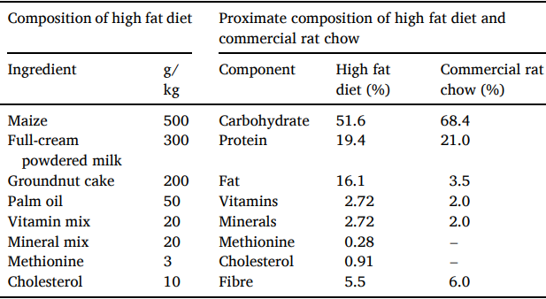
Figure 3.1: Components of the HFD and commercial rat chow
Source: Adeyanju et al., 2022.

Table 3.1: Animal Group, Feeding and Treatment
Animal Grouping | Feeding and Treatment
Group1: (Normal Control) n=10 | Standard pelletized feed and water only
Group2: (High Fat Diet Untreated) n=10 | High-Fat Diet and water only
Group3: (High Fat Diet + Sesame) n=10 | 50% SI seed + 50% HFD and water per os
Group4: (High Fat Diet + Atorvastatin) n= 10 | Oral administration of 0.02mg/kg/bw Atorvastatin + HFD and water

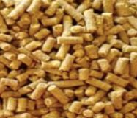
Figure 3.2: Photograph of pelletized high fat diet.

3.4 Lipid extraction from rat tissues
Following the particular procedure scheme previously disclosed by Adeyanju et al. (2022), lipid extraction from the plasma samples was carried out in accordance with the established technique by Folch et al. (1957). Lipid was extracted in chloroform-methanol (2:1 v/v) and the addition of 0.9% Nacl created a biphasic environment – the organic layer, which contain the lipids, was subsequently used for lipid profile determination.
3.5 Lipid profile determination
Commercial kits from Randox Laboratories (Antrim, United Kingdom) were used to measure the amounts of TC and TG in the lipids isolated from the rat plasma. The levels of low-density lipoprotein cholesterol (LDL-C) and high-density lipoprotein (HDL)-cholesterol were also measured using the same commercial kits in accordance with the method previously outlined by Gidez and colleagues (1982).
3.6 Determination of Antioxidant Enzymes Activities
Activities of intracellular antioxidant enzymes in the plasma were determined via spectrophotometry using the following standard protocols as previously described.
3.6.1 Determination of Superoxide dismutase Activity
The technique outlined by Misra and Fridovich (1972) was used to measure superoxide dismutase (SOD) activity. Briefly, 150 µL of carbonate buffer (0.5M, pH 10) was added to 50 µL of the dissolved sample. Subsequently, 50 µL of freshly prepared epinephrine (0.03M) in hydrochloric acid (HCl) was added, and the absorbance was read spectrophotometrically over a period of 5 minutes. SOD activity (U/L) was then calculated based on the rate of epinephrine auto-oxidation inhibition. One unit of enzyme (SOD activity) is the amount of enzyme that causes 50% inhibition of epinephrine auto-oxidation, and this was calculated using te following equations:
$$∆Abs=\frac{Abs5-Abs1}{T5-T1} 1$$
$$\% Inhibition=\frac{∆Abs}{∆ABlk}*100 2$$
$$SOD Activity (U/L)=\frac{\% Inhibition}{50}*\frac{1000}{50} 3$$
3.6.2 Determination of Catalase Activity
Catalase activity was measured using the method outlined by Köth (1991). Briefly, 100 µL of the sample and 100 µL of 1X phosphate-buffered saline (PBS) were put to a 96-well plate. After that, a 100 µL aliquot of the diluted sample was moved to a different 96-well plate, and a substrate of hydrogen peroxide solution (0.65M) was added. The reaction mixture was incubated for 10 minutes, and the reaction was subsequently terminated by the addition of ammonium molybdate in sulfuric acid solution. The absorbance was then read using a LT4500 microplate reader (Labtech, France) and used to calculate catalase activity expressed as U/L as described in the equation below:
$$Catalase Activity (U/L)=\frac{Astandard-Asample}{Astandard}*F$$
Where:
F = conversion factor derived from reaction conditions

3.6.3 Determination of Glutathione Peroxidase Activity
The Paglia and Valentine (1967) method was used to measure the GPx activity in the sample. The oxidation of NADPH was measured spectrophotometrically at a wavelength of 340 nm using hydrogen peroxide (0.65M) as a substrate to gage enzyme activity. Enzyme activity were calculate as expressed in are given as U/L.
$$GPx Activity (U/L)=(∆A/min)/(Sample Volume) *F$$

3.6.4 Determination of Glutathione S - transferase Activity
The technique outlined by Habig et al. (1974) was used to measure glutathione S-transferase (GST) activity. A reaction mixture was prepared containing glutathione (GSH), 1-chloro-2,4-dinitrobenzene (CDNB), and 0.1M potassium phosphate buffer (pH 6.5) in a 1:1:16 volume ratio. 150 µL of this reaction mixture was then added to the dissolved sample. The absorbance was measured at 405 nm using a LT4500 microplate reader (Labtech, France) over a period of 5 minutes. GST enzyme activity was then calculated and expressed as units per litre (U/L).
$$∆Abs=\frac{Abs5-Abs1}{T5-T1} 1$$
$$\% Inhibition=\frac{∆Abs}{∆ABlk}*100 2$$
$$GST Activity (U/L)=\frac{\% Inhibition}{50}*\frac{1000}{50} 3$$

3.7 Determination of Reduced Glutathione (GSH) and Malondialdehyde Content
To determine the levels of MDA and GSH in the samples, the procedures described by Ohkawa et al. (1979) and Moron et al. (1979) were used. 900 µL of Tris-KCl buffer was added to plain tubes, followed by 100 µL of sample. The Tris-KCl buffer was added to maintain the physiological pH. Subsequently, 500 µL of trichloroacetic acid (TCA) was added to deproteinise the samples. The tubes were then capped and centrifuged. A 100 µL aliquot of the resulting supernatant was transferred to a 96-well plate, and 100 µL of thiobarbituric acid (TBA) reagent was added. The plate was then incubated at 80°C for 30 minutes, and the absorbance was read using a LT4500 microplate reader (Labtech, France) to determine MDA levels.
For GSH determination, 100 µL of the supernatant was transferred to a separate 96-well plate, and 100 µL of dithiobis (2-nitrobenzoic acid) (DTNB) reagent was added. The plate was then incubated in the dark for 10 minutes, and the absorbance was read at 412 nm using a LT4500 microplate reader (Labtech, France) to determine GSH levels.
$$MDA \left(µM\right)=\frac{A532}{{1.5*10}^{5}}*{10}^{6}$$
Where:
1.56 x 10⁵ M⁻¹cm⁻¹ is the extinction coefficient of the MDA-TBA complex.
3.8. Statistical Analysis
Every outcome was shown as mean ± SD. To ascertain treatment effects, the data were examined using a one-way ANOVA followed by a Tukey's post-hoc test for multiple comparisons between the experimental groups. The threshold for statistical significance was set at p < 0.05. The statistical analysis was conducted using GraphPad Prism version 9.

CHAPTER FOUR
RESULTS AND DISCUSSION
4.1 Body weight change
Figure 4.1 shows the changes in body weight of rats during hyperlipidemia induction and treatment. There was no difference between the body weight of the groups at baseline (p>0.05). All the induced groups gained weight progressively compared to basal control after a period of fat feeding which verified the successful induction of hyperlipidaemia. The untreated hyperlipidemic group had the greatest amount of body weight gain during the study, suggesting that these rabbits were gaining weight in fat. But the sesame-supplemented diet was significantly able to reduce the weight gain compared with the untreated diet. This effect was similar to that which was observed in the atorvastatin group. Although body weight in the sesame-treated animals was slightly above the basal control, the marked reduction relative to the untreated group suggests improved lipid metabolism and energy utilization. These findings indicate that sesame possesses anti-obesity and antihyperlipidemic properties capable of mitigating high-fat diet-induced weight gain.
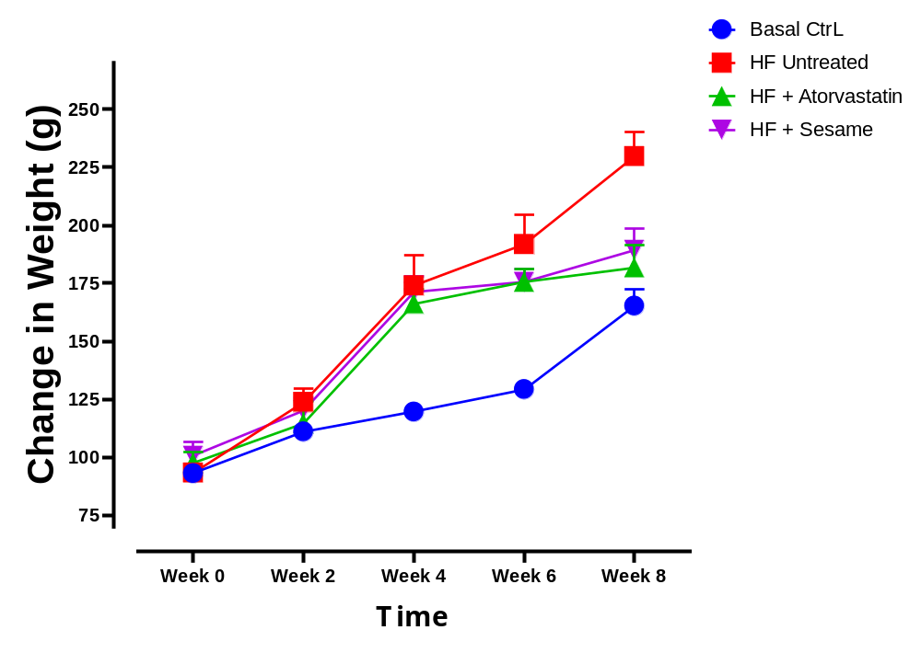
Figure 4.1: Body weight change data over eight weeks in HFD-fed rats and treatment groups (n = 10). Data presented are mean ± SD.

4.2 Lipid profile
Figure 4.2 depicts the effect of sesame supplementation and atorvastatin treatment on total cholesterol concentration in high-fat diet-induced hyperlipidemic rats. The untreated hyperlipidemic group exhibited a substantial increase (p < 0.05) in total cholesterol level relative to the basal control group. Treatment with atorvastatin significantly reduced (p < 0.05) total cholesterol relative to the untreated group. Similarly, sesame supplementation significantly lowered (p < 0.05) total cholesterol in comparison to the untreated group. No significant difference (p > 0.05) was recorded between the atorvastatin- and sesame-treated groups, indicating comparable cholesterol-lowering effects.
Figure 4.3 presents the total triglyceride concentrations of the experimental set-up. A significant elevation (p < 0.05) in triglyceride level was observed in the untreated hyperlipidemic group in relation with the basal control. Administration of atorvastatin significantly decreased (p < 0.05) triglyceride concentration relative to the untreated group. Likewise, treatment with sesame significantly reduced (p < 0.05) triglyceride levels relative to the untreated hyperlipidemic rats. No marked difference (p > 0.05) was observed between the atorvastatin- and sesame-treated groups, stating that sesame supplementation effectively attenuated the hypertriglyceridemia caused by high-fat diet.
Effect of treatment on HDL-cholesterol concentration is shown in Figure 4.4. The untreated hyperlipidemic group recorded a significant reduction (p < 0.05) in HDL-cholesterol level in comparison with the basal control group. Treatment with atorvastatin significantly increased (p < 0.05) HDL-cholesterol relative to the untreated group. Similarly, sesame supplementation significantly elevated (p < 0.05) HDL-cholesterol concentration relative to the untreated hyperlipidemic group. Although HDL-cholesterol concentration in both treatment groups remained lower than the basal control, there was no substantial difference (p > 0.05) between the atorvastatin- and sesame-treated groups.
Figure 4.5 shows the LDL-cholesterol concentration of the experimental animals. The untreated hyperlipidemic rats exhibited a substantial increase (p < 0.05) in LDL-cholesterol in comparison to the basal control group. However, treatment with atorvastatin substantially reduced (p < 0.05) LDL-cholesterol relative to the untreated group. Sesame supplementation also significantly decreased (p < 0.05) LDL-cholesterol concentration when related with untreated hyperlipidemic rats. No marked difference (p > 0.05) was observed between the atorvastatin- and sesame-treated groups. Overall, both interventions effectively improved the lipid profile altered by high-fat diet feeding, with sesame demonstrating efficacy comparable to that of atorvastatin

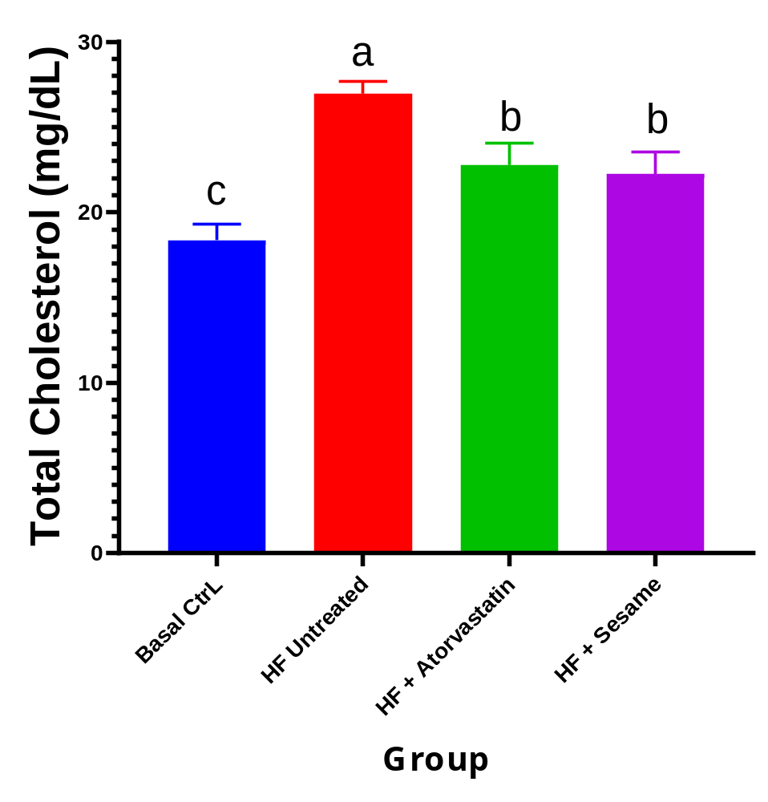
Figure 4.2: Total cholesterol concentration (TC) in HFD-fed rats and treatment groups (n = 10). Data presented are mean ± SD. Significant difference at p < 0.05.

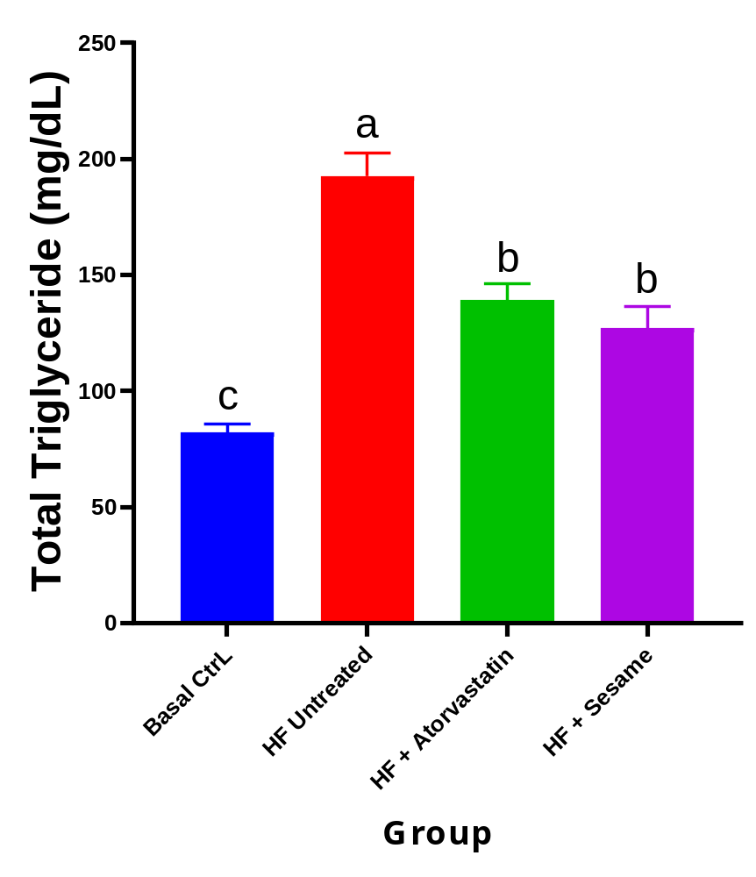
Figure 4.3: Total Triglyceride (TRIG) concentration in HFD-fed rats and treatment groups (n = 10). Data presented are mean ± SD. Significant difference at p < 0.05.

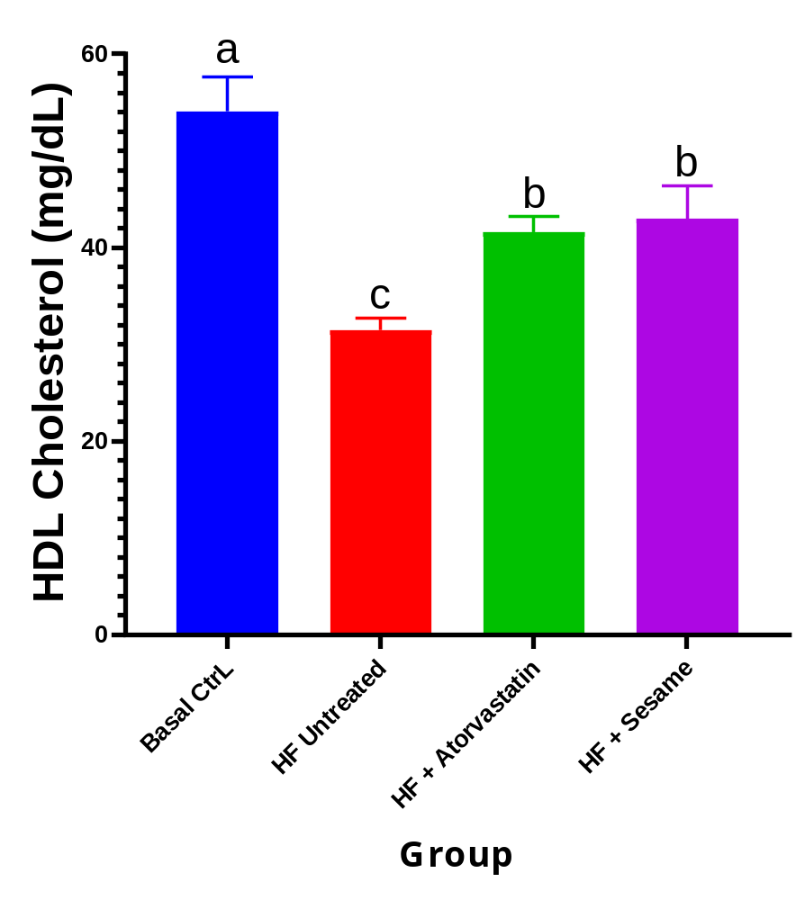
Figure 4.4: High density lipoprotein cholesterol concentration in HFD-fed rats and treatment groups (n = 10). Data presented are mean ± SD. Significant difference at p < 0.05.

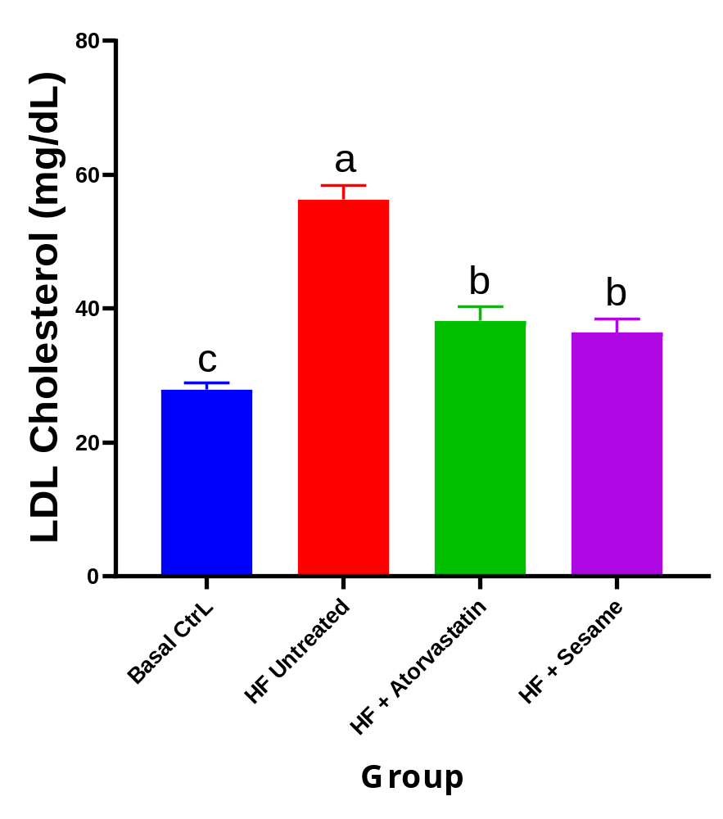
Figure 4.5: Low density lipoprotein cholesterol concentration in HFD-fed rats and treatment groups (n = 10). Data presented are mean ± SD. Significant difference at p < 0.05.

4.3 Antioxidant enzymes
Figure 4.6 presents the catalase (CAT) activity of the experimental groups. CAT activity was substantially decreased (p < 0.05) in the untreated hyperlipidemic group relative to the basal control. Treatment with atorvastatin significantly increased (p < 0.05) CAT activity relative to the untreated group but remained significantly reduced (p < 0.05) than the basal control. Sesame supplementation also significantly elevated (p < 0.05) CAT activity relative to the untreated group and produced markedly higher activity (p < 0.05) than atorvastatin, although values remained below those of the basal control.
Figure 4.7 presents the superoxide dismutase (SOD) activity of the experimental groups. The untreated hyperlipidemic group showed a substantial decrease (p < 0.05) in SOD activity relative to the basal control. Both atorvastatin and sesame treatments significantly increased (p < 0.05) SOD activity relative to the untreated group. No significant difference (p > 0.05) was observed between the two treatment groups; however, their activities remained significantly lower (p < 0.05) than the basal control. Figure 4.8 shows the glutathione-S-transferase (GST) activity of the experimental subjects. GST activity was significantly reduced (p < 0.05) in untreated hyperlipidemic rats relative to the basal control rats. Treatment with either atorvastatin or sesame significantly increased (p < 0.05) GST activity relative to the untreated group. There was no significant difference (p > 0.05) between the two treatment groups, although both remained markedly lower (p < 0.05) than the basal control.
Figure 4.9 presents the glutathione peroxidase (GPx) activity of the experimental groups. The untreated group exhibited significantly declined (p < 0.05) GPx activity than the basal control. Administration of atorvastatin and sesame significantly increased (p < 0.05) GPx activity relative to the untreated rats. No marked difference (p > 0.05) was observed between the two treatments, but both groups maintained significantly lower (p < 0.05) GPx activity than the basal control.

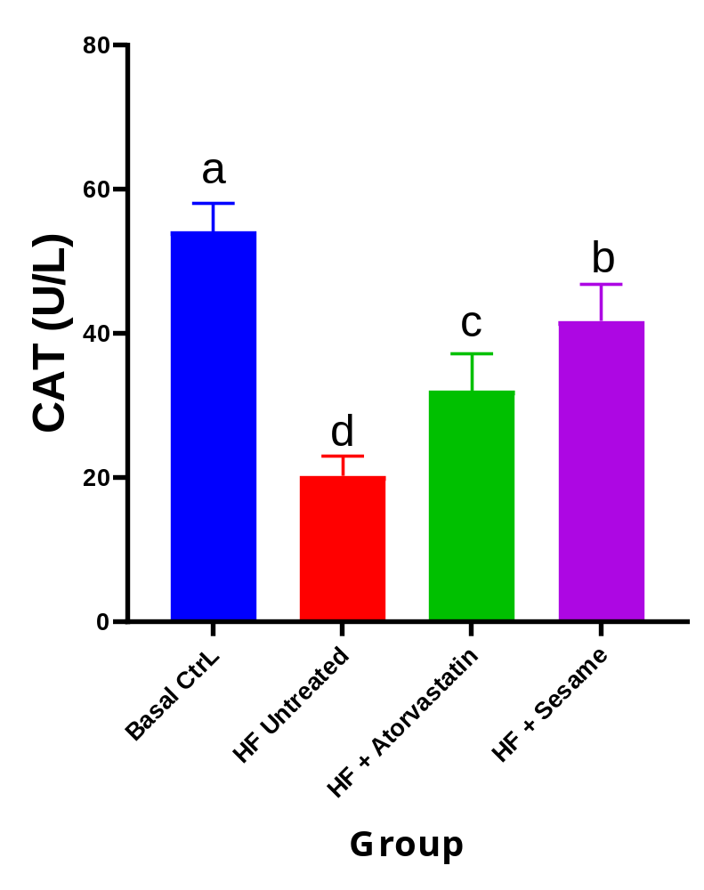
Figure 4.6: Catalase activity in HFD-induced hyperlipidemic Wistar rats treated with sesame seed-based diet and atorvastatin (n = 10). Data presented are mean ± SD. Significant difference at p < 0.05.

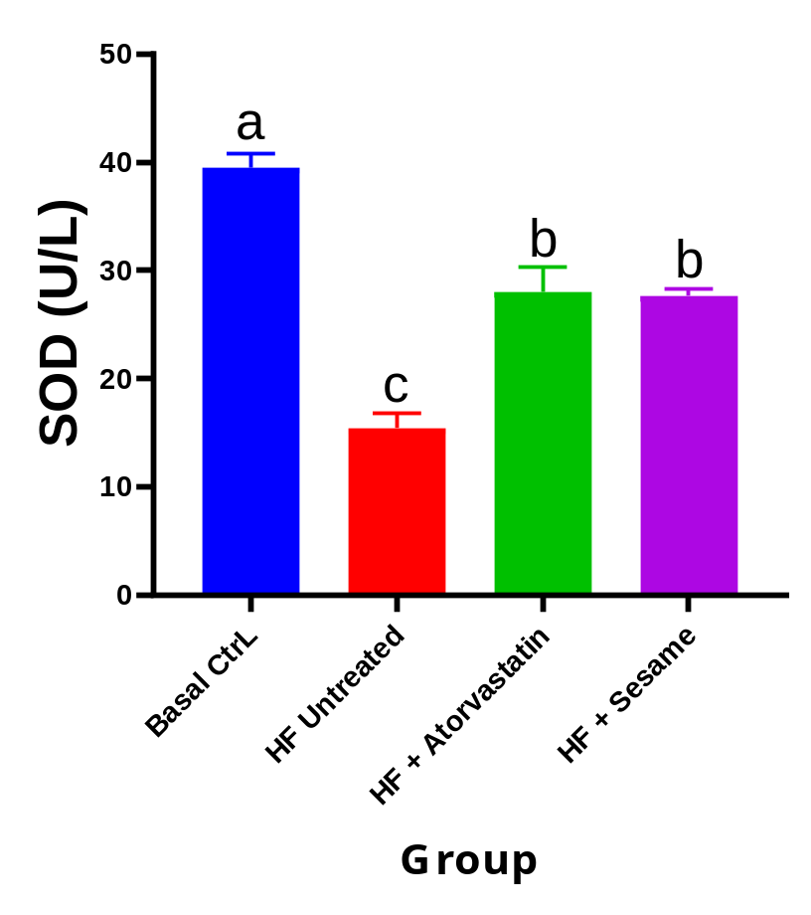
Figure 4.7: Superoxide dismutase activity in HFD-induced hyperlipidemic Wistar rats treated with sesame seed-based diet and atorvastatin (n = 10). Data presented are mean ± SD. Significant difference at p < 0.05.

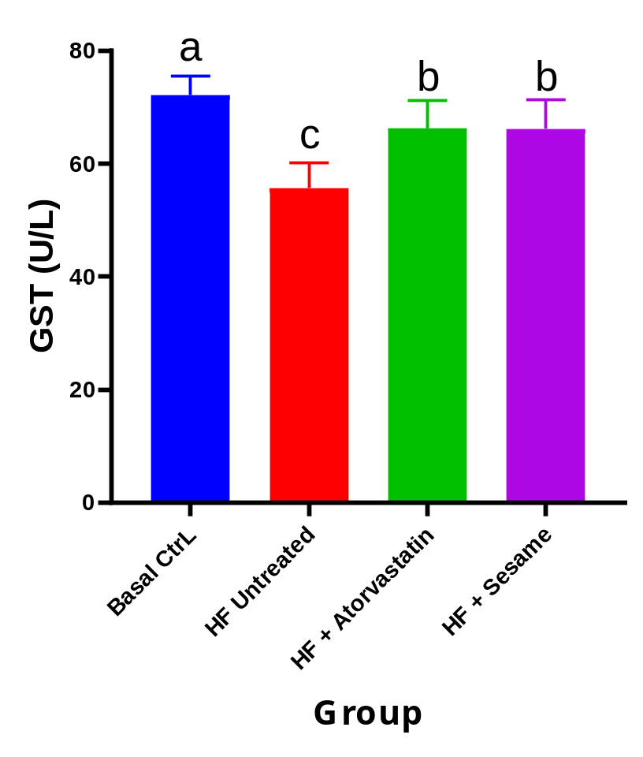
Figure 4.8: Glutathione S - transferase activity in HFD-induced hyperlipidemic Wistar rats treated with sesame seed-based diet and atorvastatin (n = 10). Data presented are mean ± SD. Significant difference at p < 0.05.

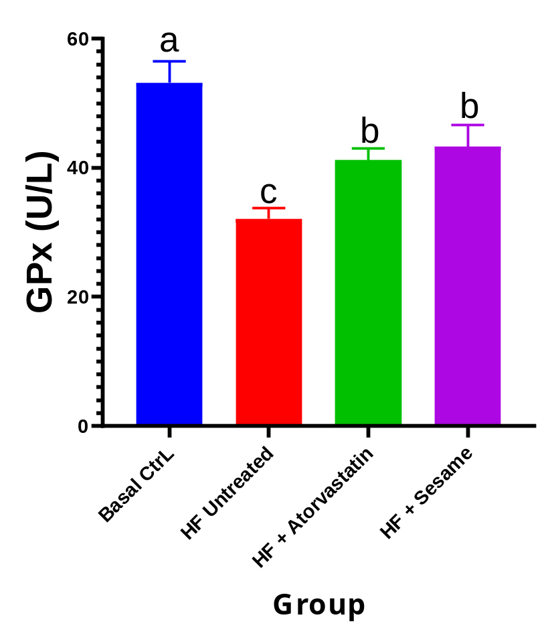
Figure 4.9: Glutathione peroxidase activity in HFD-induced hyperlipidemic Wistar rats treated with sesame seed-based diet and atorvastatin (n = 10). Data presented are mean ± SD. Significant difference at p < 0.05.

4.4 Oxidative stress markers
Figure 4.10 presents the malondialdehyde (MDA) levels of the experimental groups. The untreated hyperlipidemic group exhibited a substantial increase (p < 0.05) in MDA concentration relative to the basal control group, indicating elevated lipid peroxidation. Treatment with atorvastatin significantly reduced (p < 0.05) MDA levels relative to the untreated group. Similarly, sesame supplementation significantly decreased (p < 0.05) MDA concentration when compared with untreated hyperlipidemic rats. No significant difference (p > 0.05) was observed between the atorvastatin- and sesame-treated groups, although both groups maintained significantly higher (p < 0.05) MDA levels than the basal control.
Figure 4.11 shows the reduced glutathione (GSH) levels of the experimental groups. The untreated hyperlipidemic rats recorded a substantial decrease (p < 0.05) in GSH contents relative to the basal control rats. Administration of atorvastatin significantly increased (p < 0.05) GSH levels relative to the untreated group. Sesame supplementation also markedly elevated (p < 0.05) GSH concentration relative to untreated hyperlipidemic rats and produced substantially higher (p < 0.05) GSH levels than atorvastatin treatment. Nevertheless, GSH levels in the sesame-treated group remained substantially lower (p < 0.05) than those of the basal control group. These results indicate partial restoration of endogenous glutathione following treatment

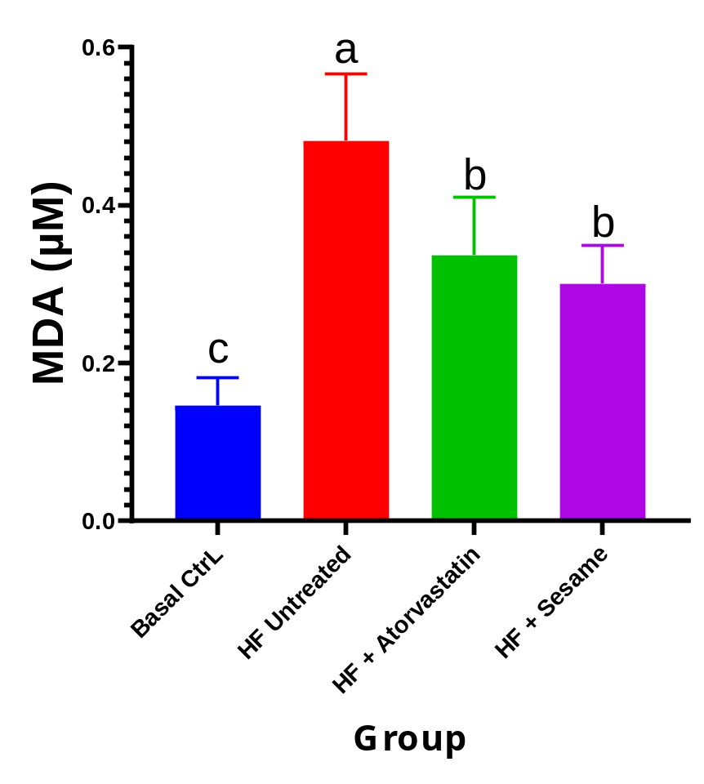
Figure 4.10: Malondialdehyde concentration in HFD-induced hyperlipidemic Wistar rats treated with sesame seed-based diet and atorvastatin (n = 10). Data presented are mean ± SD. Significant difference at p < 0.05.

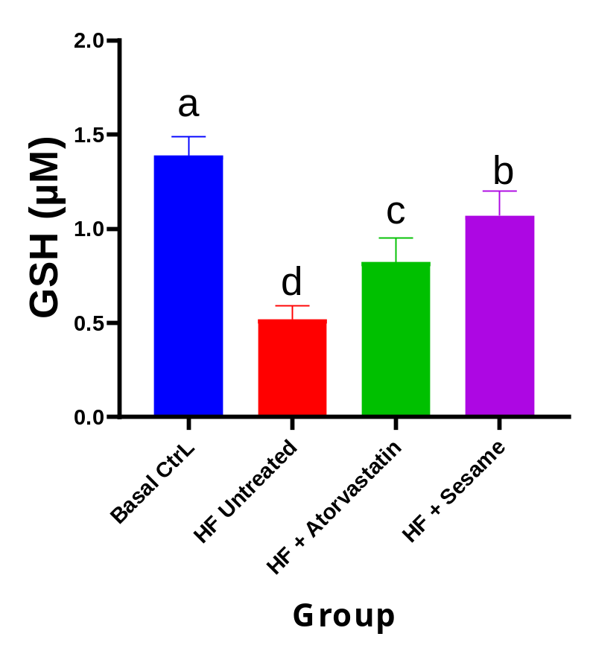
Figure 4.11: Effect of treatments on reduced glutathione (GSH) levels. Bars represent mean ± SD, and different superscript letters (a–d) indicate statistically significant differences between groups (p < 0.05).

4.5 Discussion
This study demonstrates that inclusion of sesame seed in diet has an effect on the plasma lipid profile, and the activities of antioxidant enzyme in hyperlipidemic male wistar rats fed with a high fat diet (HFD). All of these indicate that sesame has a complex therapeutic scope as a functional food, similar to the lipid-lowering drug, atorvastatin, and has an important therapeutic role in reducing oxidative stress and related metabolic effects of hyperlipidaemia.
The obesogenic effects of chronic HFD feeding leading to adiposity, insulin resistance and dysregulated lipid metabolism significantly raised body weight gain in HFD untreated group. Rats on sesame-supplemented diet showed a markedly reduced weight gain as in the atorvastatin group. The decrease indicates that the bioactives in sesame may inhibit the appetite or increase energy expenditure, or possibly block intestinal lipid absorption and hepatic lipogenesis. Maintenance of body weight is an important factor in the treatment of hyperlipidaemia, since obesity is a major contributor to cardiovascular risk via the increase in free fatty acid flux, and overproduction of VLDL. This is similar to the previously reported effects of sesame lignans in high-fat fed rodents that demonstrated weight loss and suggested a role for downregulation of SREBP-1c and upregulation of fatty acid oxidation pathways by PPAR-α. The effectiveness of sesame compared to atorvastatin further establishes its potential as a safe and effective natural source that does not have long-term side-effect concerns as typically linked to statins.
HFD feeding had a significant impact on plasma lipid parameters. In the untreated hyperlipidemic group the levels of TC increased considerably, which was in keeping with increased synthesis of cholesterol in the liver and decreased clearance. There was a significant decrease in TC on Sesame supplementation that was comparable to the amount obtained with atorvastatin. Mechanistically, the hypocholesterolemic effect of sesame could be associated with the action of sesame phytosterols, which inhibit the absorption of cholesterol in the intestine by competitive action on NPC1L1 transporters, and the action of lignans, which inhibit HMG-CoA reductase activity and stimulate the expression of LDL receptors. A key objective for lowering atherogenic burden and preventing plaque formation is to reduce TC.
The same was true for triglyceride (TG) levels. In HFD untreated rats, there was a significant increase in TG that suggests a diminished activity of lipoprotein lipase and overproduction of VLDL in the liver. Plasma TG significantly decreased by sesame supplementation, which was similar to the atorvastatin group. This TG reducing capacity is correlated with the presence in the sesame seeds of polyunsaturated fatty acids (linoleic and oleic acids) that increase the β-oxidation and lignans that inhibit diacylglycerol acyltransferase and decrease the production of TGs and their secretion. To prevent the occurrence of postprandial lipemia, endothelial dysfunction and acute pancreatitis, TG reduction is a must. These findings are supported by Hussain et al. (2023) and Mili et al. (2021) who showed that sesame activates PPAR-α and inhibits SREBP-1c, leading to TG-lowering effects in high-fat fed rodents. The parallel efficacy with atorvastatin further supports the importance of sesame as an additional functional food with the potential to be used in the treatment of hypertriglyceridemia without the myopathic side effects that can be seen with fibrates or high dose statins.
The HFD untreated group showed elevated levels of LDL-C, which facilitates the initiation of atherogenesis by an increased deposition of lipids in the vascular wall. Both the sesame and atorvastatin treatments resulted in large reductions in LDL-C. This is accomplished partly by the action of sesame lignans and phytosterols, which block cholesterol absorption and increase the clearance of LDL cholesterol from the liver by increasing LDL receptor activity. The basis of cardiovascular risk reduction is LDL-C lowering. The observed reduction is similar to that reported by Wei et al. (2022) and Andargie et al. (2021), where increased LDL clearance was achieved with sesame supplementation through increased expression of LDL receptors in the liver. The reduction observed in the sesame group, which is approaching that of atorvastatin, is significant, indicating that it is a promising complementary nutraceutical in statin intolerant patients and as a natural lipid-modulating agent.
In contrast, there was a significant decrease in HDL-C in the HFD untreated group, which interferes with reverse cholesterol transport and increases atherogenic risk. The supplementation with sesame significantly increased the HDL-C concentration, which is similar to the atorvastatin group. The HDL-raising effect is due to the unsaturated fatty acids present in sesame, and the lignans which increase the expression of apolipoprotein A-I and lecithin-cholesterol acyltransferase activity, thereby enhancing HDL maturation and function. At the clinical level, high levels of HDL-C are known to be protective against atherosclerosis and cardiovascular health in general. The results support the results of Sharma et al. (2020) and Wu et al. (2019), which demonstrated that sesame can enhance the function of HDL. The restoration of the HDL-C further exemplifies the holistic cardio protective profile of sesame.
In addition to lipid modulation, sesame had significant actions on markers of oxidative stress. The activity of superoxide dismutase (SOD) was significantly reduced in the HFD untreated group (Fig. 4.7), indicating the inability of antioxidant defenses and a greater amount of superoxide radical. At the same time, sesame supplementation up-regulated the level of SOD activity to near normal levels, comparable to atorvastatin. Sesame lignans and polyphenols directly scavenge the superoxide radicals, and activate Nrf2 pathway to upregulate the expression of SOD gene. The restoration of SOD activity helps restore the antioxidant properties of the endothelium, which prevents endothelial damage and lipid peroxidation caused by ROS, two major factors in the initiation of atherosclerosis.
The catalytic activity of catalase (CAT) was similarly observed. HFD feeding significantly reduced the level of CAT, and the sesame diet significantly elevated the level of CAT. The accumulation of hydrogen peroxide is decreased and the function of peroxisomes is supported by sesame bioactives, which increase the activity of CAT. Improved CAT results in reducing the oxidative damage of pancreatic beta cells, vascular endothelium and other tissues that are susceptible in hyperlipidemia (Kelle et al., 2024).
The levels of glutathione peroxidase (GPx) activity were also reduced in the HFD untreated group and elevated after the sesame supplementation. Sesame lignans increase GPx levels in a selenium-dependent manner and by glutathione recycling, thereby decreasing lipid hydroperoxides. The GPx activity is enhanced which prevents the progression of atherosclerosis by protecting the PUFAs in cell membranes and lipoproteins from oxidative damage. Similar suppression was observed in the untreated hyperlipidemic state in the case of GST activity (Fig 4.8), but it was significantly enhanced by the treatment with sesame. The expression of GST is induced by sesame polyphenols that increase detoxification of lipid peroxides and xenobiotics.
The level of reduced glutathione (GSH) was decreased in HFD untreated group, reflecting the impaired redox buffering capacity. GSH pools were significantly restored with sesame supplementation. Sesame lignans and vitamin E act as an antioxidant by supporting the activity of glutathione reductase and recycling oxidized glutathione to maintain GSH. Preserved GSH is able to inhibit oxidative stress and activate detoxification channels.
The HFD untreated group showed significantly elevated levels of malondialdehyde, thus demonstrating the oxidative damage of lipids. Higher supplementation with sesame resulted in the significant reduction of MDA as compared with the atorvastatin group. The antioxidants in sesame are able to break the chain of lipid peroxidation, removing free radicals and stabilizing membranes. Lower MDA levels are associated with lower atherogenic risk and protection against endothelial dysfunction.
In summary, the results showed that the diet supplemented with Sesamum indicum has significant hypolipidemic and antioxidant activity in hyperlipidemic male Wistar rats. The bioactives extracted from Sesame can function synergistically by several mechanisms: inhibition of intestinal cholesterol absorption, suppression of hepatic lipogenesis, promotion of the clearance of LDL by increasing the expression of its receptors, activation of the expression of antioxidant enzymes through activation of Nrf2, and the ability to directly scavenge ROS to prevent lipid peroxidation. These activities also normalize plasma lipid profile and improve the endogenous antioxidant defense, reducing the worsening consequences of hyperlipidaemia due to oxidative stress.
A noteworthy aspect of this is the near-equivalence of the efficacy of sesame and atorvastatin. Although atorvastatin mainly acts on HMG-CoA reductase, sesame has more comprehensive effects, such as inhibiting lipid synthesis, reducing oxidative stress, and anti-inflammatory, which do not have the potential myopathy and hepatotoxicity effects observed with long-term statin use. This makes sesame a relatively inexpensive, safe and natural complementary or alternative approach, particularly where pharmaceuticals are not easily available in low resource areas such as Africa.
Oxidative stress and hyperlipidaemia are significant factors involved in the pathogenesis of atherosclerosis and cardiovascular disease, and also in the subsequent complications like diabetes. In addition to having a positive effect on lipid profile, sesame supplementation could also have a positive effect on antioxidant status and thus, it can lower cardiovascular risk, augment endothelial function, and prevent damage to beta-cells which causes insulin resistance. The study also confirms the use of male Wistar rats as a good model for assessing functional food interventions, which serves as a basis for future translational research.
Phenologically, Sesame is widely available, has low cost, available culturally in many parts of Nigeria and hence it is regarded from public health point of view as a good source. Incorporating sesame into diet may be a sustainable option for hyperlipidaemia management, particularly when lifestyle and dietary changes are not sufficient, and may help to decrease the need for drug-based interventions on a population level. The results validate the recommendations for nutrition for cardiometabolic health, which focus on functional foods that contain lignans and unsaturated fatty acids.
Mechanistically, the study identifies the relationship between oxidative stress and lipid metabolism, indicating that they are interdependent. High lipids lead to increased ROS generation and eventually to the modification of lipid metabolism and a decrease in antioxidant enzymes activity, forming a vicious circle. But sesame is a different story, because it tackles both arms of the cycle - lipid modulation and antioxidant restoration - and provides a broad therapeutic benefit that often single-target drugs are unable to deliver.
In summary, dietary supplementation with S. indicum seed reduces hyperlipidaemia, due to oxidative stress, in male Wistar rats with an efficacy comparable to that of atorvastatin. The results validate the therapeutic potential of sesame as a functional food and its contribution in dietary interventions to improve lipid Disorders and related complications.
CHAPTER FIVE
SUMMARY, CONCLUSION AND RECOMMENDATIONS
5.1 Summary
The present study was aimed to investigate the effect of dietary supplementation with Sesamum indicum seeds on lipid profile and antioxidant status of high fat diet induced hyperlipidemic male Wistar rats. Hyperlipidemia significantly elevated body weight, LDL-cholesterol, triglycerides, total cholesterol, oxidative stress and lipid peroxidation, and decreased HDL-cholesterol and antioxidant enzyme activities. Body weight gain was significantly decreased, lipid parameters were significantly improved, antioxidant defenses were increased (SOD, CAT, GPx and GST), and malondialdehyde was decreased by feeding sesame seed diet. The effects obtained were similar to those obtained with atorvastatin, indicating that sesame has a good hypolipidemic and antioxidant effect, and therefore, may have nutraceutical properties.
5.2 Conclusion
The present study revealed that lipid profile and antioxidant status of male Wistar rats fed a high-fat diet could be significantly improved by sesamum indicum seed diet. Sesame reduced triglycerides, total cholesterol and LDL-C, while increasing HDL-C concentration, and was similar to atorvastatin. The activities of SOD, CAT, GPx, and GST were also increased by Sesamum indicum seed diet whereas the malondialdehyde levels were decreased, suggesting the decrease in the activities of lipid peroxidation. Further, sesame reduced body weight gain induced by high fat diet. In general, sesame has dual hypolipidemic and antioxidant effects, which could be attributed to the presence of some bioactive lignans, unsaturated fatty acids and phytosterols; indicating that sesame is a potential functional food for controlling lipid accumulation and oxidative stress.

5.3 Recommendations
Given the potential for the effectiveness and safety of sesame supplementation in hyperlipidemic humans, particularly in low-resource communities, clinical trials are recommended. It needs to be studied for long-term effects on lipid levels and to prevent atherosclerosis and diabetes. Other dose optimization, bioavailability and molecular mechanisms studies are required for supporting nutraceutical development. Sesame could be a cost-effective dietary therapy for hyperlipidaemic and oxidative stress-related diseases and therefore should be encouraged as public health interventions.

REFERENCES
Abo-Elenien, W. I. and Mohamed, W. (2024). Exploring the Relationship Among Stroke, Hypertension, and Hyperlipidemia: A 10-Year Bibliometric Analysis. In Nutrition and Stroke: Current State and Future Perspectives. 6 (3): 175-210.
Adeyanju, M. M., Saheed, I. A., Oyelekan, O. I., Dele-Osibanjo, T. A., Adelegan, A. A., Raimi, A. J... and Alli, K. M. (2022). Sesamum indicum diet prevents hyperlipidemia in experimental rats. Food Chemistry: Molecular Sciences, 4, 100092.
Aguilar-Salinas, C. A., Gómez-Díaz, R. A., and Corral, P. (2022). New therapies for primary hyperlipidemia. The Journal of Clinical Endocrinology and Metabolism, 107(5), 1216-1224.
Ali, N., Rahman, S., Islam, S., Haque, T., Molla, N.H., Sumon, A.H., Kathak, R.R., Asaduzzaman, M., Islam, F., Mohanto, N.C. and Hasnat, M.A. (2019). The relationship between serum uric acid and lipid profile in Bangladeshi adults. BMC cardiovascular disorders, 19(1), 42.
Alloubani, A., Nimer, R. and Samara, R. (2021). Relationship between hyperlipidemia, cardiovascular disease and stroke: a systematic review. Current cardiology reviews, 17(6), 52-66.
Ambikairajah, A., Walsh, E. and Cherbuin, N. (2019). Lipid profile differences during menopause: a review with meta-analysis. Menopause, 26(11), 1327–1333.
Amoo, S. O., Okorogbona, A. O. M., Du Plooy, C. P. and Venter, S. L. (2017). Sesamum indicum. In Medicinal spices and vegetables from Africa (549-579). Academic Press.
Andargie, M., Vinas, M., Rathgeb, A., Möller, E. and Karlovsky, P. (2021). Lignans of sesame (Sesamum indicum L.): a comprehensive review. Molecules, 26(4), 883.
Artha, I.M.J.R., Bhargah, A., Dharmawan, N.K., Pande, U.W., Triyana, K.A., Mahariski, P.A., Yuwono, J., Bhargah, V., Prabawa, I.P.Y., Manuaba, I.B.A.P. and Rina, I.K. (2019). High level of individual lipid profile and lipid ratio as a predictive marker of poor glycemic control in type-2 diabetes mellitus. Vascular health and risk management, 7 (3):149-157.
Barr, A. J. (2018). The biochemical basis of disease. Essays in biochemistry, 62(5), 619–642. https://doi.org/10.1042/EBC20170054
Bhattacharjee, M., Iqbal, A., Singha, S., Nath, D., Prakash, S. H. and Dasgupta, T. (2019). Genetic diversity in Sesamum indicum L. Bangladesh Journal of Botany, 48(3), 497-506.
Bratovcic, A. J. A. S. (2020). Antioxidant enzymes and their role in preventing cell damage. Acta Science and Nutritional Health, 4(3), 01-07.
Caverzan, A., Casassola, A. and Brammer, A. P. (2016). Reactive oxygen species and antioxidant enzymes. Abiotic and biotic stress in plants—recent advances and future perspectives involved in plant tolerance to stress. Intech, Croatia, 463-480.
Cecerska-Heryć, E., Surowska, O., Heryć, R., Serwin, N., Napiontek-Balińska, S. and Dołęgowska, B. (2021). Are antioxidant enzymes essential markers in the diagnosis and monitoring of cancer patients–a review. Clinical biochemistry, 93, 1-8.
Chen, S. and Cheng, W. (2022). Relationship between lipid profiles and hypertension: a cross-sectional study of 62,957 Chinese adult males. Frontiers in public health, 10, 895499.
Dibaba, D. T. (2019). Effect of vitamin D supplementation on serum lipid profiles: A systematic review and meta-analysis. Nutrition Reviews, 77(12), 890–902.
Doewes, R. I., Gharibian, G., Zaman, B. A. and Akhavan-Sigari, R. (2023). An updated systematic review on the effects of aerobic exercise on human blood lipid profile. Current problems in cardiology, 48(5), 101108.
Dossa, K., Diouf, D., Wang, L., Wei, X., Zhang, Y., Niang, M., Fonceka, D., Yu, J., Mmadi, M.A., Yehouessi, L.W. and Liao, B. (2017). The emerging oilseed crop Sesamum indicum enters the “Omics” era. Frontiers in plant science, 8, 1154.
Dravie, E. E., Kortei, N. K., Essuman, E. K., Tettey, C. O., Boakye, A. A. and Hunkpe, G. (2020). Antioxidant, phytochemical and physicochemical properties of sesame seed (Sesamum indicum L). Scientific African, 8, e00349.
Durrington, P., Bashir, B. and Soran, H. (2026). Hyperlipidemia. In Metabolism of Human Diseases: Organ Physiology and Pathophysiology (311-324).
Elleuch, M., Besbes, S., Roiseux, O., Blecker, C. and Attia, H. (2011). Quality characteristics of sesame seeds and by-products. Food Chemistry, 103(2), 641–650.
El-Tantawy, W. H. and Temraz, A. (2019). Natural products for controlling hyperlipidemia. Archives of physiology and biochemistry, 125(2), 128-135.
Folch, J., Lees, M. and Stanley, G. S. (1957). A simple method for the isolation and purification of total lipides from animal tissues. Journal of biological chemistry, 226(1), 497-509.
Gaio, V., Roquette, R., Dias, C. M. and Nunes, B. (2019). Ambient air pollution and lipid profile: Systematic review and meta-analysis. Environmental Pollution, 254, 113036.
Gidez, L. I., Miller, G. J., Burstein, M., Slagle, S. and Eder, H. A. (1982). Separation and quantitation of subclasses of human plasma high density lipoproteins by a simple precipitation procedure. Journal of lipid Research, 23(8), 1206-1223.
Giles, L. A. (2024). Hyperlipidemia prevention and management utilizing lifestyle changes. Journal of Midwifery and Women's Health, 69(3), 361-369.
Glorieux, C. and Calderon, P. B. (2017). Catalase, a remarkable enzyme: targeting the oldest antioxidant enzyme to find a new cancer treatment approach. Biological chemistry, 398(10), 1095-1108.
Gordon, B., Chen, S. and Durstine, J. L. (2016). The effects of exercise training on the traditional lipid profile and beyond. Translational Journal of the American College of Sports Medicine, 1(18), 159-164.
Góth, L. (1991). Serum catalase: reversibly formed charge isoform of erythrocyte catalase. Clinical chemistry, 37(12), 2043-2047.
Gupta, D. K., Palma, J. M. and Corpas, F. J. (Eds.). (2018). Antioxidants and antioxidant enzymes in higher plants (1-300).
Habig, W. H., Pabst, M. J., Fleischner, G., Gatmaitan, Z., Arias, I. M. and Jakoby, W. B. (1974). The identity of glutathione S-transferase B with ligandin, a major binding protein of liver. Proceedings of the National Academy of Sciences, 71(10), 3879-3882.
He, N. and Ye, H. (2020). Exercise and hyperlipidemia. In Physical exercise for human health (pp. 79-90).
Huchzermeyer, B., Menghani, E., Khardia, P. and Shilu, A. (2022). Metabolic pathway of natural antioxidants, antioxidant enzymes and ROS providence. Antioxidants, 11(4), 761.
Hussain, M., Ul-Allah, S. and Farooq, S. (2023). Sesame (Sesamum indicum L.). In Neglected and Underutilized Crops (733-755).
Jomova, K., Alomar, S. Y., Alwasel, S. H., Nepovimova, E., Kuca, K. and Valko, M. (2024). Several lines of antioxidant defense against oxidative stress: antioxidant enzymes, nanomaterials with multiple enzyme-mimicking activities, and low-molecular-weight antioxidants. Archives of toxicology, 98(5), 1323-1367.
Karr, S. (2017). Epidemiology and management of hyperlipidemia. The American journal of managed care, 23(9 Suppl), S139-S148.
Kelle, B. P., Ćesić, A. K., Čustović, S., Ćosović, E., Lagumdžija, D., Jordamović, N. and Kusturica, J. (2024). Improvement of a diet-induced model of hyperlipidemia in Wistar rats: Assessment of biochemical parameters, the thickness of the abdominal aorta and liver histology. Journal of King Saud University-Science, 36(2), 103068.
Kiruthika, S., Narayanan, S. L., Parameswari, C., Mini, M. L. and Arunachalam, P. J. (2018). Genetic variability studies for yield and yield components in sesame (Sesamum indicum L.). 1529-1537.
Kris-Etherton, P. M., Sanders, L., Lawler, O., Riley, T. and Maki, K. (2023). Hyperlipidemia. In Encyclopedia of Human Nutrition: Volume 1-4, Fourth Edition (361-379). Elsevier.
Langsted, A. and Nordestgaard, B. G. (2019). Nonfasting versus fasting lipid profile for cardiovascular risk prediction. Pathology, 51(2), 131-141.
Last, A. R., Ference, J. D. and Menzel, E. R. (2017). Hyperlipidemia: drugs for cardiovascular risk reduction in adults. American family physician, 95(2), 78-87.
Mili, A., Das, S., Nandakumar, K. and Lobo, R. (2021). A comprehensive review on Sesamum indicum L.: Botanical, ethnopharmacological, phytochemical, and pharmacological aspects. Journal of Ethnopharmacology, 281, 114503.
Miraj, S. and Kiani, S. (2016). Bioactivity of Sesamum indicum: A review study. Der Pharmacia Lettre, 8(6), 328-34.
Misra, H. P. and Fridovich, I. (1972). The role of superoxide anion in the autoxidation of epinephrine and a simple assay for superoxide dismutase. Journal of Biological chemistry, 247(10), 3170-3175.
Moron, M. S., Depierre, J. W. and Mannervik, B. (1979). Levels of glutathione, glutathione reductase and glutathione S-transferase activities in rat lung and liver. Biochimica et biophysica acta (BBA)-general subjects, 582(1), 67-78.
Myint, D., Gilani, S. A., Kawase, M. and Watanabe, K. N. (2020). Sustainable sesame (Sesamum indicum L.) production through improved technology: An overview of production, challenges, and opportunities in Myanmar. Sustainability, 12(9), 3515.
Nagarthna, P. K. M., HarshaVardhini, N. and Sridhar, K. M. (2020). Hyperlipidemia and its treatment: A review. Journal of Advanced Scientific Research, 11(01), 1-6.
Namiki, M. (2007). Nutraceutical functions of sesame: A review. Critical Reviews in Food Science and Nutrition, 47(7), 651–673.
Naser, I. H., Alkareem, Z. A. and Mosa, A. U. (2021). Hyperlipidemia: pathophysiology, causes, consequences, and treatment. A review. Karbala Journal of Pharmaceutical Sciences, 1(19).
Nordestgaard, B. G. (2017). A test in context: Lipid profile, fasting versus nonfasting. Journal of the American College of Cardiology, 70(13), 1637–1646.
Nouh, F., Omar, M. and Younis, M. (2019). Risk factors and management of hyperlipidemia. Asian Journal of Cardiology Research, 2(1), 1-10.
Ohkawa, H., Ohishi, N. and Yagi, K. (1979). Assay for lipid peroxides in animal tissues by thiobarbituric acid reaction. Analytical biochemistry, 95(2), 351-358.
Paglia, D. E. and Valentine, W. N. (1967). Studies on the quantitative and qualitative characterization of erythrocyte glutathione peroxidase. The Journal of laboratory and clinical medicine, 70(1), 158-169.
Paredes, S., Fonseca, L., Ribeiro, L., Ramos, H., Oliveira, J. C. and Palma, I. (2019). Novel and traditional lipid profiles in Metabolic Syndrome reveal a high atherogenicity. Scientific reports, 9(1), 11792.
Parhofer, K. G. and Laufs, U. (2023). Lipid profile and lipoprotein (a) testing. Deutsches Ärzteblatt International, 120 (35-36), 582.
Pathak, K., Rahman, S. W., Bhagawati, S. and Gogoi, B. (2017). Sesame (Sesamum indicum L.), an underexploited oil seed crop: Current status, features and importance-A review. Agricultural Reviews, 38(3).
Pathak, N., Rai, A. K., Kumari, R. and Bhat, K. V. (2014). Value addition in sesame: A perspective on bioactive components for enhancing utility and profitability. Pharmacognosy Reviews, 8(16), 147–155.
Peña-Saldarriaga, L. M., Fernández-López, J. and Pérez-Alvarez, J. A. (2020). Quality of chicken fat by-products: Lipid profile and colour properties. Foods, 9(8), 1046.
Poornima, I. G., Indaram, M., Ross, J. D., Agarwala, A. and Wild, R. A. (2022). Hyperlipidemia and risk for preclampsia. Journal of clinical lipidology, 16(3), 253-260.
Rani, R. R., Banu, Z. and Rahman, A. (2024). Comprehensive Review of Hyperlipidemia: Pathophysiology, Diagnosis, and Management. International Journal of All Research Education and Scientific Methods, 12(11), 111-120.
Rauf, A., Akram, M., Anwar, H., Daniyal, M., Munir, N., Bawazeer, S., Bawazeer, S., Rebezov, M., Bouyahya, A., Shariati, M.A. and Thiruvengadam, M. (2022). Therapeutic potential of herbal medicine for the management of hyperlipidemia: latest updates. Environmental Science and Pollution Research, 29(27), 40281-40301.
Rezaei, A., Neshat, S. and Heshmat-Ghahdarijani, K. (2022). Alterations of lipid profile in COVID-19: a narrative review. Current Problems in Cardiology, 47(3), 100907.
Roy, Z., Bansal, R., Siddiqui, L. and Chaudhary, N. (2023). Understanding the role of free radicals and antioxidant enzymes in human diseases. Current pharmaceutical biotechnology, 24(10), 1265-1276.
Sanni, G.B., Ezin, V., Chabi, I.B., Missihoun, A.A., Florent, Q., Hamissou, Z., Niang, M. and Ahanchede, A. (2024). Production and achievements of Sesamum indicum industry in the world: past and current state. Oil Crop Science, 9(3), 187-197.
Santos, H. O., Bueno, A. A. and Mota, J. F. (2018). The effect of artichoke on lipid profile: A review of possible mechanisms of action. Pharmacological research, 137, 170-178.
Shahwan, M. J., Jairoun, A. A., Farajallah, A. and Shanabli, S. (2019). Prevalence of dyslipidemia and factors affecting lipid profile in patients with type 2 diabetes. Diabetes and Metabolic Syndrome: Clinical Research and Reviews, 13(4), 2387-2392.
Sharma, L., Saini, C. S., Punia, S., Nain, V. and Sandhu, K. S. (2020). Sesame (Sesamum indicum) seed. In Oilseeds: health attributes and food applications (305-330).
Silva, R. C. D., Diniz, M. D. F. H. S., Alvim, S., Vidigal, P. G., Fedeli, L. M. G. and Barreto, S. M. (2016). Physical activity and lipid profile in the ELSA-Brasil study. Arquivos Brasileiros de Cardiologia, 107(1), 10–19.
Stewart, J., McCallin, T., Martinez, J., Chacko, S. and Yusuf, S. (2020). Hyperlipidemia. Pediatrics in review, 41(8), 393-402.
Teklu, D. H., Shimelis, H. and Abady, S. (2022). Genetic improvement in sesame (Sesamum indicum L.): Progress and outlook: A review. Agronomy, 12(9), 2144.
Tripathy, S. K., Kar, J. and Sahu, D. (2019). Advances in sesame (Sesamum indicum L.) breeding. In Advances in Plant Breeding Strategies: Industrial and Food Crops: Volume 6 (577-635).
Trivedi, S. and Lal, N. (2017). Antioxidant enzymes in periodontitis. Journal of oral biology and craniofacial research, 7(1), 54-57.
Wang, S. and Bao, X. (2019). Hyperlipidemia, blood lipid level, and the risk of glaucoma: a meta-analysis. Investigative ophthalmology and visual science, 60(4), 1028-1043.
Wei, P., Zhao, F., Wang, Z., Wang, Q., Chai, X., Hou, G. and Meng, Q. (2022). Sesame (Sesamum indicum L.): A comprehensive review of nutritional value, phytochemical composition, health benefits, development of food, and industrial applications. Nutrients, 14(19), 4079.
Wu, M. S., Aquino, L. B. B., Barbaza, M. Y. U., Hsieh, C. L., De Castro-Cruz, K. A., Yang, L. L.,and Tsai, P. W. (2019). Anti-inflammatory and anticancer properties of bioactive compounds from Sesamum indicum L.—A review. Molecules, 24(24), 4426.
Yanai, H., Adachi, H., Hakoshima, M. and Katsuyama, H. (2023). Postprandial hyperlipidemia: its pathophysiology, diagnosis, atherogenesis, and treatments. International journal of molecular sciences, 24(18), 13942.
Yao, Y. S., Li, T. D. and Zeng, Z. H. (2020). Mechanisms underlying direct actions of hyperlipidemia on myocardium: an updated review. Lipids in health and disease, 19(1), 23.
Yaseen, G., Ahmad, M., Zafar, M., Akram, A., Sultana, S., Ahmed, S. N. and Kilic, O. (2021). Sesame (Sesamum indicum L.). In Green Sustainable Process for Chemical and Environmental Engineering and Science (253-269).
Zoidis, E., Seremelis, I., Kontopoulos, N. and Danezis, G. P. (2018). Selenium-dependent antioxidant enzymes: Actions and properties of selenoproteins. Antioxidants, 7(5), 66.

